Virtual Community of Support for Early Learning
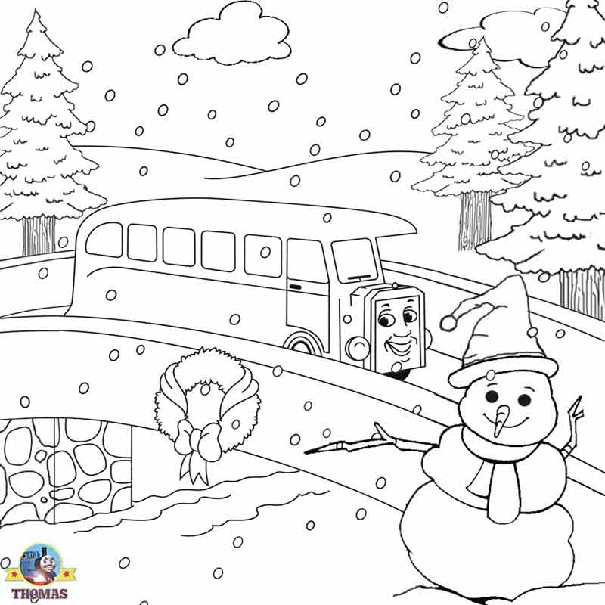

December 2024
2  3-5 yr Activity Post #4 | 3  Parent Tip #7 | 4  Activity Session 9 am | 5  0-2 Yr Activity Post #3 | 6  Recording Posted
9  Session Email Package sent | 10  Parent Session 9 am  Parent Tip #8 | 11  Literacy Session 9 am | 12  Recordings Posted | 13
16  Session Email Packages sent | 17  Parent Tip #9 | 18  Story Time Session 9 am | 19  Recordings  Posted | 20
23  Christmas holidays begins | 24 | 25 | 26 | 27

