
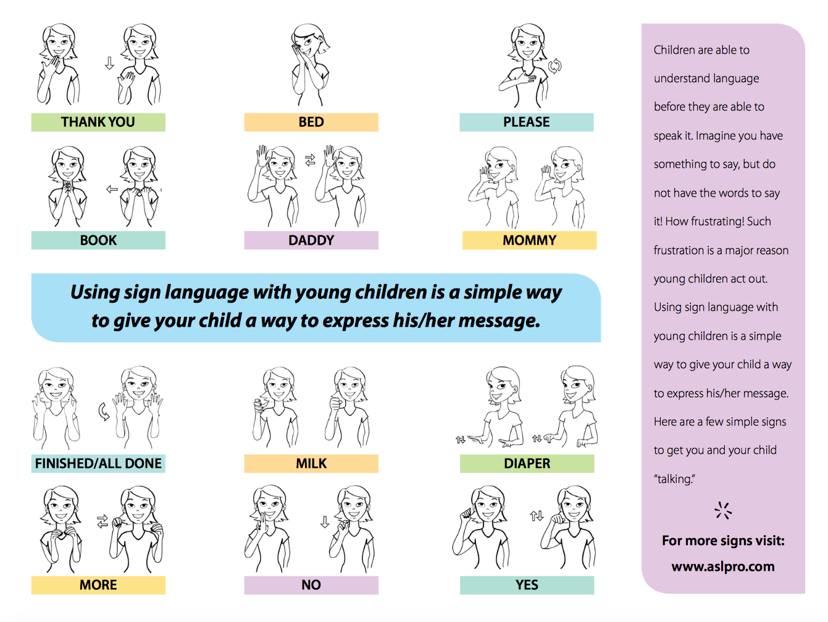

0-2
Activity Post
Let’s Go!
0-2activity post DECEMBER 2018 2018
Sign Language is an amazing way to begin communication with your baby.

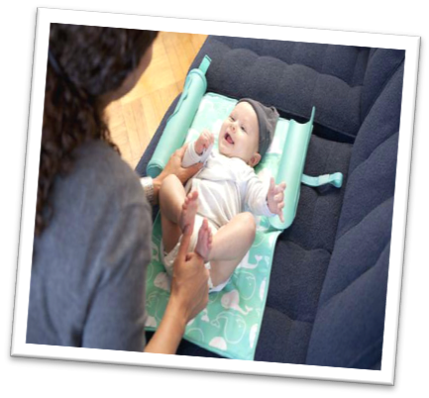
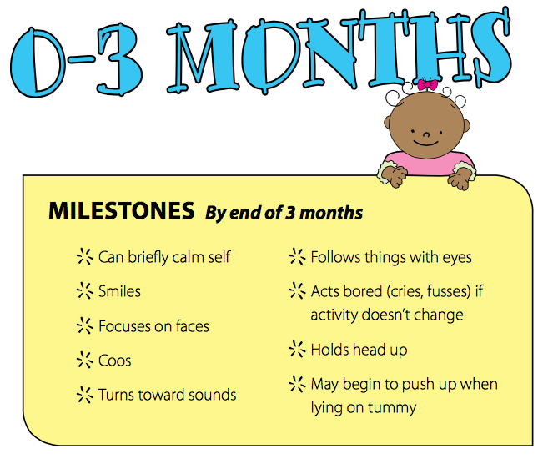

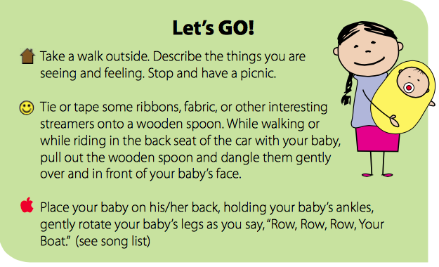
- A newborn baby’s first movements may appear jerky and random. However, usually the newborn baby moves in a pattern or rhythm, sometimes in rhythm to their mother's voice.
- Newborn babies have a wide repertoire of reflex and voluntary movements at birth including rooting, crawling, grasping, startle, placing and stepping reflexes.

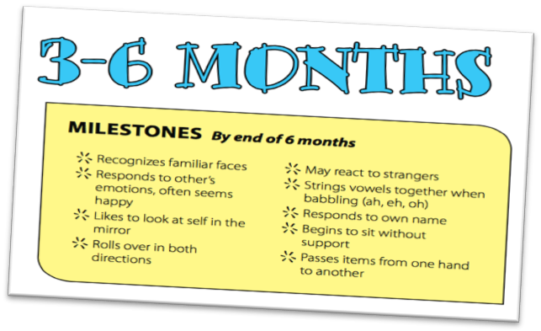
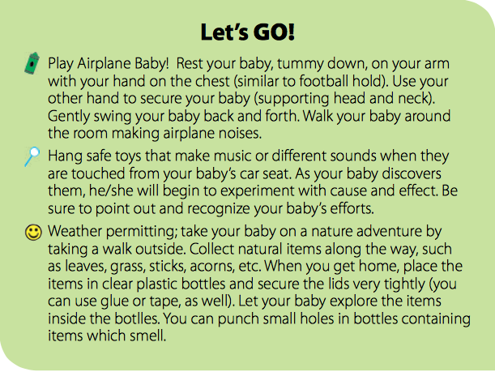
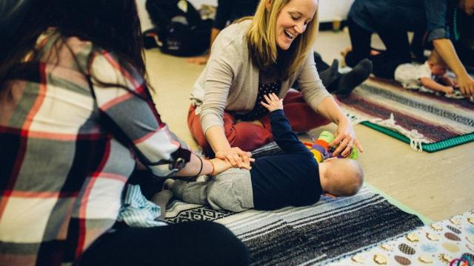
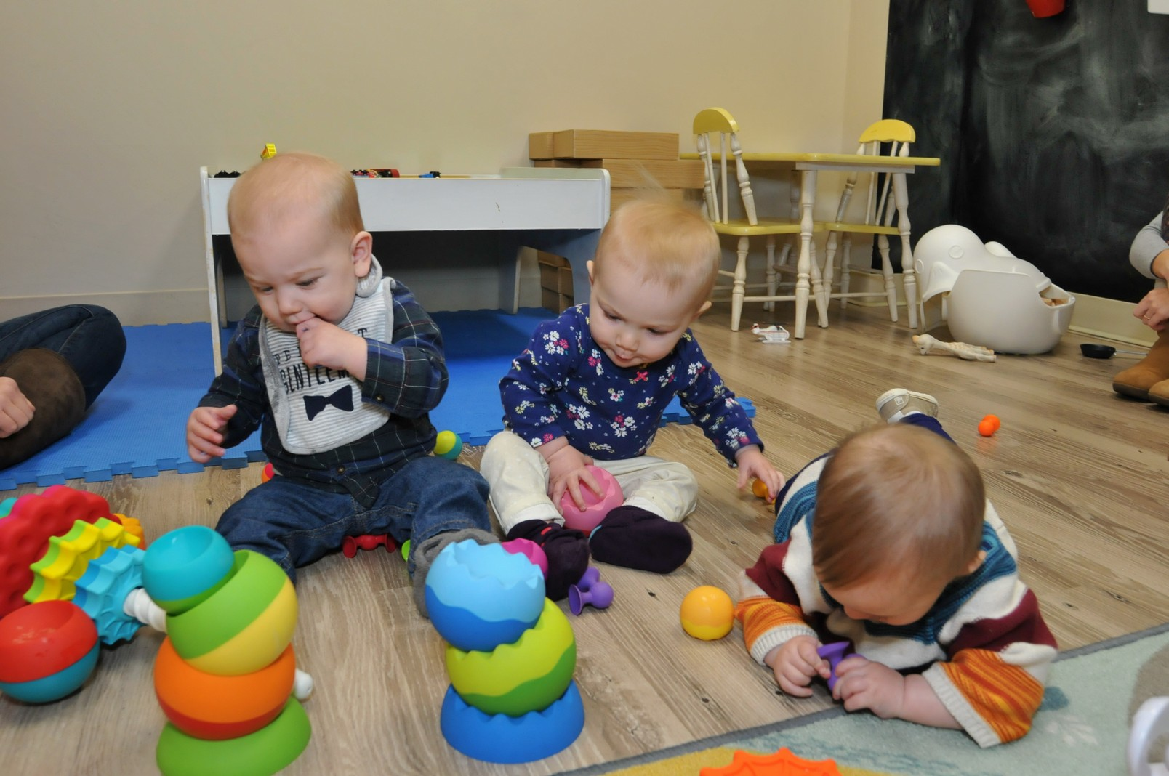

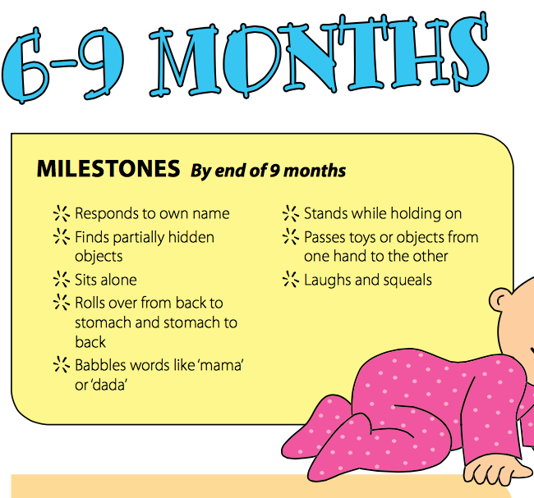
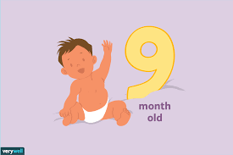
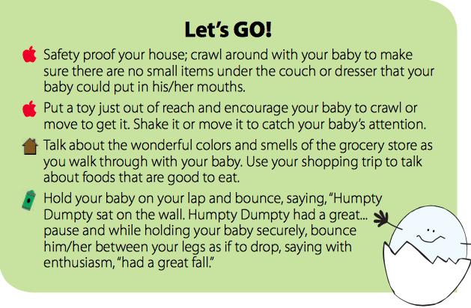
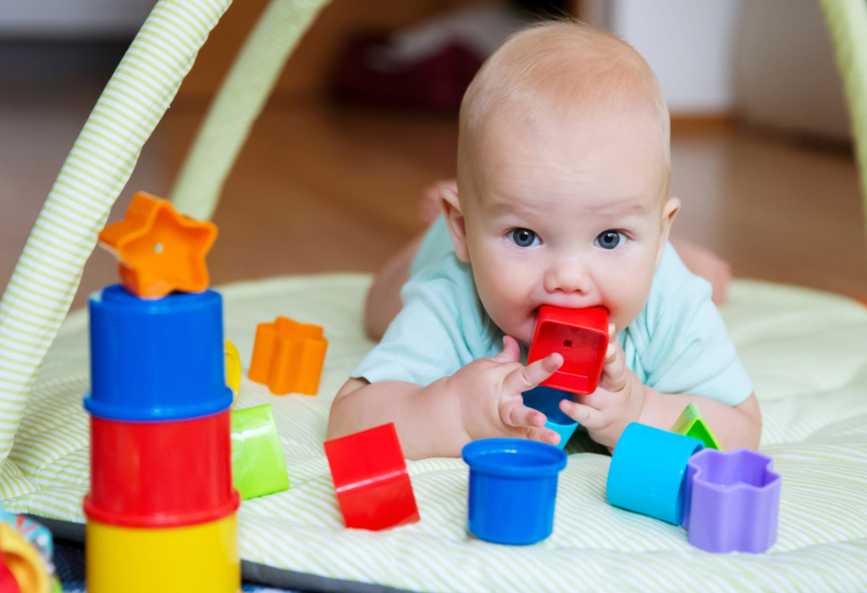
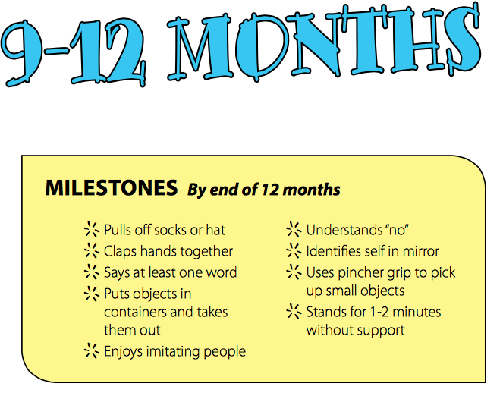
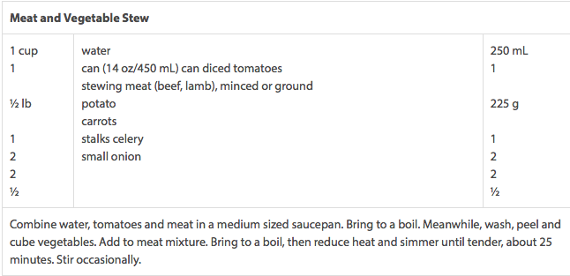

Moving around
If your tot hasn’t taken those first steps yet, take heart and consider yourself lucky: They’ll be on the move in no time, which means you’ll always be following behind, making sure that they don’t get into too much mischief. Expect a lot of hands-on exploration now that they’re seeing the world around them in a new light. You’ll also notice that their mobility has really picked up—they might push or drag toys, squat to pick up objects, attempt to climb (stairs and anything else they can scale), learn to jump or kick. Prepare yourself and your home accordingly.

Honing fine motor skills
Watch as your toddler picks up tiny bits of food or other small objects using the pincer grip they’ve been practising (that’s index finger to thumb). They’ll also be able to drink from a cup with little assistance and feed themselves using toddler-size cutlery. Yes, it will get very messy. Make sure to keep an eye on things like your purse buckle and medicine bottles (even if they’re childproof)—these kids are determined, and now they’ve figured out how to use those tiny fingers.

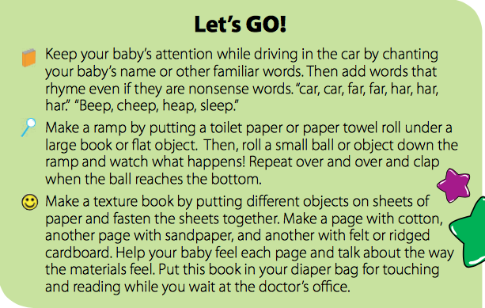
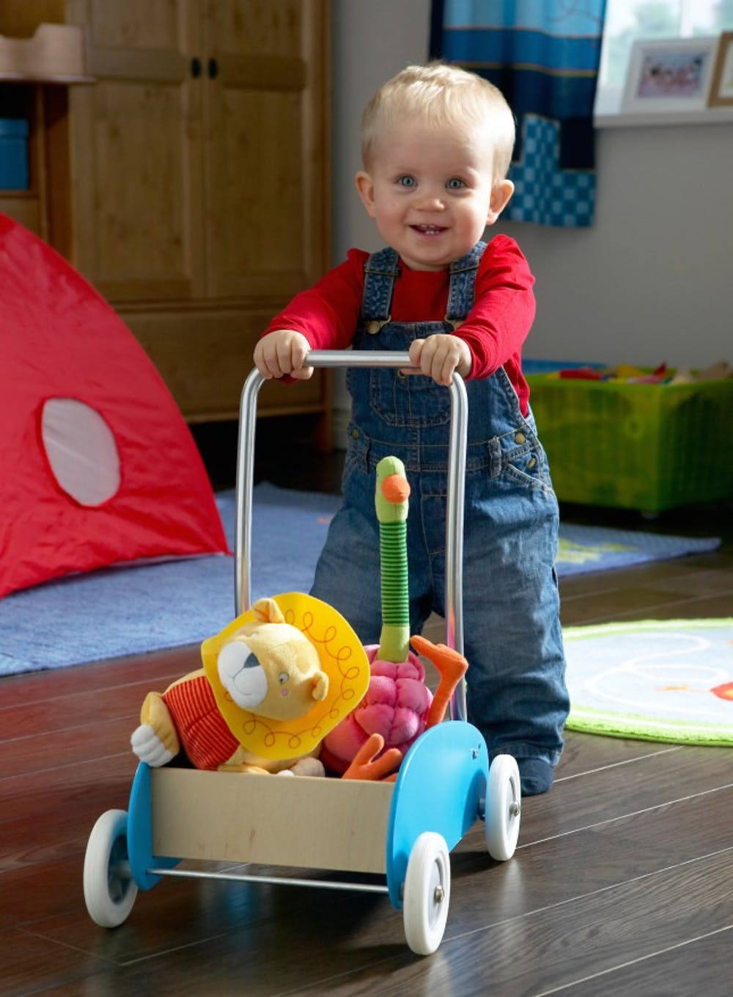
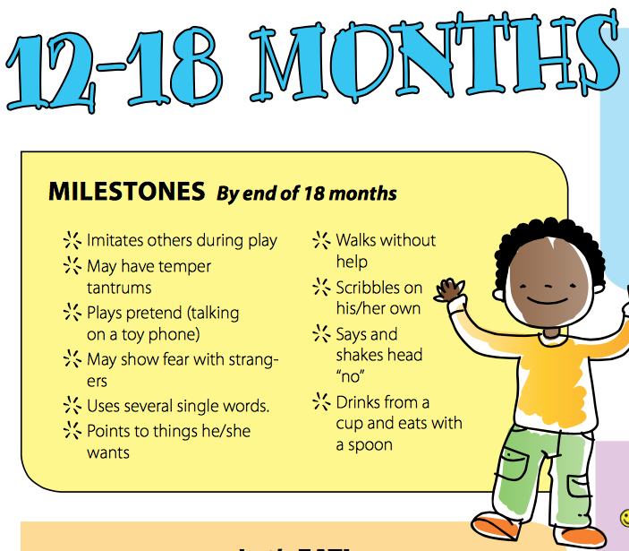
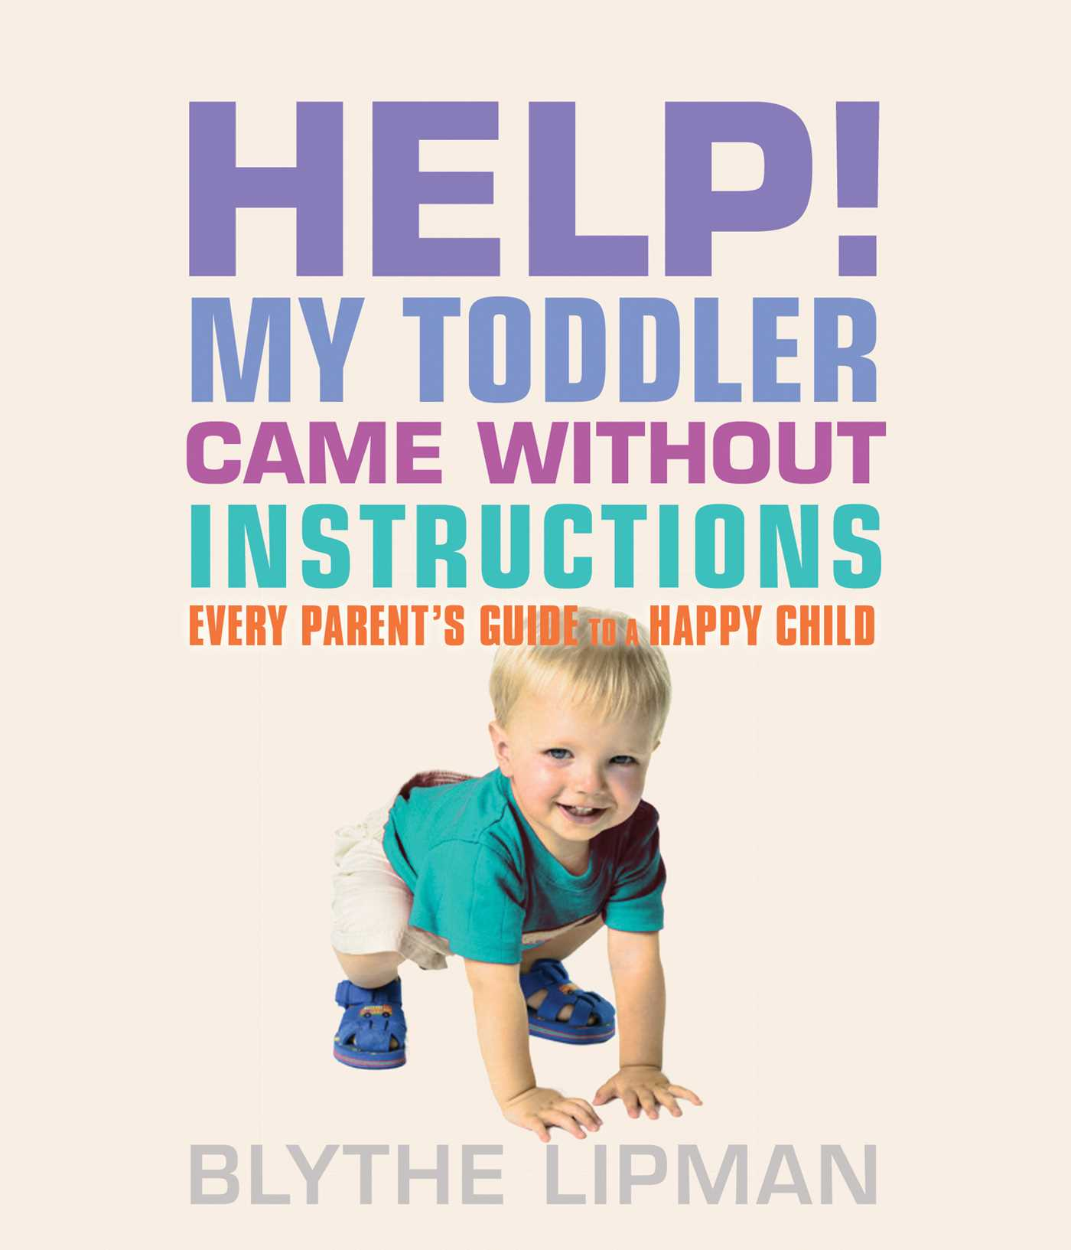
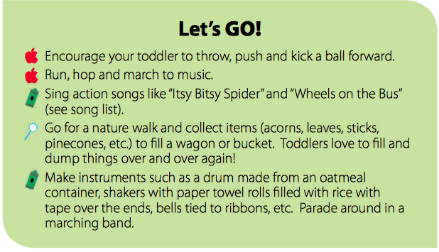
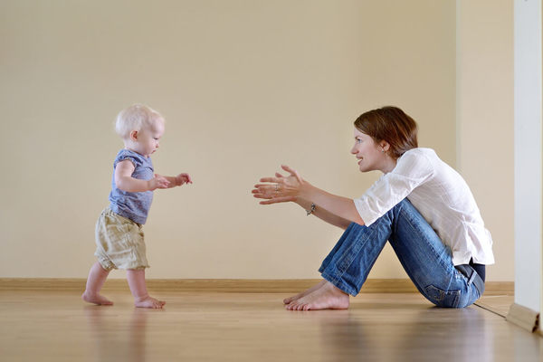
When to expect it: Many children graduate from pulling up to cruising (or walking by holding on to furniture) around month 9 or 10. When cruisers "reach altitude" and make their first attempts at letting go of whatever piece of furniture (or part of Mom or Dad's leg) they're using to stay upright, you could see your child's first toddling steps. Most children don't take their first independent steps until well after their first birthdays (around month 14, on average), although it’s not unusual for them to start as late as 18 months (or in some cases, as early as 7 months).Some of it may be in her wiring: Your little one may follow in your or her dad’s (early or late) footsteps. Build and temperament play parts, too. A lean, high-energy baby will probably strut her stuff sooner than a mellow Buddha-baby. And some kids are more cautious and only want to take a step when they’re positive they won’t tumble; others are daredevils and will dive right in — literally.


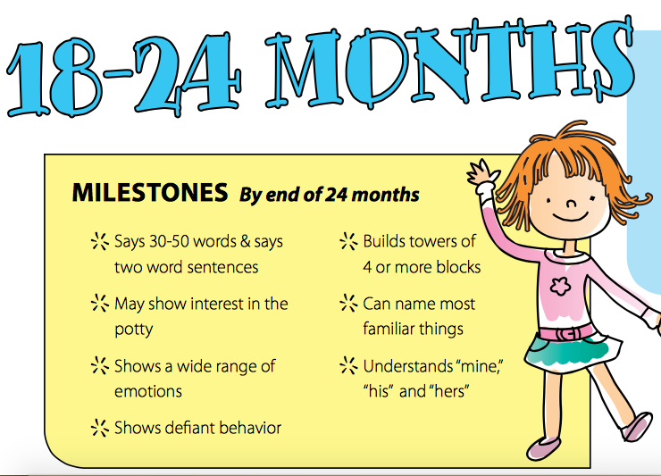

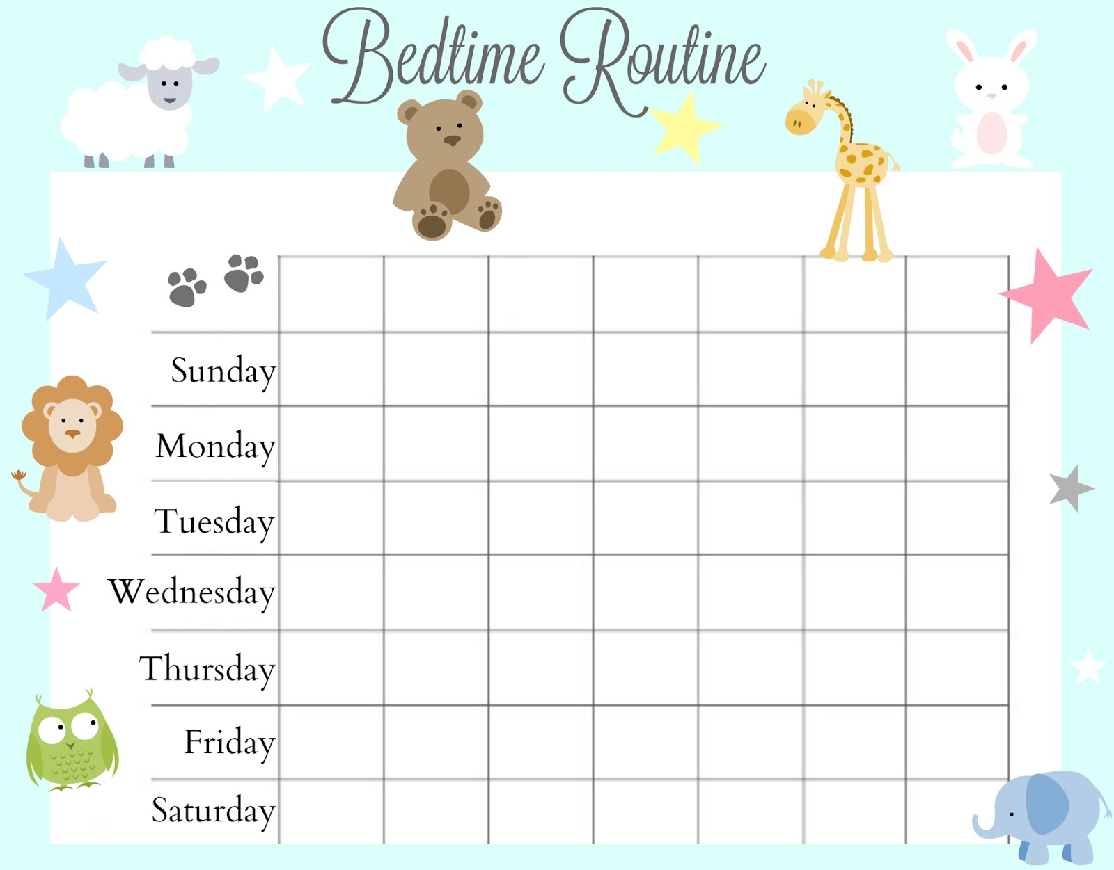
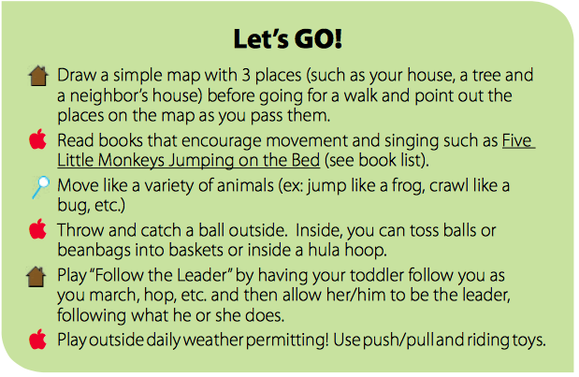

Lorem Ipsum!
0-2 Activity Post
DecemBER

