Virtual Community of Support for Early Learning

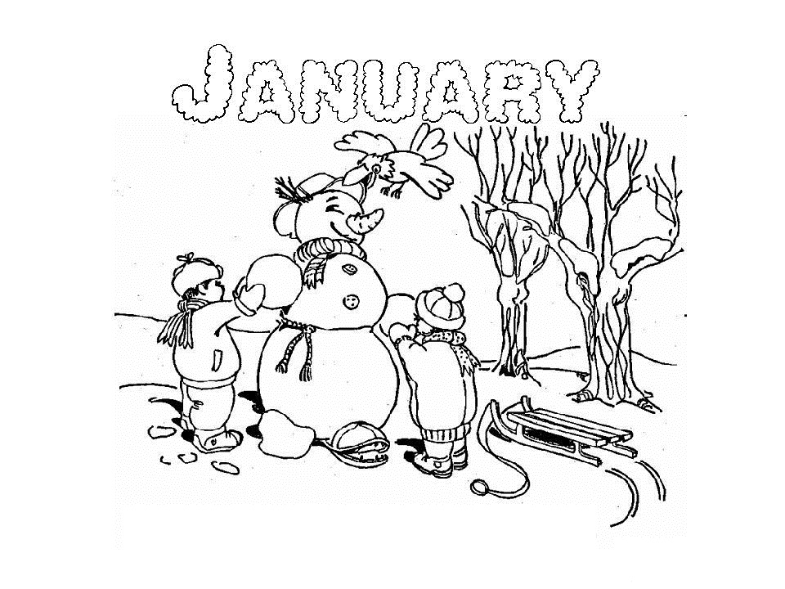

January 2025

|  |  |  |  |  |
| --- | --- | --- | --- | --- |
| 6 | 7 | 8 | 9  0-2 Yr Activity Post #4 | 10  Recording Posted |
| 13  Session Email Package sent | 14  Parent Tip #11 | 15  Activity Session 9 am Podcast | 16  Recordings Posted | 17 |
| 20  Session Email Packages sent | 21  Parent Session 9 am Podcast  Parent Tip #12 | 22  Literacy Session 9 am  Podcast | 23  Recordings  Posted | 24 |
| 27  Session Email Packages sent | 28  23-Parent Tip #13  30-Parent Session 9 am | 29  24-Story Time Session 9 am  31-Numeracy Session 9 am | 30  Recordings Posted | 31 |