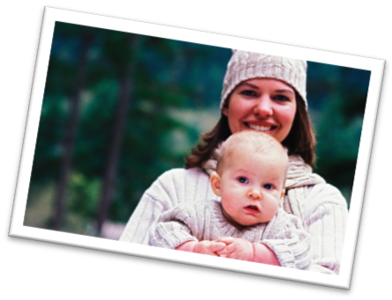
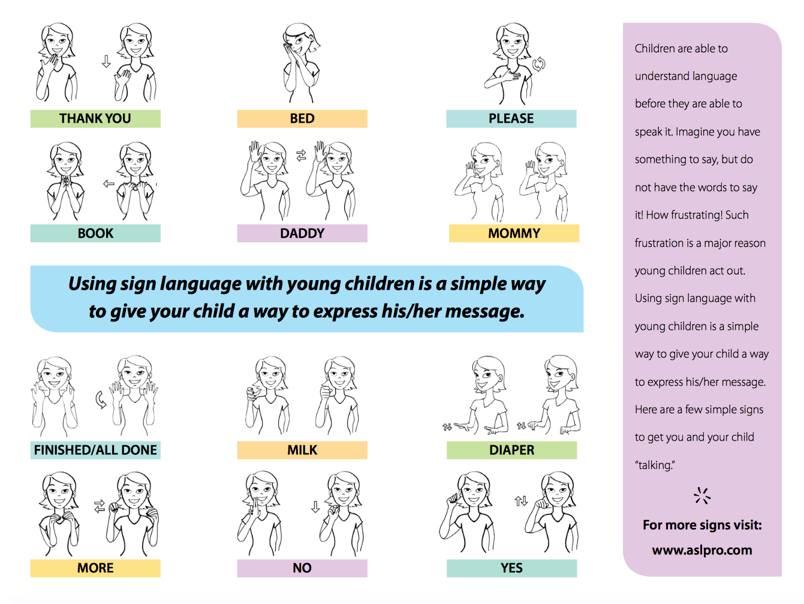

0-2
Activity Post
Let’s Go!
0-2activity post January 2018 2018
Sign Language is an amazing way to begin communication with your baby.
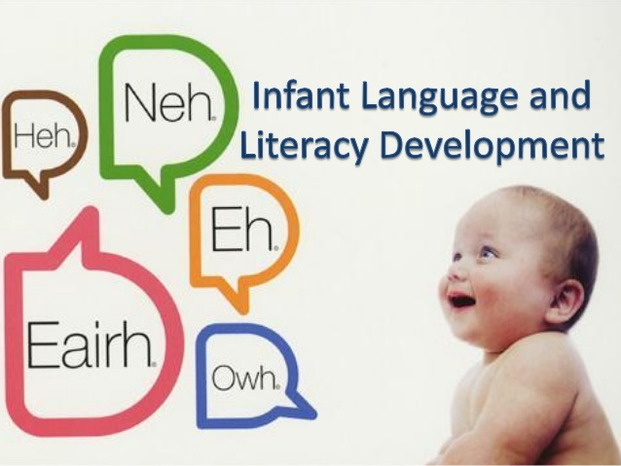
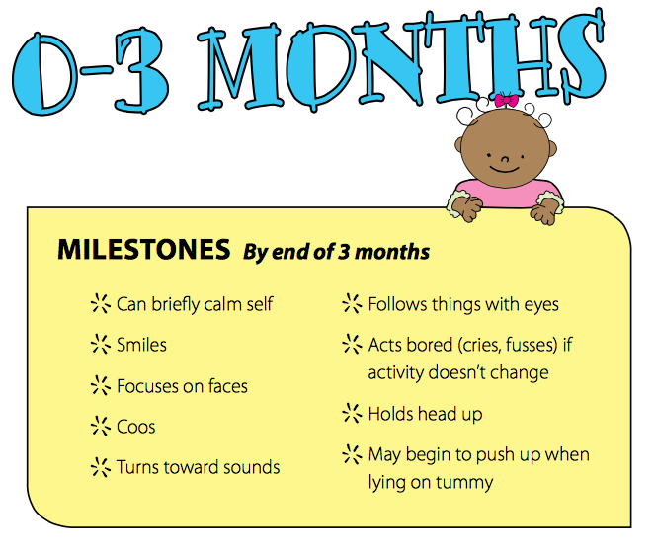
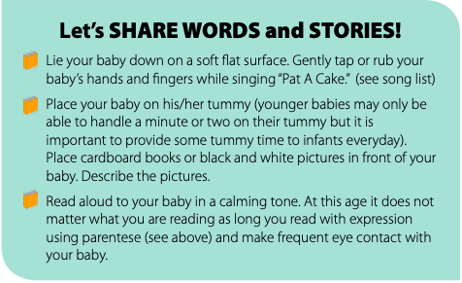
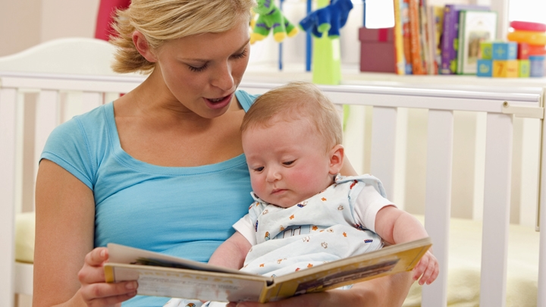

What can you do?
Describe her feelings and experiences. For example, when you see that she is hungry, you can say: You are nuzzling at my shirt. You’re telling me you’re hungry. Okay, your milk is coming right up! Although your baby won’t understand your words right away, your caring, loving tone of voice and actions will make her feel understood. And hearing these words over and over again will help her come to understand them over time.

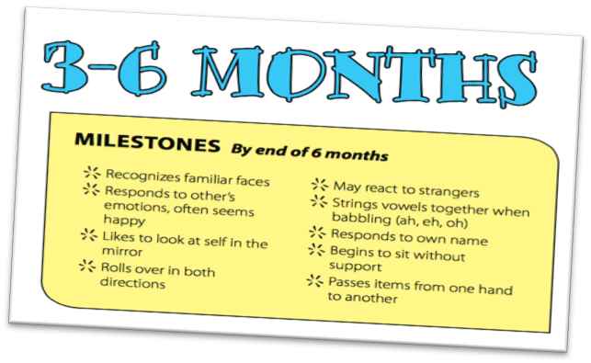
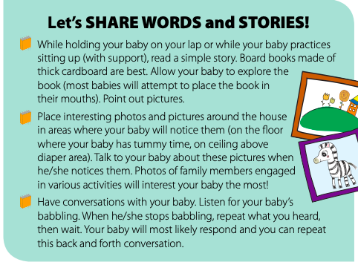
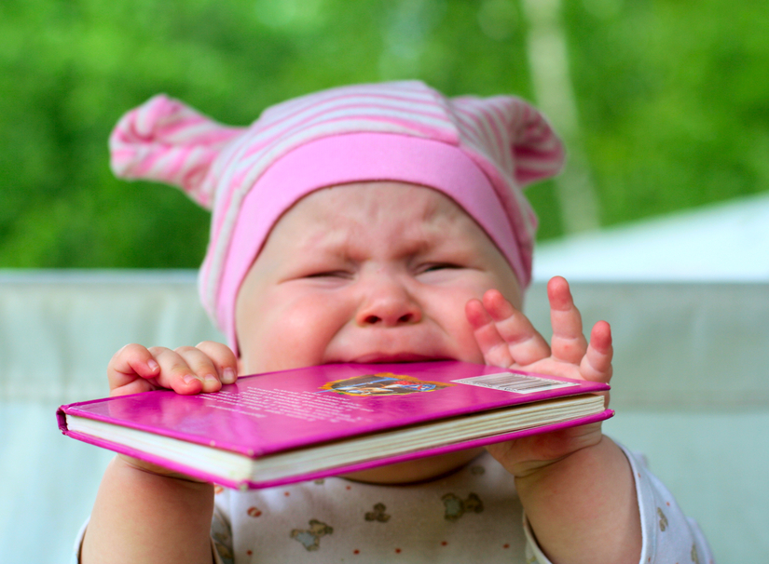
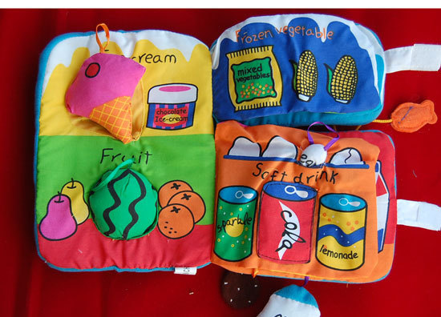
Introduce cardboard or cloth books with brightly colored pictures. Try to select books that reflect the child's own experiences such as books about daily life, family members, animals, or food
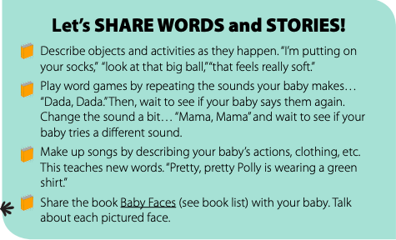
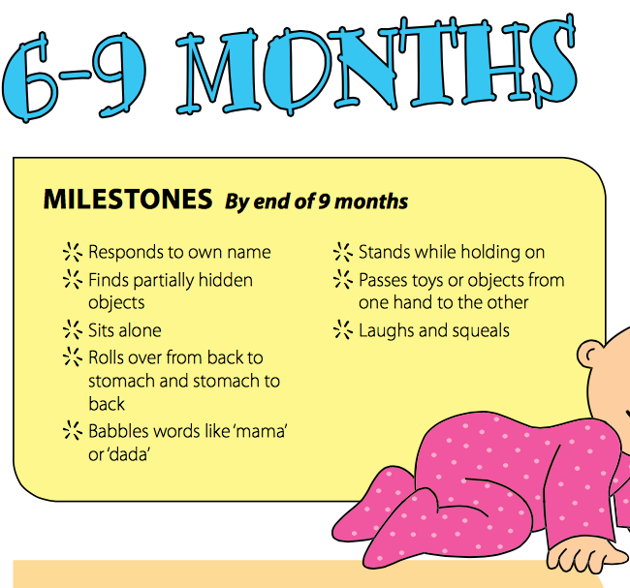
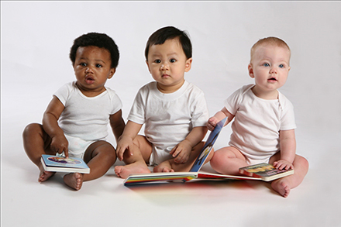
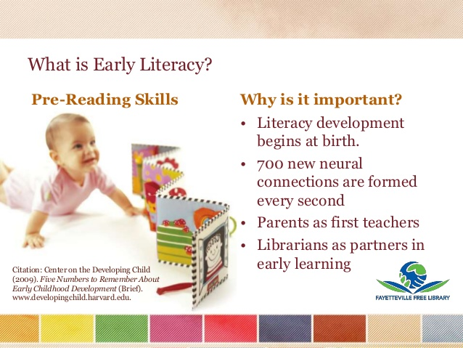
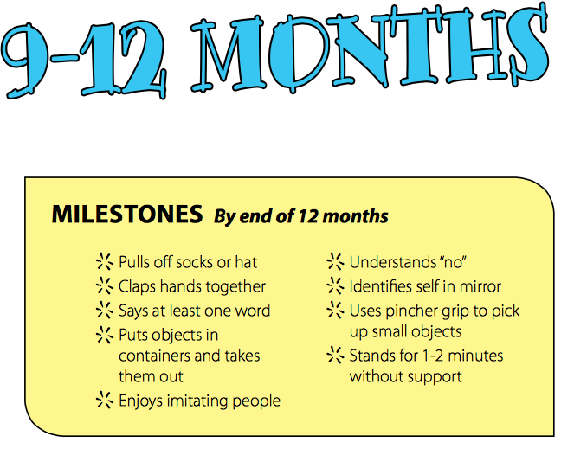
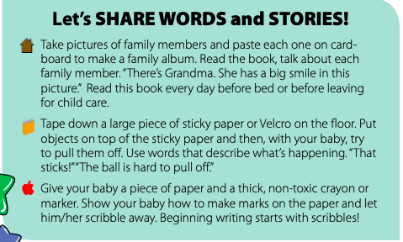
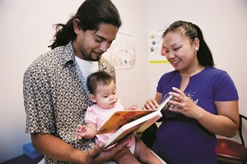
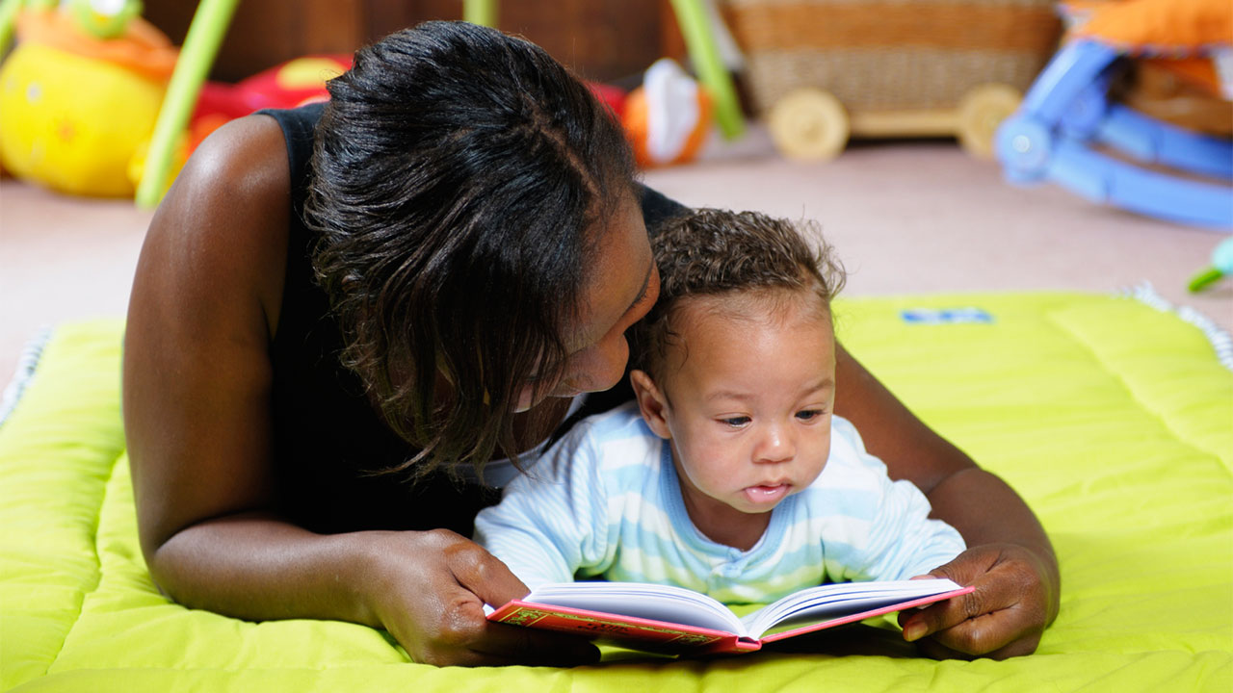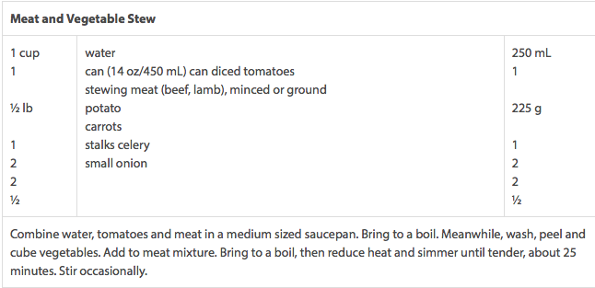

Language Milestones
Typical language development milestones between nine and 12 months include:
- Babbling in long, repetitive strings.
- Understanding simple sentences, questions, and requests, such as "Please give the book to Daddy."
- Taking turns making sounds with you.
- Copying speech sounds.
- Responding to her name.
- Pointing and talking to specific objects.
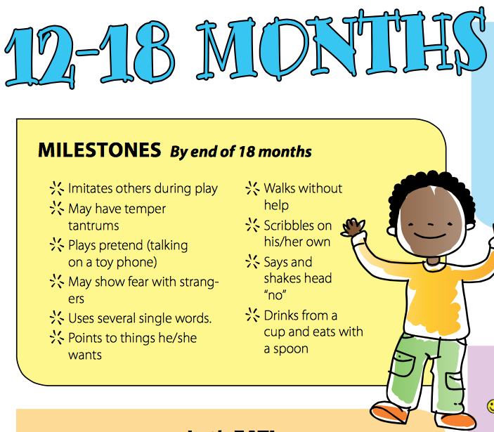
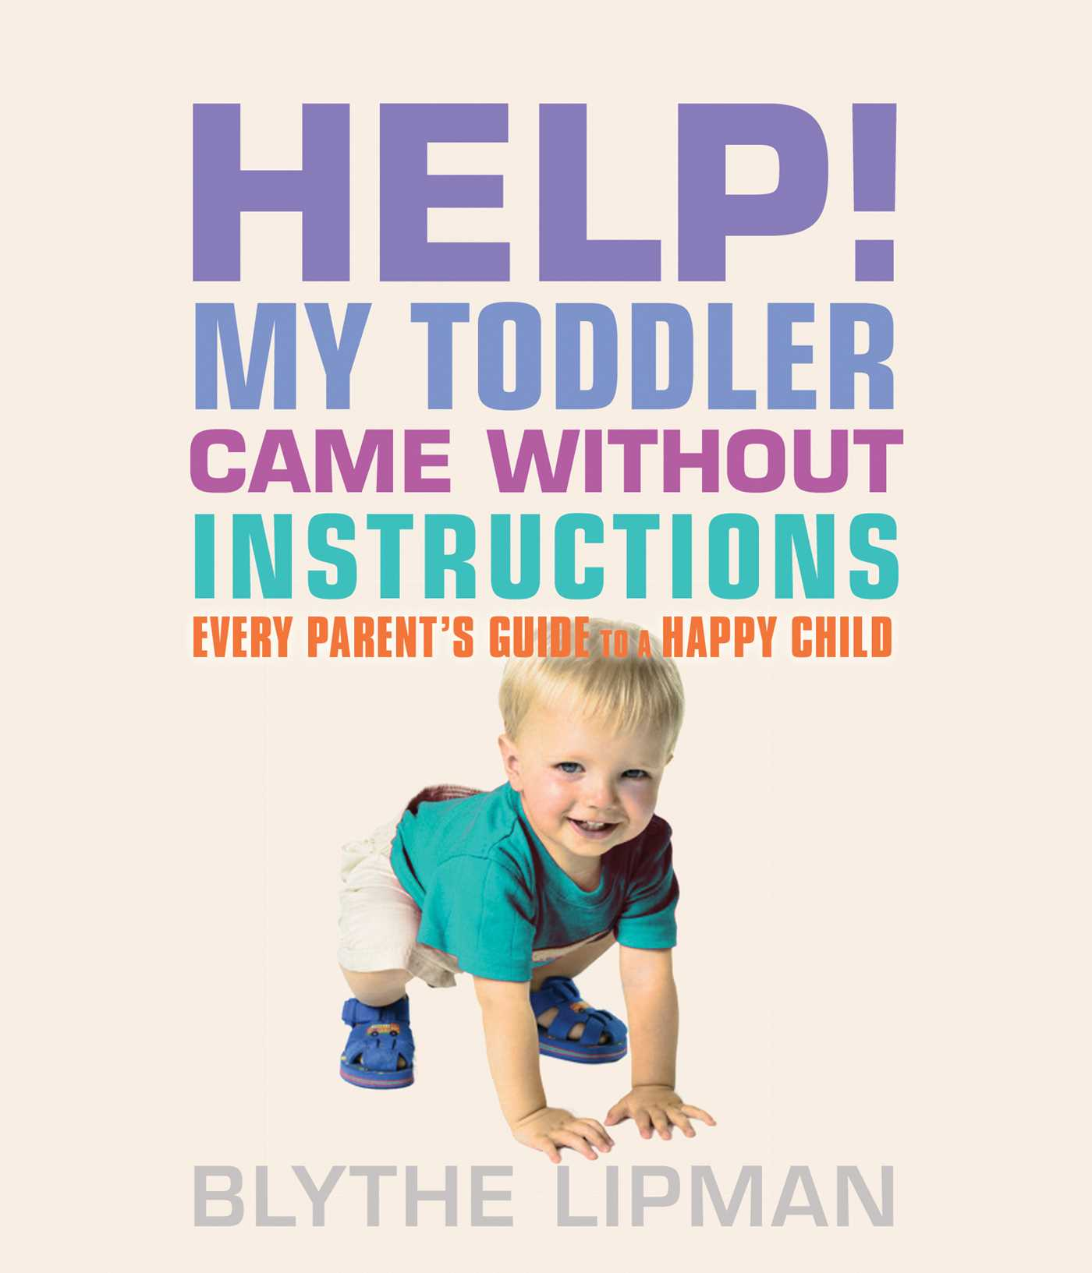
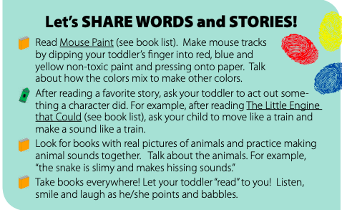
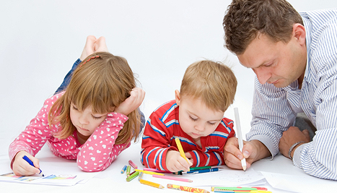

Other Language Milestones
At 12 to 18 months, the typical toddler:
- Will point to show you something.
- Understands far more words than he can speak. For example, he can point when asked, "Where's your belly button?"
- Uses a vocabulary of five or more words to make short expressions such as “all gone.”
- Uses "no" correctly, often with a shake of her head.
- Forms questions by making his voice rise at the end of the sentence: “Daddy go?”
- Tries to sing songs.

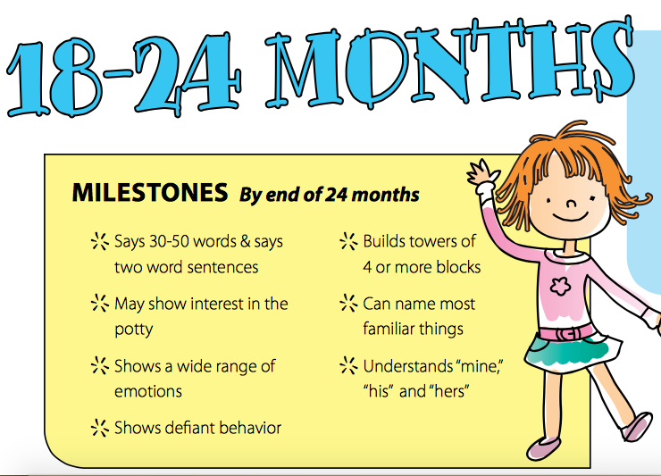
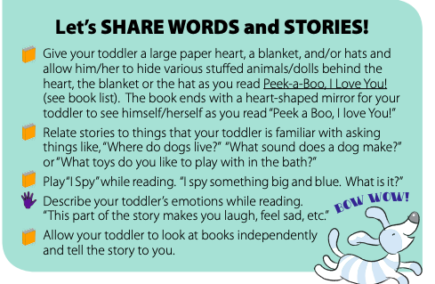
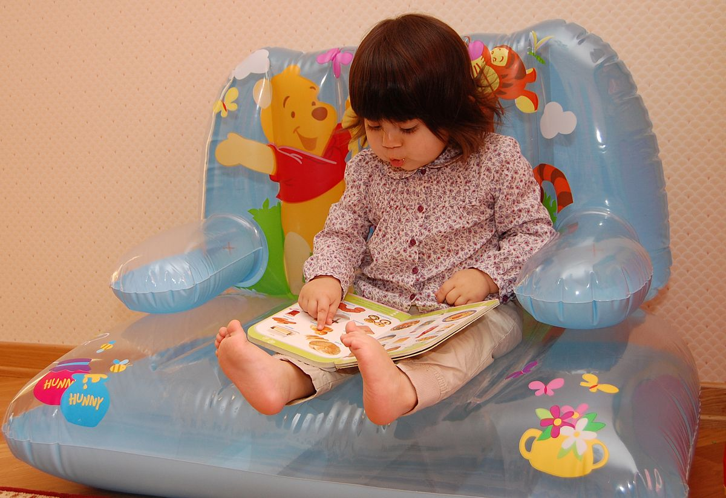
Lorem Ipsum!
0-2 Activity Post
January

Language Milestones
At this age, most toddlers recognize about 200 words and may use them to make two- or three-word sentences like, “More milk, please” and “No, mine!” Other typical language milestones include:
Asking for help using words or actions.
At 18 months, say about 20 words (they do not have to be clear).
Talking in a run-on flow of words while chatting with stuffed animals or to herself. The words may not make sense.
Naming some pictures in a book.
Copying new words and phrases you say: “Go bye bye.” “Grandpa’s car.”

