Virtual Community of Support for Early Learning

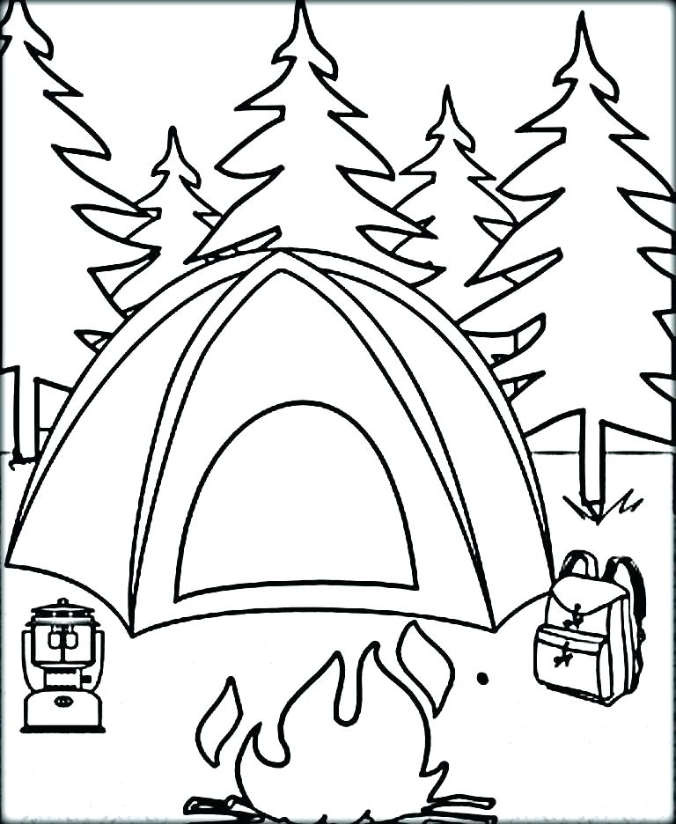

June 2024
3  3-5 yr Activity Post #10 | 4  Parent Session 9 am Parent Tip #28 | 5  Activity Session 9 am | 6  0-2 Yr Activity Post #9 | 7  Recording Posted
10  Session Email Package sent | 11  Parent Tip #29 | 12  Story Time Session 9 am | 13  Recordings Posted | 14
17  Session Email Packages sent | 18 | 19  Activity Summer Fun Session 9 am | 20  Recordings  Posted | 21
24  Closed for Summer Vacation | 25 | 26 | 27 | 28

