Virtual Community of Support for Early Learning

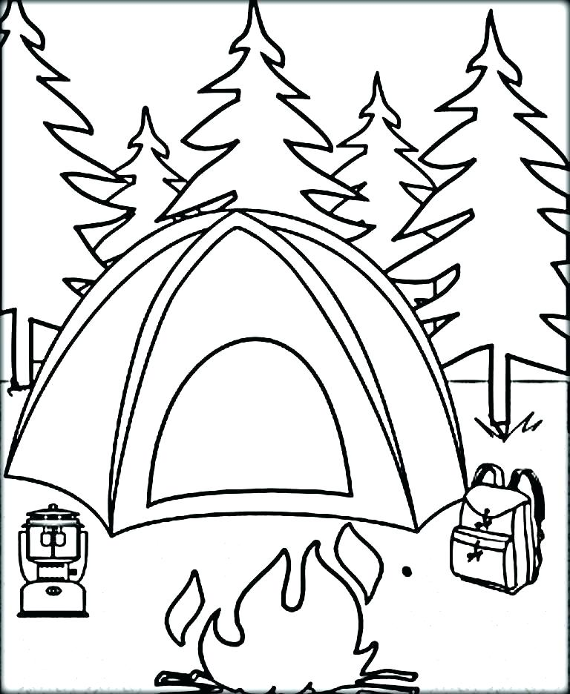

June 2026
1  3-5 yr Activity Post #10 | 2  Parent Session 9 am Parent Tip #28 | 3  Literacy Session 1 9 am | 4  0-2 Yr Activity Post #9 | 5  Recording Posted
8  Session Email Package sent | 9  Parent Tip #29 | 10  Literacy Session 2 9 am | 11  Recordings Posted | 12
15  Session Email Packages sent | 16 | 17  Activity Summer Fun Session 9 am | 18  Recordings  Posted | 19
22/29  Closed for Summer Vacation | 23/30 | 24 | 25 | 26

