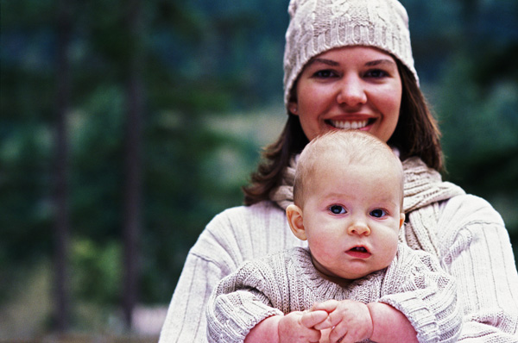
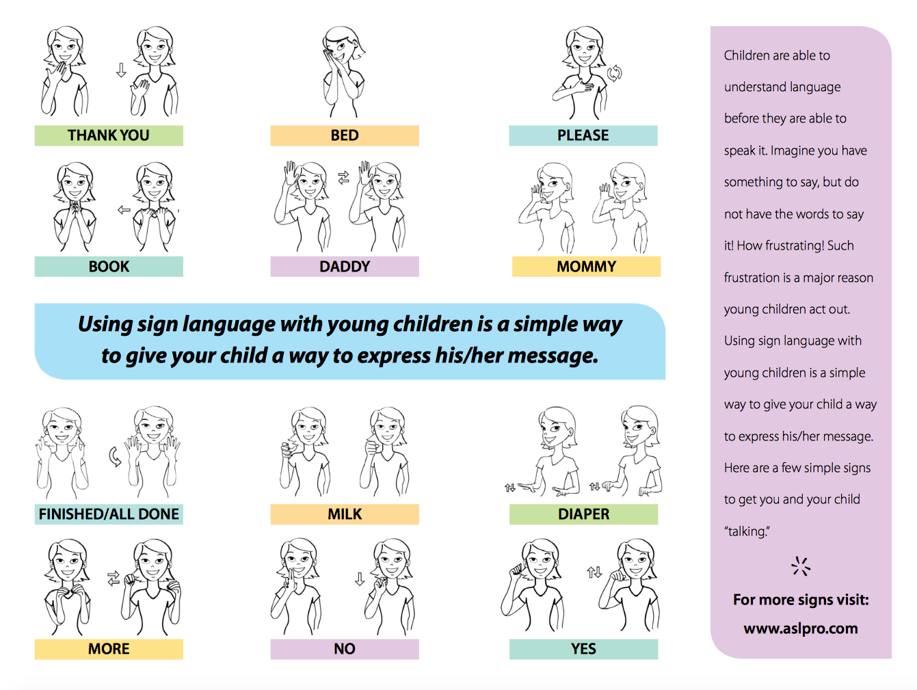

0-2

Activity Post
Milestones
0-2activity post JUNe
Sign Language is an amazing way to begin communication with your baby.
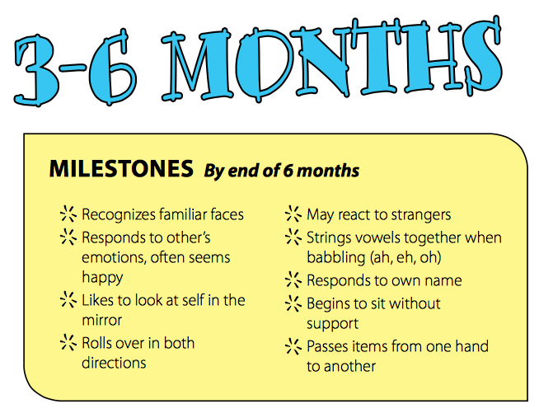
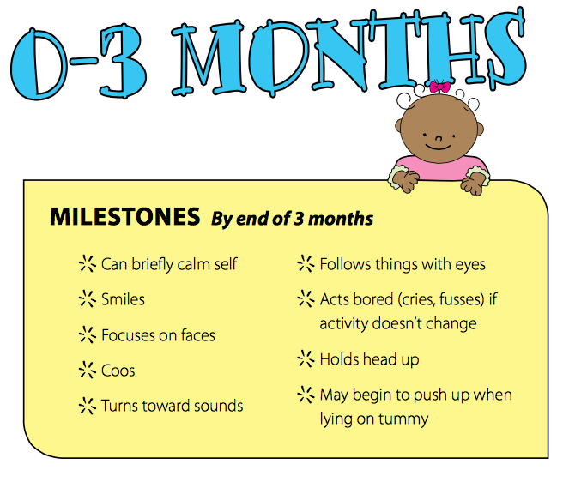
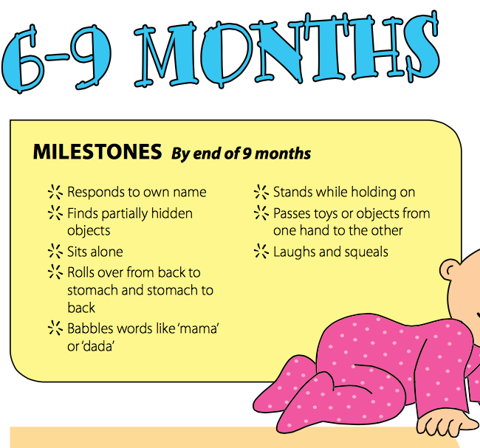
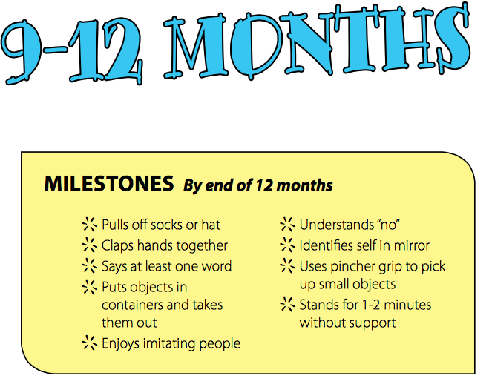
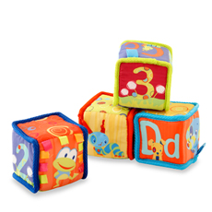
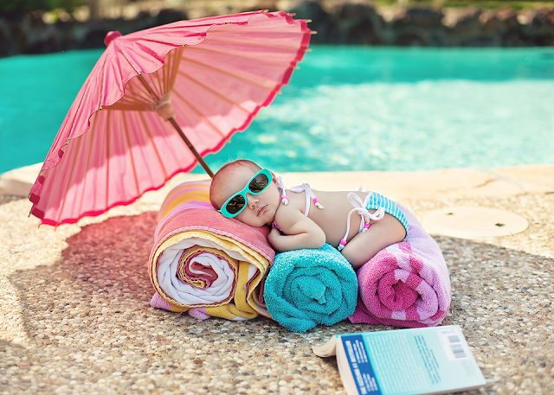
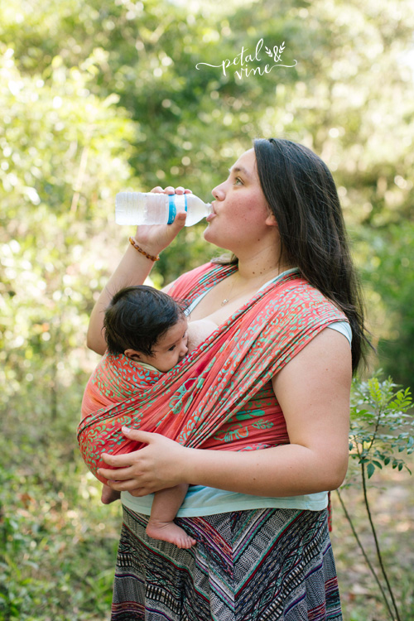
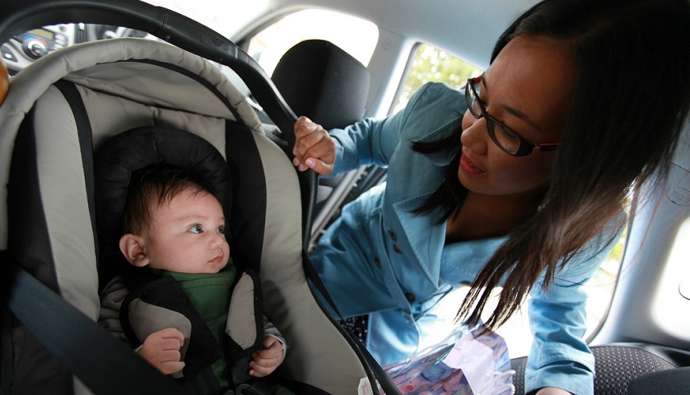
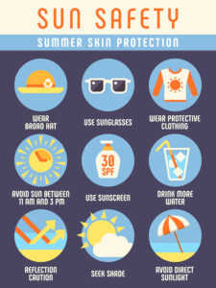
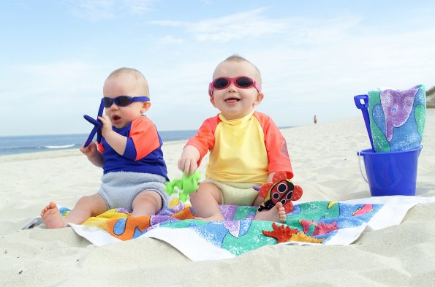
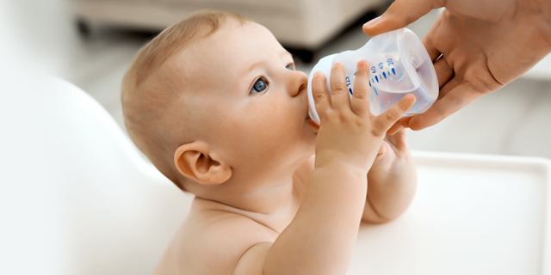
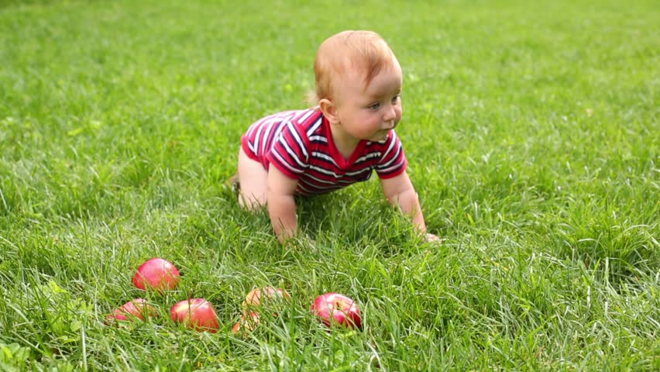
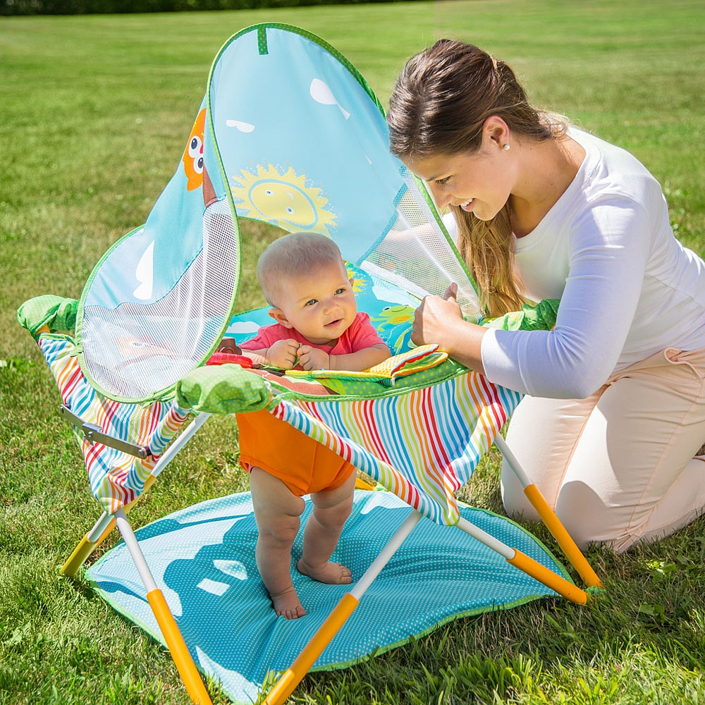

Use Caution When in Water
Sadly, drowning is among the leading causes of accidental death in children. The American Academy of Pediatrics says parents should not enroll children under age 4 in formal swimming lessons that teach water survival skills. If you want them to play in water, supervise them within arm's reach, even in shallow water.
Special Concerns: When choosing a flotation device, go for a child-size life vest. Little arms are less likely to slip out than they are with water wings. And when compared with using a swim ring, there's less chance of tipping over. Also, take a CPR course
Introduce cardboard or cloth books with brightly colored pictures. Try to select books that reflect the child's own experiences such as books about daily life, family members, animals, or food

Sun Protection and Heat Exhaustion
Special Concerns: Infants are vulnerable to heat-related illness, so keep them in air-conditioned areas when possible. And never leave kids in unattended cars, even with the windows cracked.

Beware of Bee Stings

Bees are attracted to flowers, so don't put fragrances or floral-patterned clothing on kids. Likewise, don't leave out open containers of food and drink, and if your kid's clothes get stained, change them. Should a bee land on or next to your child, remain calm and gently blow it away.How to Treat: If your child gets stung, brush the stinger away with the edge of a credit card. Next, apply a salve of one part meat tenderizer to four parts water and leave it on the area for about 30 minutes to neutralize the venom. Then apply cold compresses and topical hydrocortisone cream, and give an oral antihistamine to reduce swelling. You could also apply a paste of baking soda and water.

For babies 6 months and older, use sunscreen with an SPF of at least 15 (SPF 30 and higher is even better) that offers both UVA and UVB protection. For babies younger than 6 months, if adequate shade isn't available, put sunscreen in small amounts on exposed surfaces of skin. Always apply sunscreen at least 30 minutes before going outside -- even on cloudy days -- and reapply it every two hours. Even waterproof sunscreen loses its effectiveness after about 80 minutes of swimming.
How to Treat: If your child does get a sunburn, the best remedies are cold compresses, over-the-counter pain relievers, and aloe preparations.

Protect Baby When in the Sun
First, avoid being in the sun between 10 a.m. and 3 p.m., and stay in a shaded area as much as possible when outside. Dress baby in a hat, sunglasses, and clothing made with a tight weave
How to Treat: If your child does get a sunburn, the best remedies are cold compresses, over-the-counter pain relievers, and aloe preparations.

Bypass Bug Bites

When outside, cover children with lightweight clothing and use mosquito netting over strollers and infant seats. Ticks are also a concern, so check your child's body for them at the end of each day spent outside.When choosing bug repellents this summer, know that the most effective products contain DEET because it's proven to repel both mosquitoes and ticks. Products with a DEET concentration of less than 30 percent are safe for kids, but not for babies under 2 months old.

Special Concerns:
Bee stings often look worse the next day -- skin reactions are normal and may last up to a week. But some people have severe allergic reactions to bee stings that include all-over hives, difficulty breathing, dizziness or fainting, and swelling of the lips and tongue. These can be life-threatening reactions that require immediate medical help. If your child has this allergy, his doctor will prescribe an injectable form of epinephrine, a lifesaving medicine.

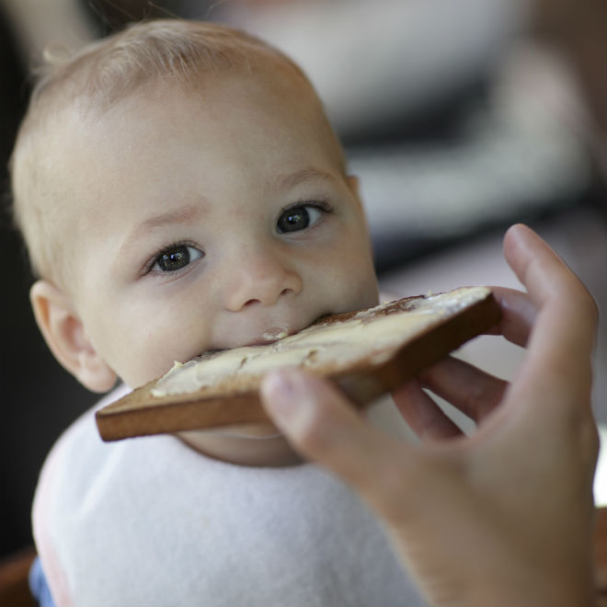

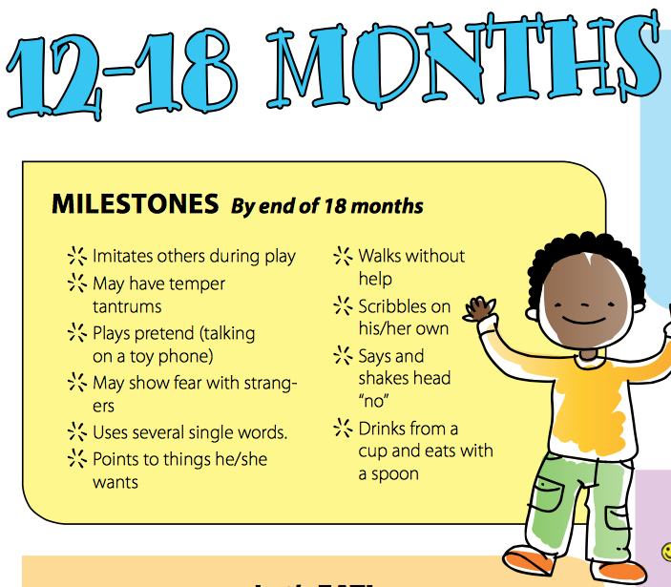
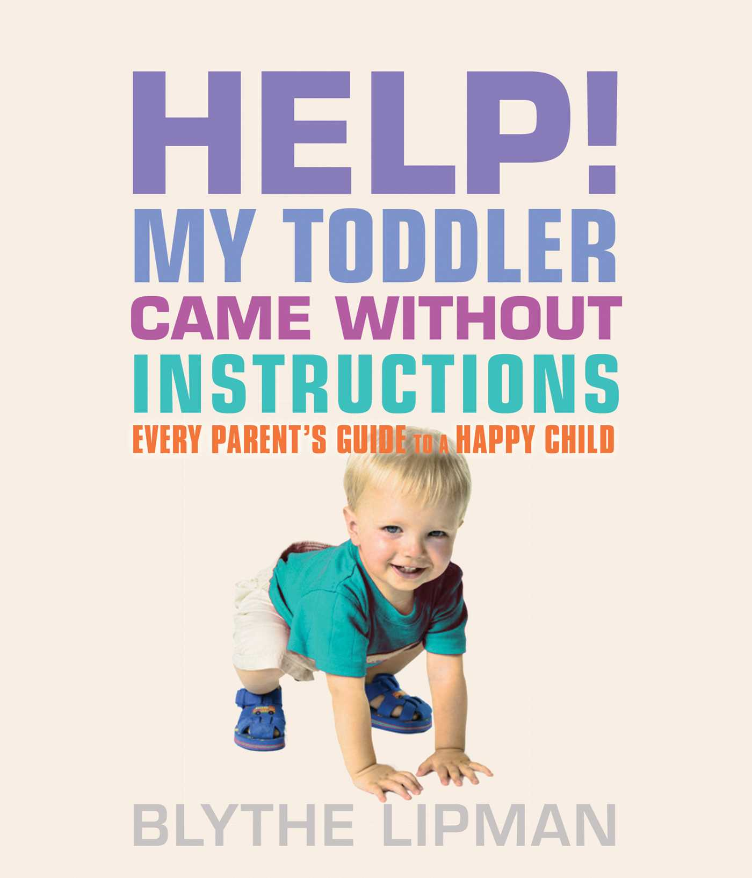
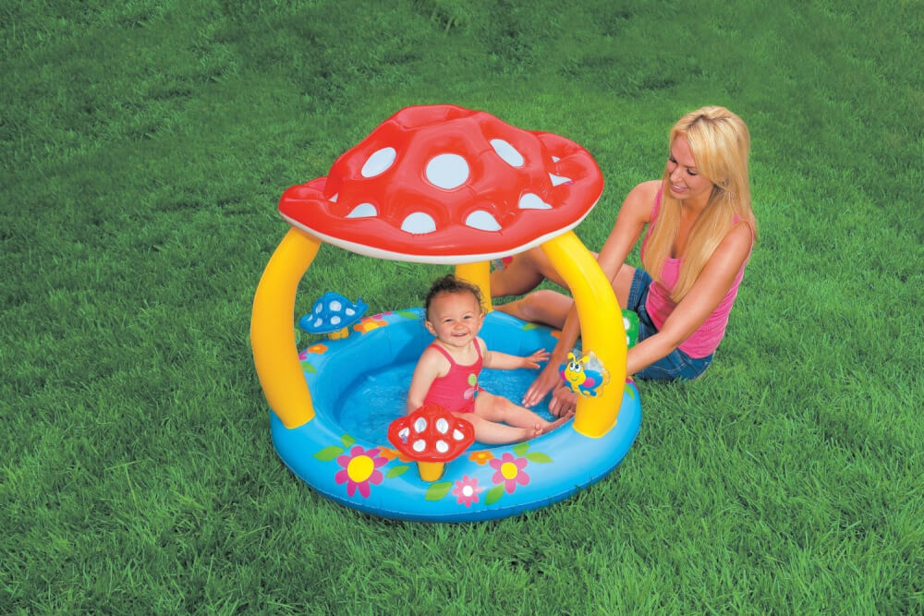
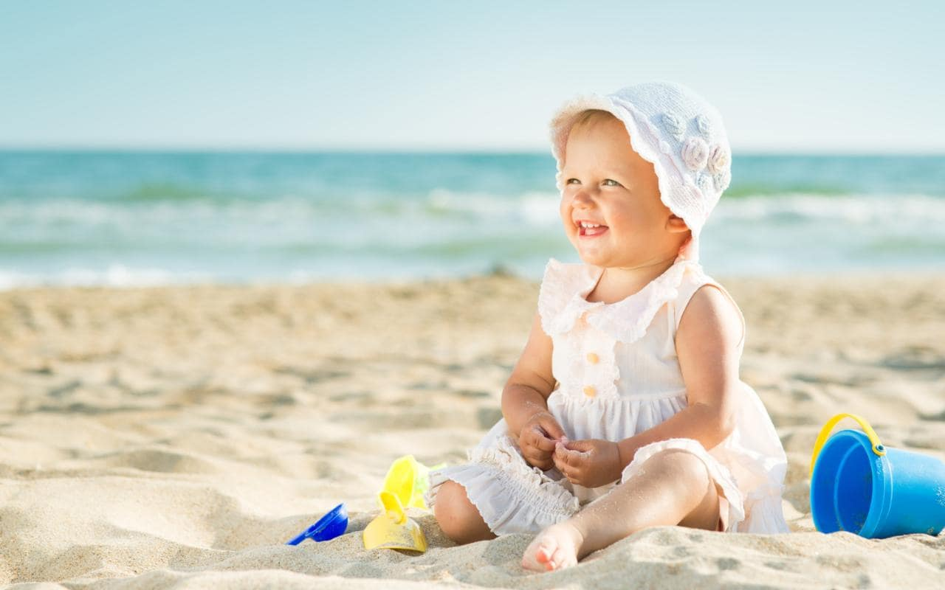

First-Aid Kit Essentials-

What better time to stock a first-aid kit than at the start of the summer season, when many accidents occur. While you can't prevent all accidents, you can be prepared. Here is a list of helpful things to include:
- Band-Aids
- Soap
- Antibacterial gel or foam
- Triple-antibiotic ointment
- Hydrocortisone cream
- Sterile gauze pads
- Adhesive tape
- Tweezers
- Washcloths
- Cold packs
- Infant and children's Motrin or Tylenol
- Oral antihistamine
- Rubbing alcohol
- Digital thermometer

Steer Clear of Food Poisoning
If you're outside at a picnic and can't wash your hands (or your kids' hands), use an antibacterial hand gel. Clean all raw fruits and vegetables, and keep raw meats separate from cooked foods. Wash food-preparation surfaces and utensils well, and cook all food thoroughly. If you're marinating food, make sure it's in the refrigerator or a cooler.

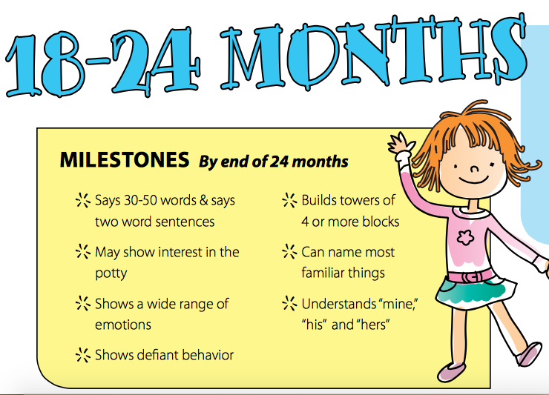
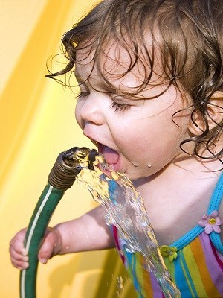
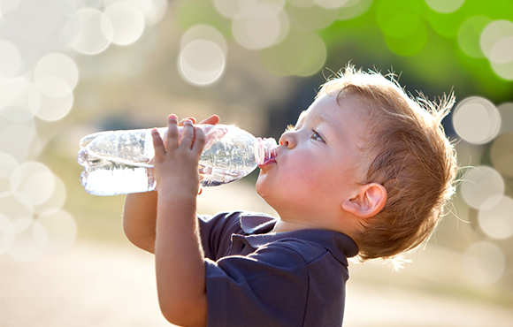

Lorem Ipsum!
0-2 Activity Post
JUNE

Keep Kids Cool
As temperatures rise, heat exhaustion becomes a concern. Symptoms include fatigue, extreme thirst, and muscle cramping. If a person doesn't cool down and rehydrate herself, heat exhaustion can lead to heatstroke (signs are headaches, dizziness, nausea, vomiting, and lack of sweat), which is potentially fatal.
How to Treat: If you notice heat illnesses in kids, spray them with cold water from a bottle or hose, fan them, and get them into the shade. Ice packs to the groin and armpits can speed up the cooling process even more. If you suspect heatstroke, call 911.

AVERT SWIMMER’S EAR-It's an infection of the outer ear canal, and pain is the earliest symptom. As it progresses, you might see drainage from your child's ear and extreme tenderness when her earlobe or the outer part of the ear is tugged. Because swimmer's ear is caused by germs that invade the ear canal due to excess moisture, dry the outside part of the ears after water play.
How to Treat: Apply prescribed antibiotic drops and curb pool time.

