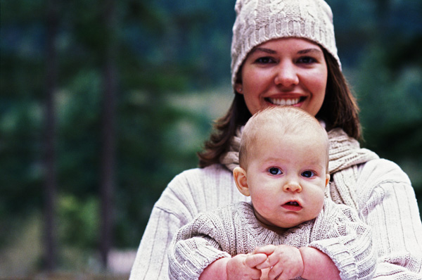
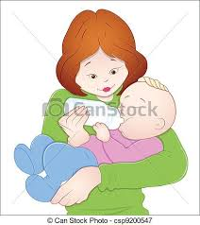
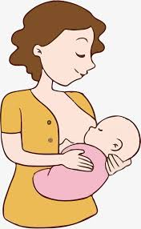
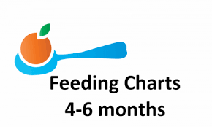
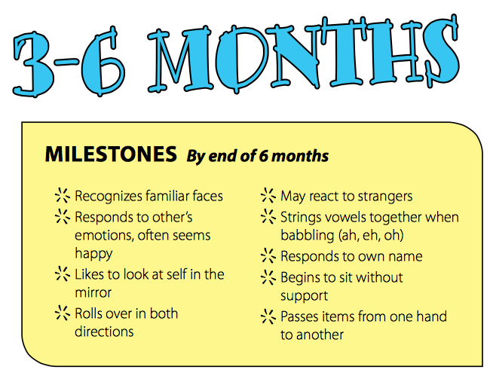
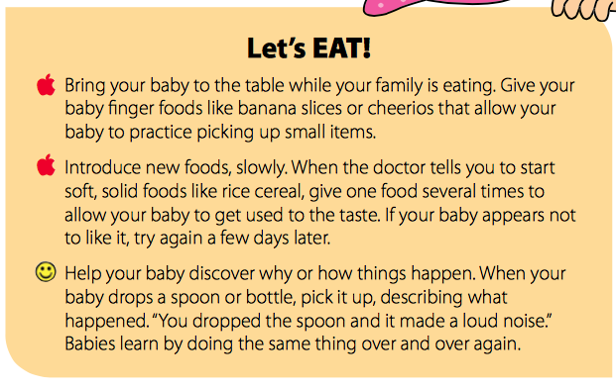

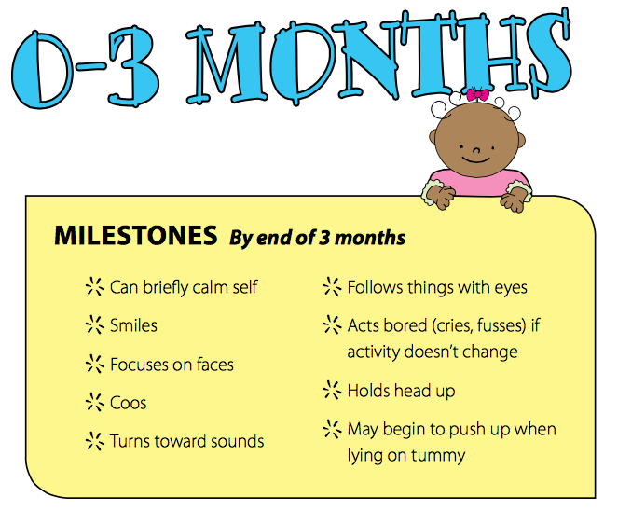
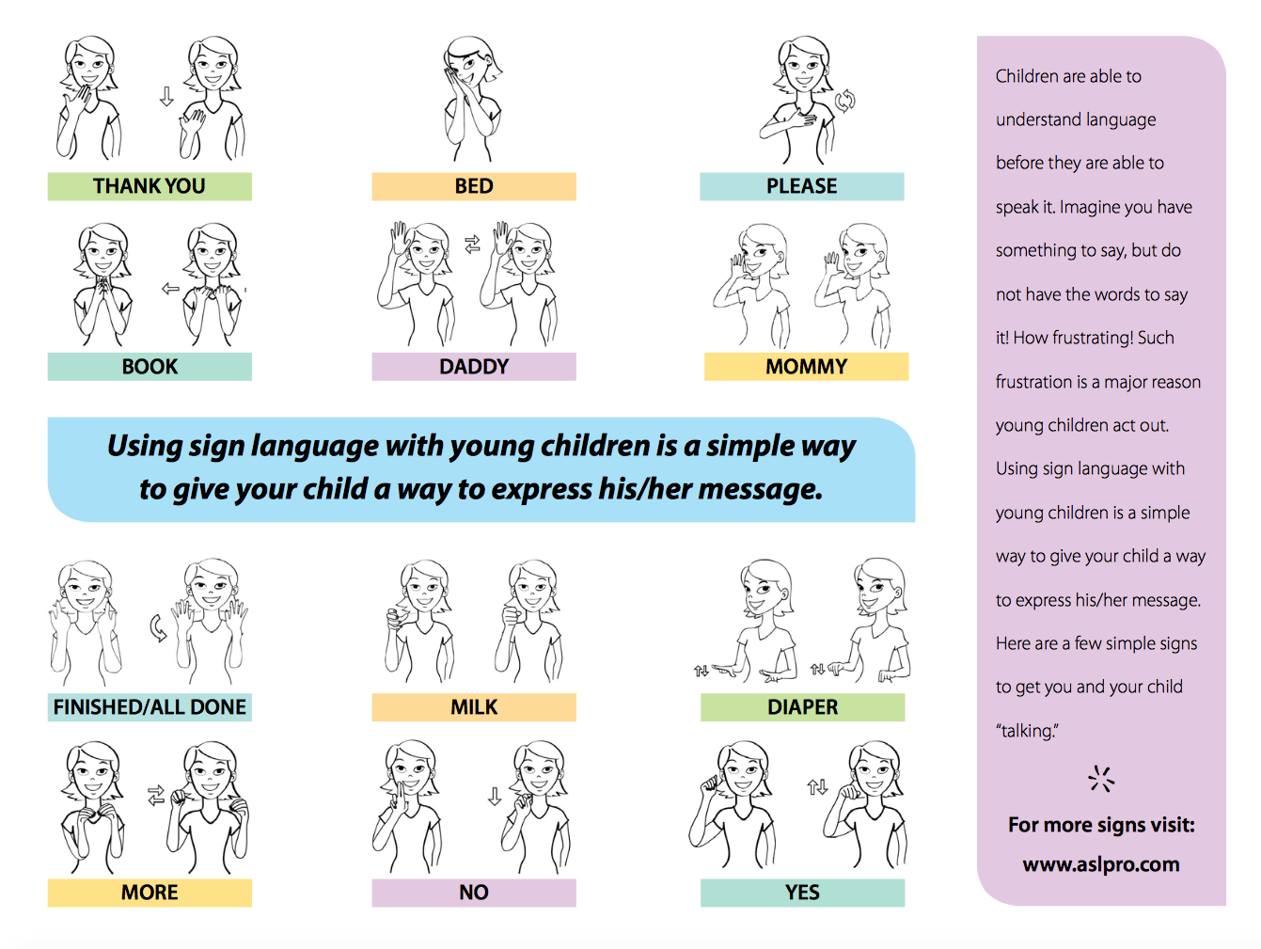
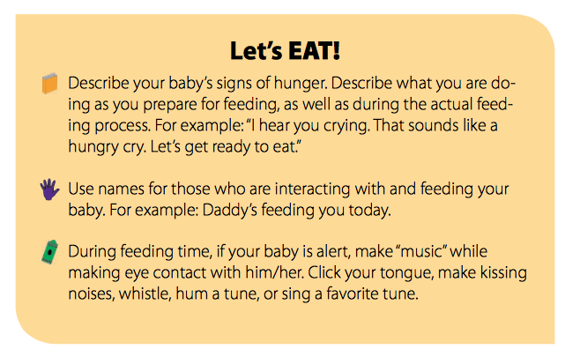
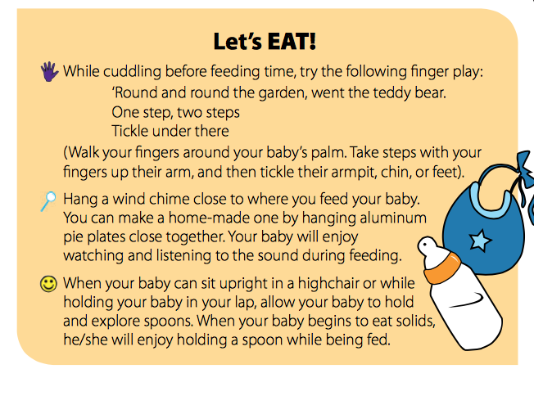
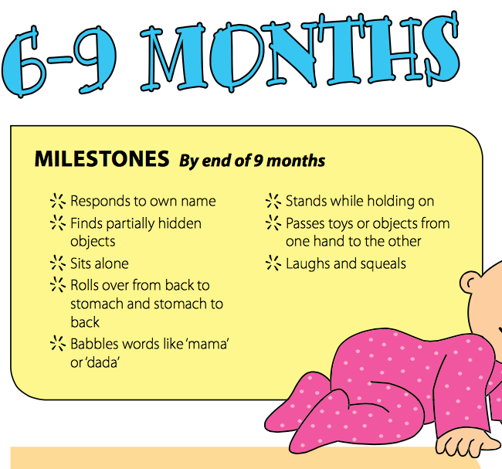
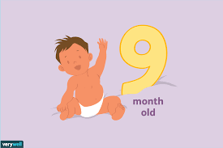
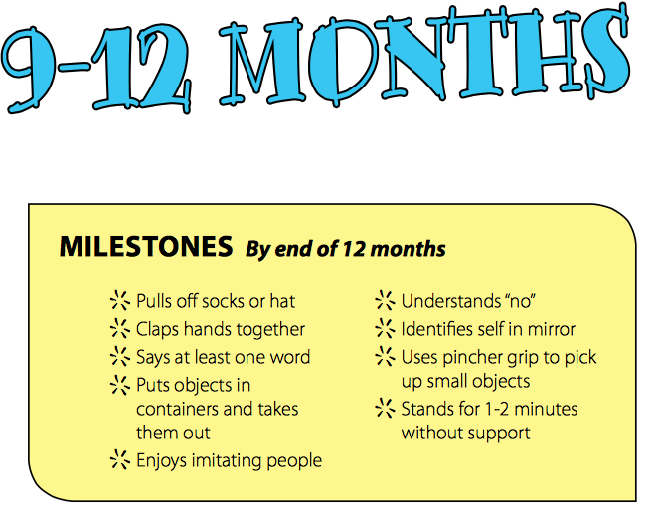
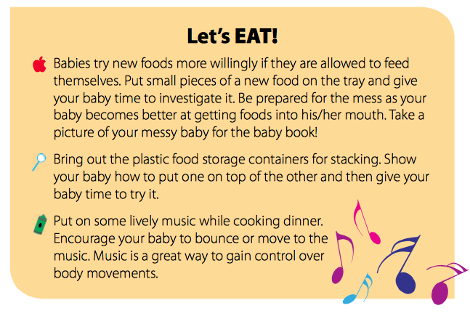
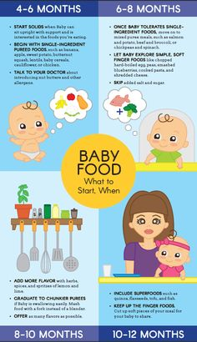

0-2

Activity Post
Let’s Eat!

Breast versus Bottle
Choosing whether to breastfeed or formula feed their baby is one of the biggest decisions expectant and new parents will make.
Health experts believe breast milk is the best nutritional choice for infants. But breastfeeding may not be possible for all women. For many, the decision to breastfeed or formula feed is based on their comfort level, lifestyle, and specific medical situations.
For moms who can't breastfeed or who decide not to, infant formula is a healthy alternative. Formula provides babies with the nutrients they need to grow and thrive.
Some mothers worry that if they don't breastfeed, they won't bond with their baby. But the truth is, loving mothers will always create a special bond with their children. And feeding — no matter how — is a great time to strengthen that bond.
The decision to breastfeed or formula feed your baby is a personal one. Weighing the pros and cons of each method can help you decide what is best for you and your baby.

When to Start Solid Foods?
Why Offer Your 6-12 month old Finger Foods?
Finger foods are small pieces of food that your baby can pick up and eat easily. Introducing finger foods early, soon after starting solids, helps your baby get used to different food textures, improves coordination and encourages self-feeding. These are important feeding skills.

Your baby is ready for finger foods when she grabs food and starts putting things in her mouth. If your baby is not taking foods with a lumpy texture and finger foods by 9 months, talk to your health care provider.

0-2activity post October
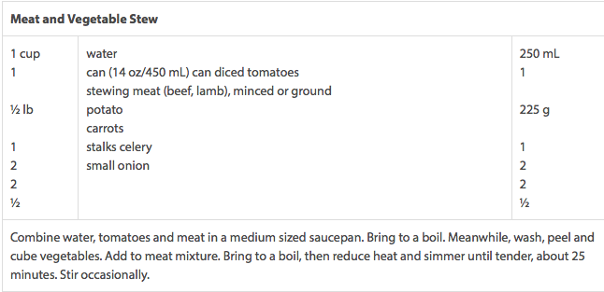
Doctors suggest starting a baby on solid foods sometime between 4 and 7 months of age. Some babies are ready for solids as early as 3 months, but it's not recommended; the earlier a baby gets started on solids, the more likely that she'll be prone to food allergies later on.
At the beginning, solid foods will just be a supplement to your child's primary source of nutrition -- breast milk or formula. So there's no need to worry if you haven't gotten your baby started on solids yet or if he's not eating as much solid food as you'd like.
It's important to determine whether your baby is ready for solids before you introduce them. Here are some signs of your baby's readiness:

- Your baby's tongue-thrust reflex is gone or diminished. This natural reflex, which prevents infants from choking on foreign objects, also causes them to push food out of their mouths.
- Your baby can support her own head. Even if your baby can't quite sit up on her own yet, she needs to be able to hold her head up in order to start eating solids.
- Your baby seems interested in food. If she's eying the food you're eating, reaching out to grab your food, or licking her lips when she smells new foods, she's probably craving the variety that comes with starting solids.

Sign Language is an amazing way to begin communication with your baby.
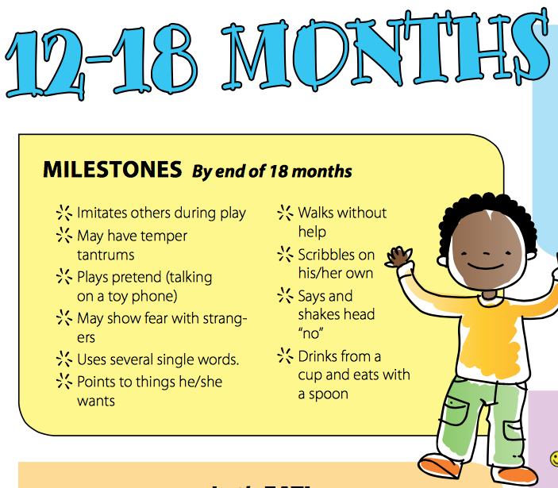
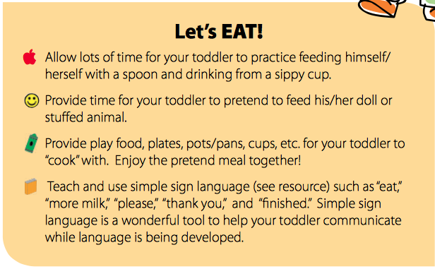
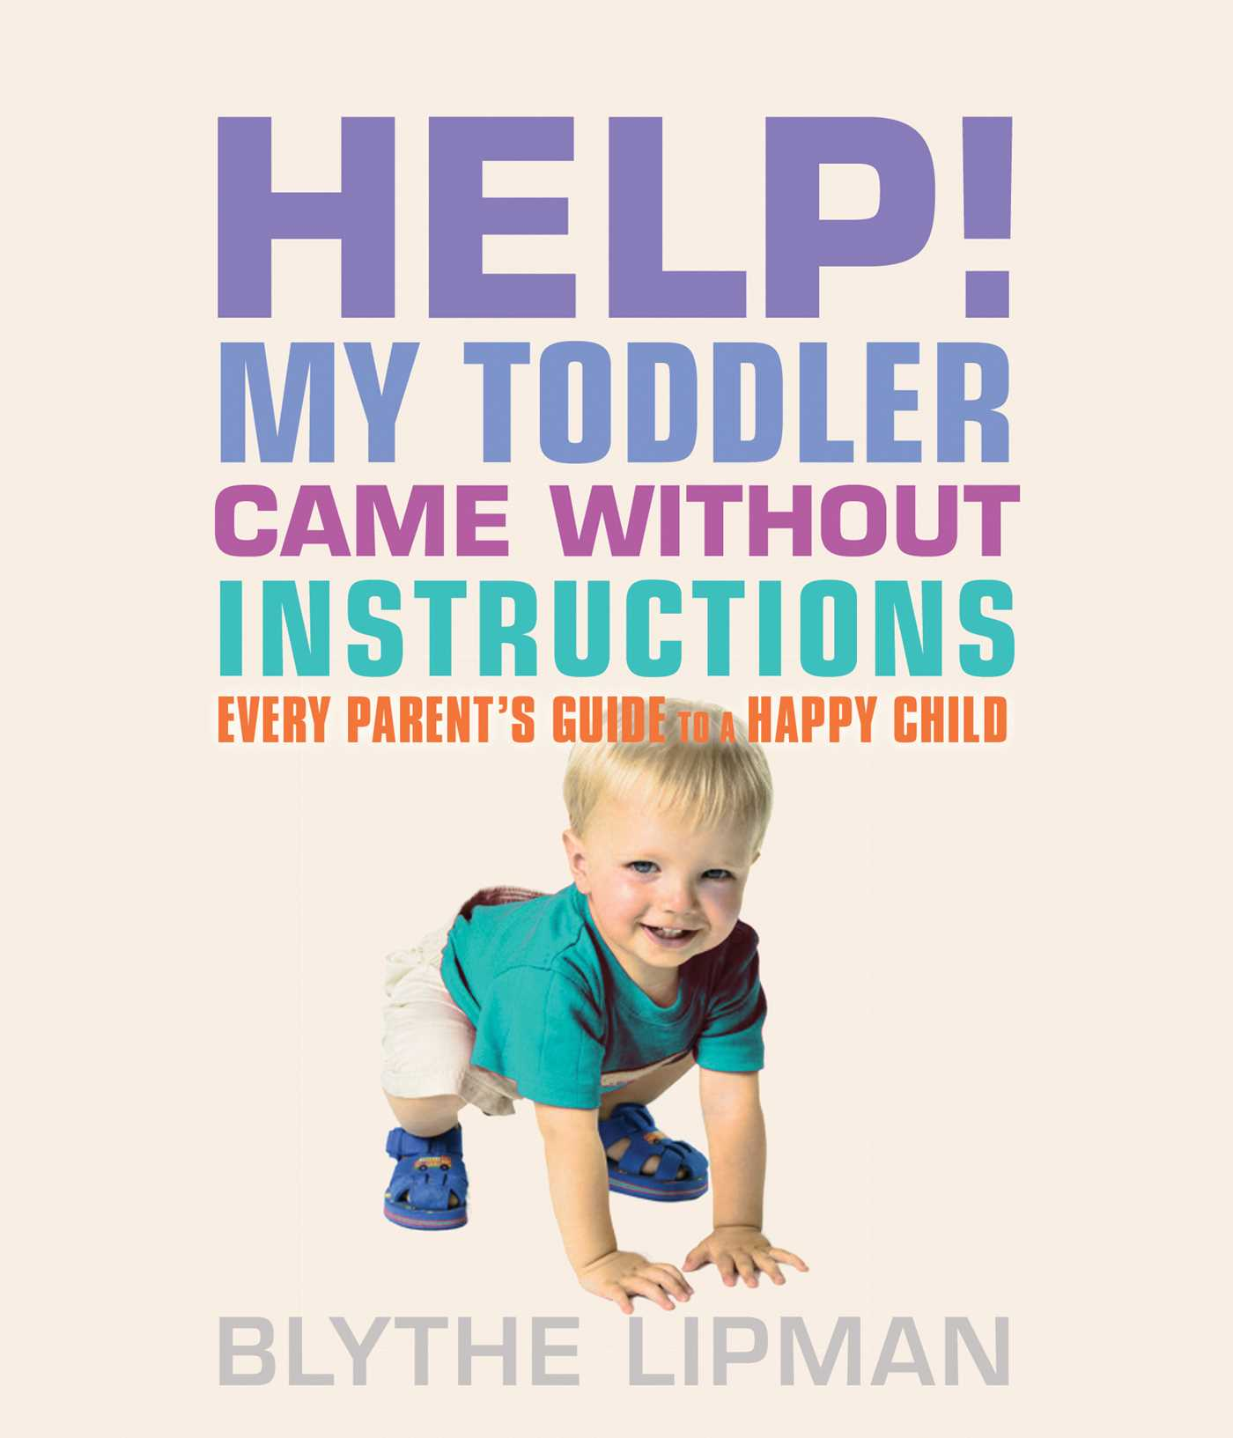

What if we're vegetarians?
If you're a vegan or vegetarian, you can still provide your infant or toddler with everything she needs. The Academy of Nutrition and Dietetics and American Academy of Pediatrics agree that well-planned vegetarian and vegan diets are fine for infants and toddlers. Just pay attention to make sure your child gets plenty of the following nutrients:
- Vitamin B12: Vegetarians can get this nutrient from milk products and eggs. Vegans can use fortified soy beverages, cereals, and meat substitutes.
- Vitamin D: Breastfed babies should get an additional 400 IU per day from fortified cow's milk or soy milk.
- Calcium: Vegan babies may need calcium-fortified foods, beverages, or supplements. Check with your doctor or a dietitian.
- Zinc: This important nutrient helps the immune system and can be found in beans, fortified cereal, milk, and wheat germ.
- Iron: You can find this mineral in iron-fortified cereal or supplements. Serve with foods high in vitamin C – like oranges, tomatoes, and strawberries – to improve iron absorption.
- Protein: Vegetarians can get added protein from yogurt and eggs. Vegans can get plant proteins from beans, cereals, and fortified soy milk.
Fiber: Good sources of fiber include whole grain breads, fortified cereals and pastas, and high-fat plant foods like sunflower butter and avocados.
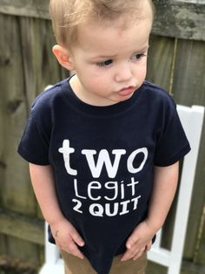
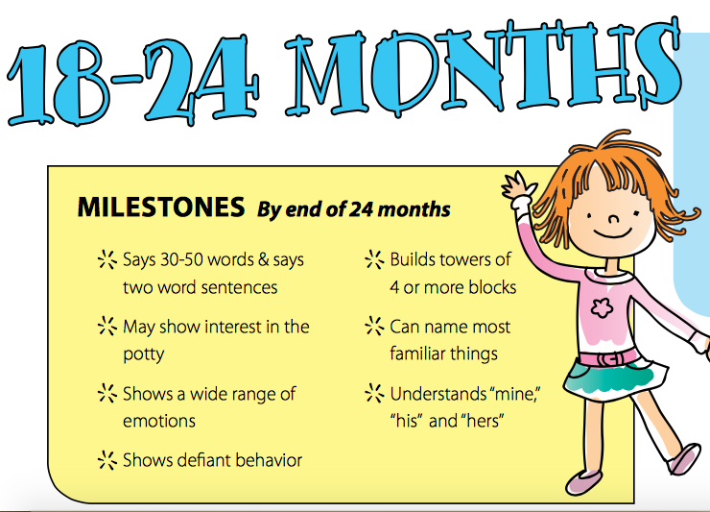
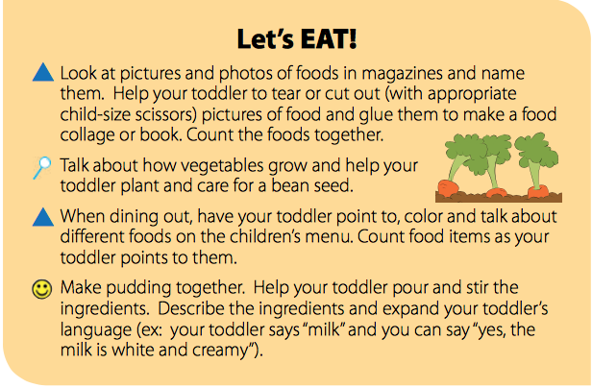
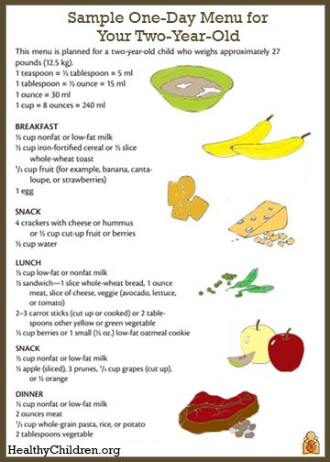

Lorem Ipsum!
0-2 Activity Post
OCTOBER

