Virtual Community of Support for Early Learning

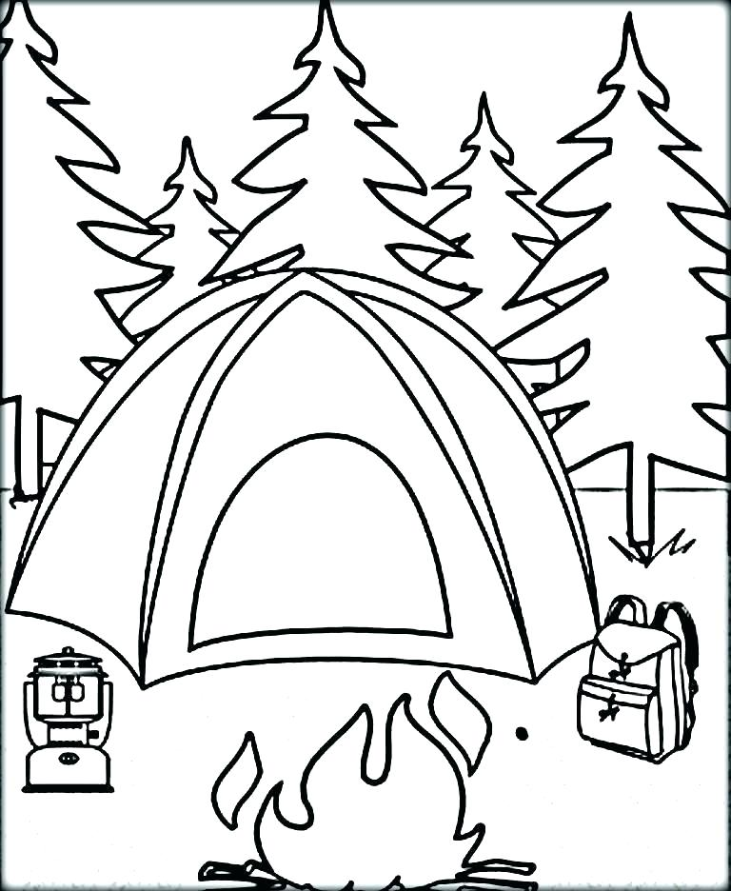

June 2022
3-5 yr Activity Post #10 | Parent Session 9 am Parent Tip #28 | 1  Activity Session 9 am | 2  0-2 Yr Activity Post #9 | 3  Recording Posted
6  Session Email Package sent | 7  Parent Tip #29 | 8  Literacy Session 9 am | 9  Recordings Posted | 10
13  Session Email Packages sent | 14  Parent Session 9 am Parent Tip #30 | 15  Story Time Session 9 am | 16  Recordings  Posted | 17
20/27 | 21/28 | 22/29 | 23/30 | 24

