Virtual Community of Support for Early Learning

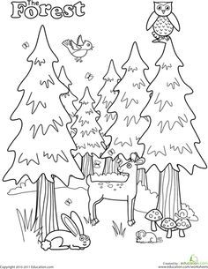

November 2023
3-5 yr Activity Post #3 | Parent Tip #3 | 1  Activity Session 9 am | 2  0-2 Yr Activity Post #2 | 3  Recording Posted
6  Session Email Packages sent | 7  Parent Session Podcast  Parent Tip #4 | 8  Literacy Session Podcast | 9  Recordings Posted | 10
13  Remembrance Day Session Email Packages sent | 14  Parent Tip #5 | 15  Story Time Session 9 am | 16  Recordings  Posted | 17
20/27  Session Email Packages sent | 21/28  21-Parent Session 9 am  Parent Tip # 6 | 22/29  22-Numeracy Session 9 am  29-Activity Session 9 am | 23/30  Recordings Posted | 24  24-NID

