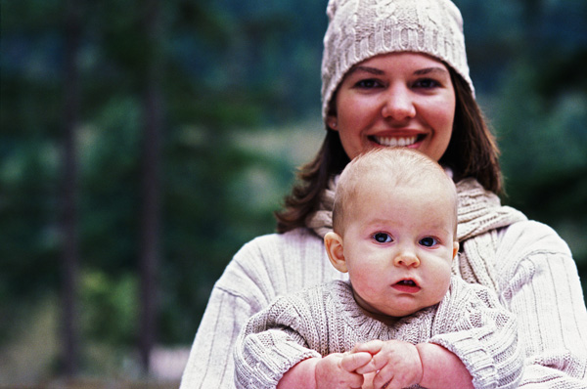
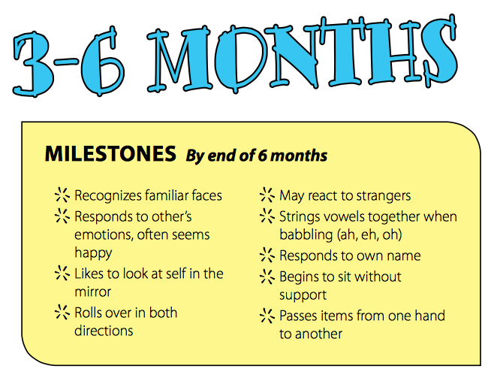
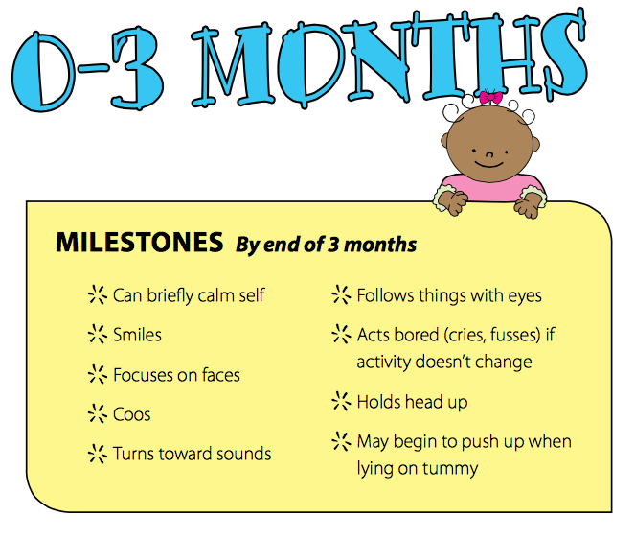
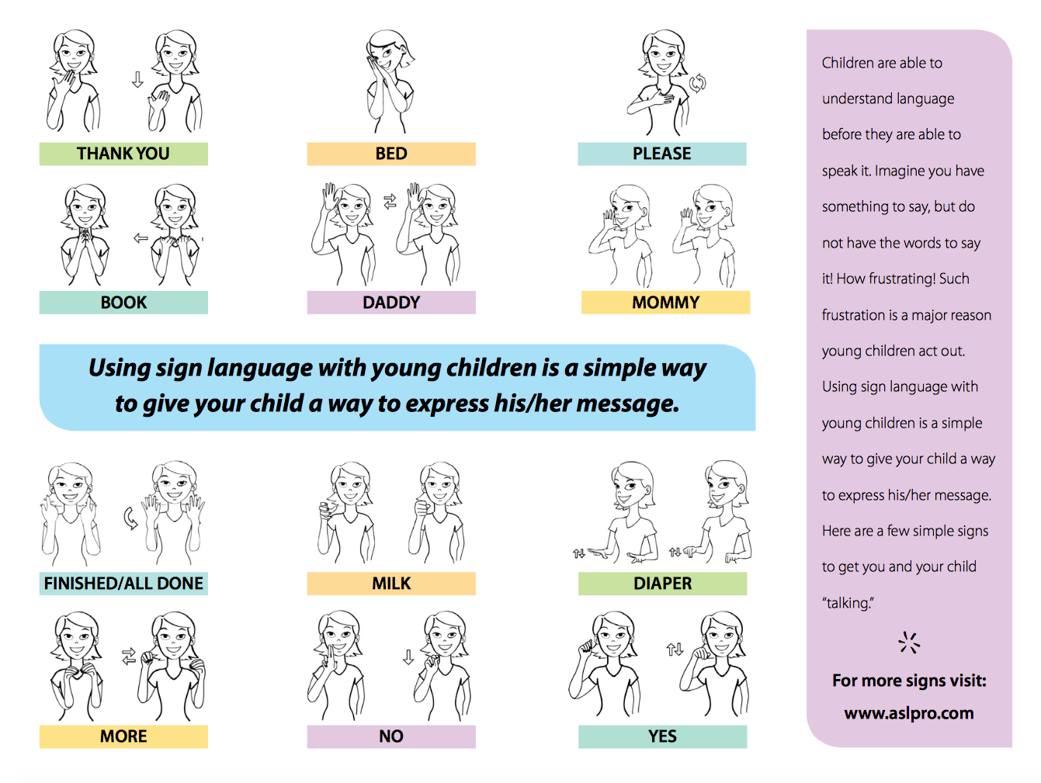

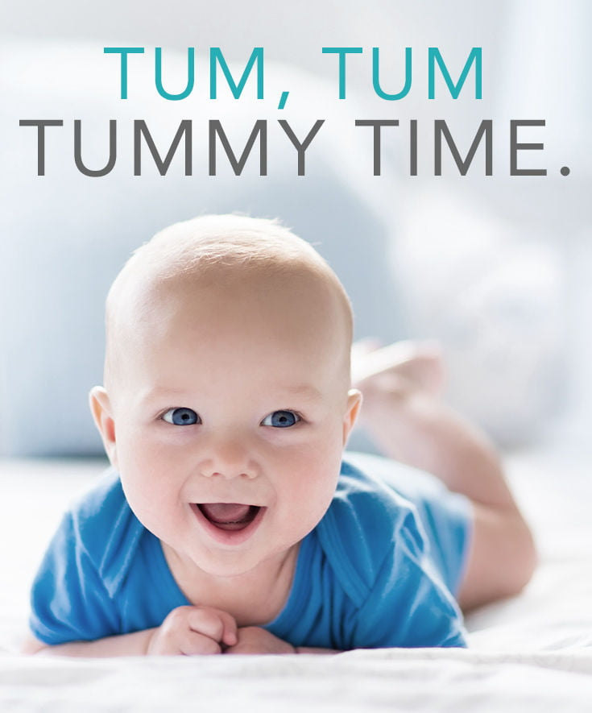
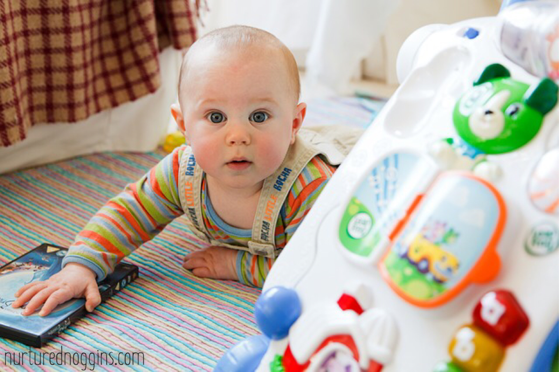

0-2

Activity Post
Milestones

0-2activity post APRIL 2019
Sign Language is an amazing way to begin communication with your baby.
Introduce cardboard or cloth books with brightly colored pictures. Try to select books that reflect the child's own experiences such as books about daily life, family members, animals, or food

Newborn Milestones
Physical Milestones
- Makes reflex movements like sucking and startling
- Has jerky, uncontrolled arm and leg movements
Cognitive Milestones
- Learns about things by feel, sound, sight and smell
- Begins repeating movements to help brain growth and memory
Social and Emotional Milestones
- Starts learning to be comforted by caregivers
- Begins getting attached to caregivers

Here are some tips for Tummy Time:
- Start tummy time when your baby is a newborn.
- Set tummy time for after every diaper change. Add one minute of tummy time each day. If your baby gets very upset, increase the time more slowly.
- Talk, sing to and comfort your baby. Try to comfort your baby.
- Massage his back, arms, or legs. Gently touch or stroke her.
- Give your baby interesting things to look at, such as brightly coloured toys or a mirror. Get down on the floor so your baby can see your face.
- You can also roll up a towel and put it under your baby’s chest with his arms propped up in front for support. Put your hand under your baby's chin to support the head until your baby is strong enough to do it independently.

Activities for a 3 to 6 month old child

Talk to your baby all the time, telling him what you are doing and what different noises are. Use simple words and very short sentences.
- Make faces and blow raspberries on his belly.
- Sing to him.
- Place him on the floor in a safe place on her tummy for short periods to play.
- Place him on the floor without a nappy to allow him the freedom to kick.
- Provide him with bright objects to look at and place some within reaching distance so that he can accidentally touch them initially and then try to touch them again.
- Provide him with a variety of things to do and either change what he is looking at or move him to a different spot so he has something else to look at.
Place colourful toys nearby for him to touch / try to touch, look at and hit

3 Months Milestones
Physical Milestones
- Props up on arms when on belly
- Holds head up unsupported for a short time
- Follows an object with eyes from one side to the middle, but not all the way around
Cognitive Milestones
- Starts paying attention to, watching and recognizing faces
- Recognizes familiar people at a distance
- Shows signs of boredom (fussiness) when doing one thing too long
- Uses eyes and hands together and plans, such as seeing a toy and reaching for it
Social and Emotional Milestones
- Smiles spontaneously
- Likes to play with people
- Coos and babbles
- Develops different cries for different needs (hungry, tired, wet)
- Responds to love and affection
- Shows happiness and sadness
- May imitate facial expressions

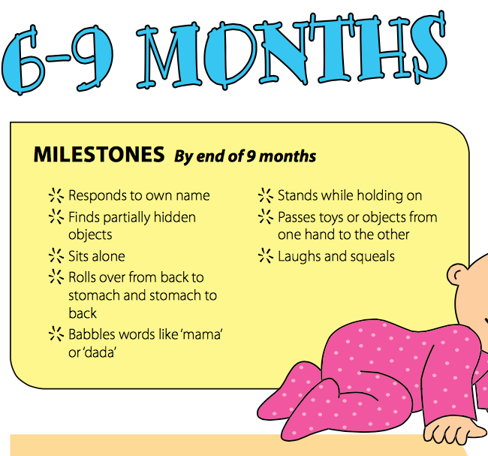
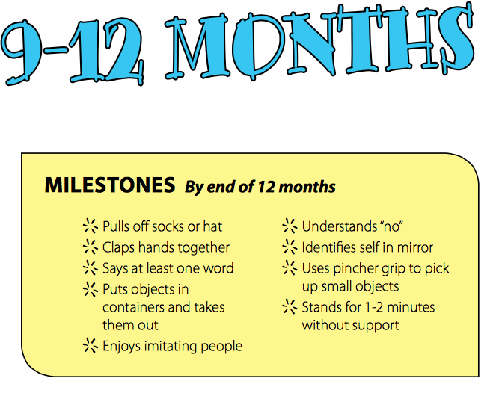
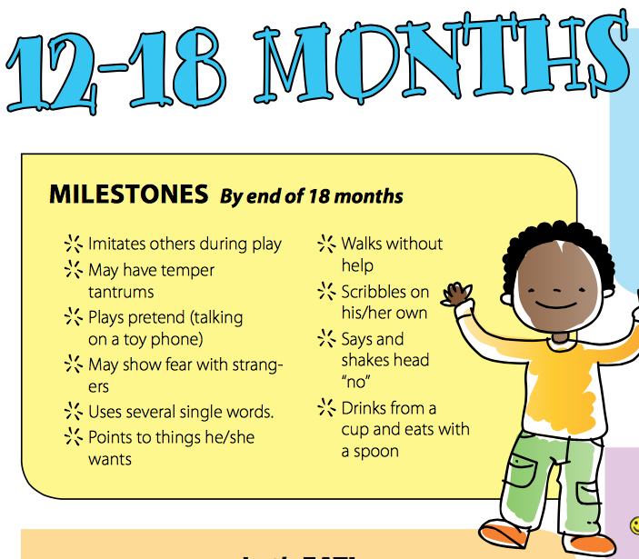
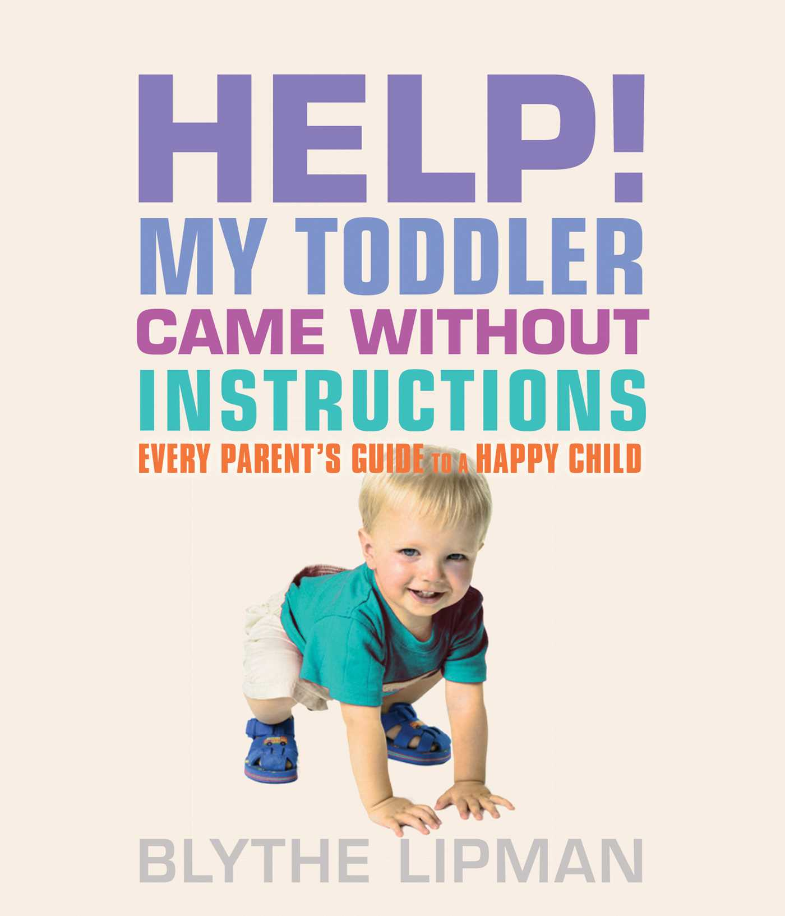
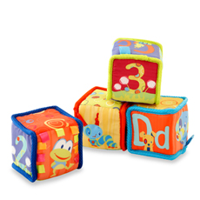
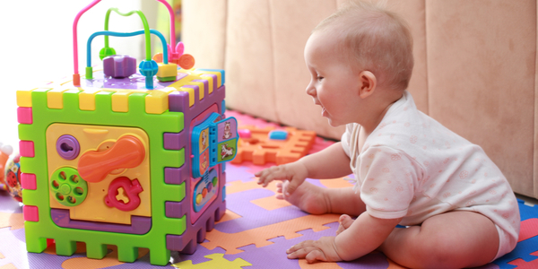
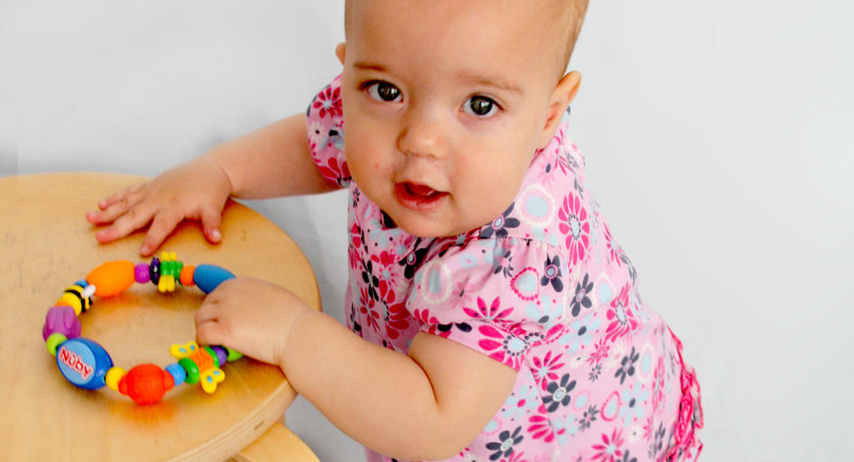
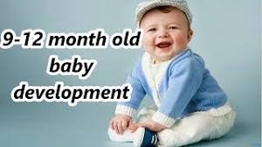
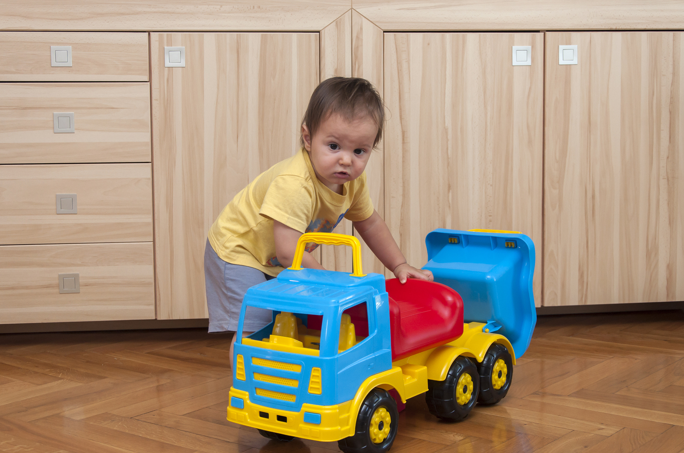

6-9 Month Milestones
Physical Milestones
- Reaches for and grabs objects
- Rocks on tummy; may be able to roll from tummy to back
- Puts weight on legs when feet are flat on the floor
- Moves things from hand to hand
- Rolls from back to tummy and tummy to back
- Sits without support
- Does “push-ups” and starts trying to move forward
Cognitive and Language Milestones
- Is curious about things out of reach and looks at new things
- Explores things by putting them in mouth
- Responds to conversation by making sounds
- Recognizes and responds to own name
- Practices turn-taking when “talking” with caregivers
- Jabbers with vowel sound combinations (eh, ah, oh) and starts using sounds like band m
- Starts testing cause and effect, such as seeing what happens when shaking a toy
Social and Emotional Milestones
- Starts to recognize and react to strangers
- Tries to get caregivers to play (sticks out tongue, pats toys, etc.)
- Is interested in looking in the mirror
- Uses sounds to express happiness, sadness and anger

- Your Child Will Love To:
- Have you look into his eyes and chat with him
- Lie on his back and grab his feet
- Lie on his tummy and reach for a brightly coloured toy or piece of paper
- Have you play ‘here is your nose – here is mummy’s nose’
- Drop his toy from the highchair or pram over and over and delight in watching you pick it up and give it back to him
- Play ‘ahh boo’ as you bring your face quickly down to his tummy
- Play ‘peek-a-boo’ as you hide your face behind a book or cloth and say his name when you come out.

9-12 Month Milestones
Physical Milestones
- Gets into and out of a sitting position
- Starts scooting, creeping or crawling
- May stand with support
- Picks up small objects using thumb and fingers (pincer grasp)
- Follows a falling object with eyes
- Looks for hidden object, but only if he sees you hide it
- Plays peekaboo and patty-cake
- Starts to understand no
- Makes vowel-consonant sounds (mama, baba)Points and copies other gestures
- Walks holding on to hands or furniture
- May stand alone
- May take a few steps alone
- Can let go of items without help
- Points
Cognitive and Language Milestones
- Finds hidden objects
- Looks at or points to a picture when you name it
- Bangs, throws and shakes things to see what happens
- Explores everyday objects, both in correct ways (using a cup to drink) and incorrect ways (puts a toy in a cup)
- Follows one-step directions
- Shakes head no and waves
- Tries to repeat words
Social and Emotional Milestones
- Begins having stranger anxiety
- May be upset when separated from caregivers
- Has favorite objects or toys
- Uses inflection and pauses to make sounds that sound like talking
- Uses simple words like mama or uh-oh
- Responds to name
- Plays favorites with people
- Is a little fearful of new things
- Uses gestures or sounds to get your attention

12-18 Month Physical Milestones
Milestones for 1-year-olds include gross motor skills using big muscles to move the whole body—and fine motor skills—using smaller muscles for little things.
Gross Motor Skills Most 1-year-olds can:
- Sit without leaning on anything or being held up
- Belly crawl, scoot or creep on hands and knees
- Pull to standing and move, holding on to furniture
Cognitive Milestones
- Know the use of everyday objects, such as a spoon, a toothbrush or phone
- Start following simple directions such as “blow me a kiss” or “sit down”
- Start simple pretend play, like feeding a stuffed animal
- Point to his own head, eyes, ears, nose or mouth
- Make the connection between a word you say and a picture in a book
- Show a reaction to familiar songs and stories
- Start testing cause and effect, such as what happens when he throws his cup on the floor
Language Milestones
- Babble in a way that sounds like talking and try to “talk” with you
- Recognize family members’ names and the words for common items (cup, ball, shoe)
- Raise his arms when he wants to be picked up, point at things he wants and shake his head no
- Understand basic commands like stop
- Say no, mama and several other words
- Express happiness, sadness and frustration with different sounds or cries

Social and Emotional Milestones
One-year-olds have limited social interactions with other children. But your child may learn many social skills and ways to express emotion this year. Most 1-year-olds can do these things:
- Smile and laugh in reaction to somebody else or when playing
- Cry when someone nearby is upset
- Feel comfortable exploring the room when a caregiver is nearby
- Show affection to familiar people
- Have mild temper tantrums when frustrated
- Be nervous around new people and clingy with caregivers

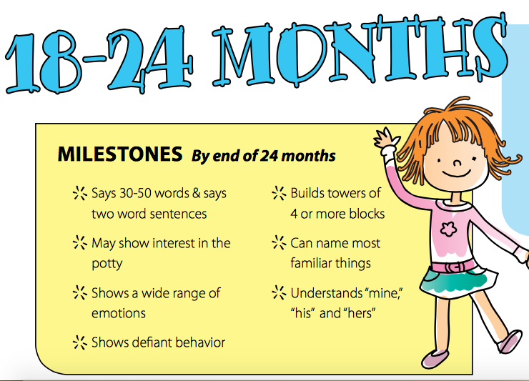

Lorem Ipsum!
0-2 Activity Post
APRIL

Physical Milestones
Most 2-year-olds learn to do things like these by the end of their third year:
Gross Motor Skills
- Walk, run and start learning to jump with both feet
- Pull or carry toys while walking
- Throw and kick a ball; try to catch with both hands
- Stand on tiptoes and balance on one foot
- Climb on furniture and playground equipment
- Walk up stairs, holding on to the railing; may alternate feet.
Fine Motor Skills
- Start brushing own teeth and hair
- May pull pants up and down
- Turn on the faucet and wash hands
- Build a block tower of at least four blocks
- Start practicing snaps and zipping up (if you start the zip)
- Hold utensils and crayons with fingers instead of a fist, although the grasp still may not be quite right
Cognitive Milestones
- Enjoy more complicated pretend play, like pretending that a box is a spaceship or assigning people characters when playing.
- Remember and talk about things that happened in the past, using phrases like “the other day” or “a long time ago”
- Do three- to four-piece puzzles
- Group toys by type, size or color
- Recite favorite books and nursery rhymes with you
- May follow two-step directions, such as “take off your coat and hang it up”

Language Milestones
- Understand the words for familiar people, everyday objects and body parts
- Use a variety of single words by 18 months and speak in sentences of two to four words by 24 months (may combine nouns and verbs, like “mommy eat”); have a vocabulary of 200+ words by 36 months
- Repeat words she hears
- Start asking “what’s that?” and “why?”
- Begin using plurals (dogs) and basic pronouns (me, you)

Social and Emotional Milestones
- Mimic what other kids and adults do and say, as well as how they say it
- Be happy to play near, if not with, other kids
- Start to realize she can do things without your help
- Disobey more than before, doing things she’s told not to do, just to test what happens
- Have tantrums when frustrated
- Show increasing separation anxiety by 18 months, which typically eases considerably by 24 months; become increasingly independent and aware of herself as her own person between 24 and 36 months

