Virtual Community of Support for Early Learning
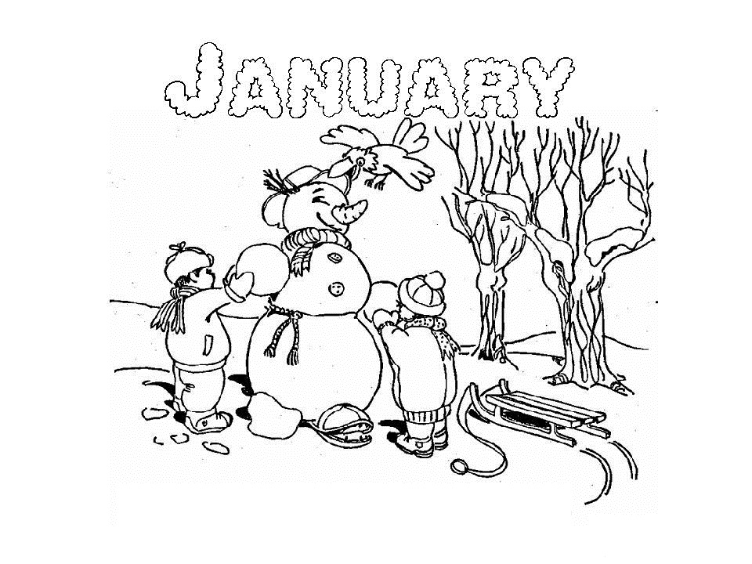

January 2026
5 | 6 | 7  Activity Session 10 am Podcast | 8  0-2 Yr Activity Post #4 | 9  Recording Posted
12  Session Email Package sent | 13  Parent Tip #11 | 14  Literacy Session 10 am  Podcast | 15  Recordings Posted | 16
19  Session Email Packages sent | 20  Parent Session 9 am Podcast  Parent Tip #12 | 21  Story Time Session 10 am | 22  Recordings  Posted | 23
26  Session Email Packages sent | 27  Parent Tip #13 | 28  Numeracy Session 10 am | 29  Recordings Posted | 30

