Virtual Community of Support for Early Learning

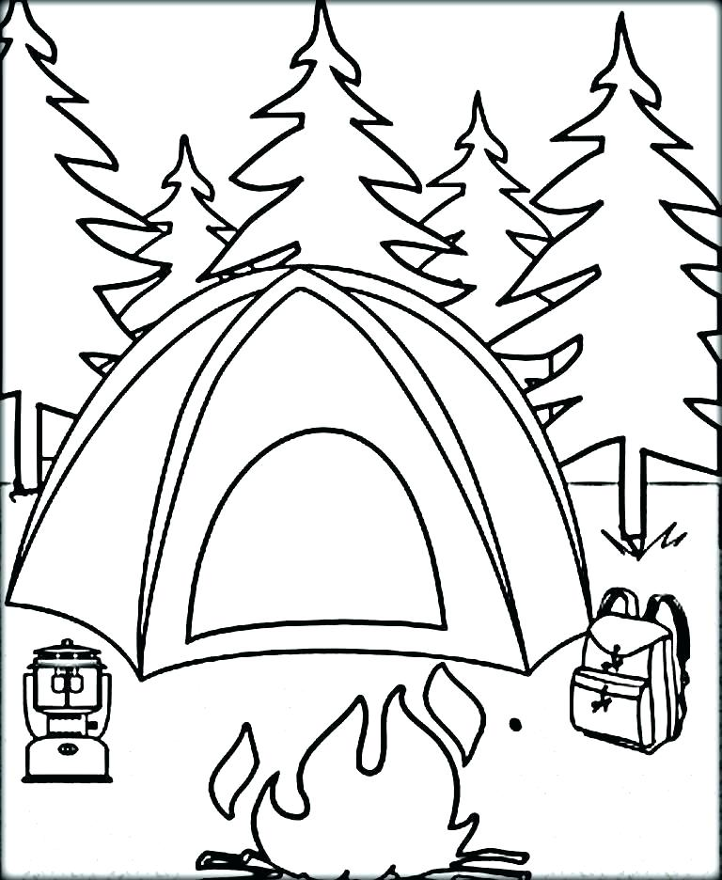

June 2025
2  3-5 yr Activity Post #10 | 3  Parent Session 9 am Parent Tip #28 | 4  Literacy Session 1 9 am | 5  0-2 Yr Activity Post #9 | 6  Recording Posted
9  Session Email Package sent | 10  Parent Tip #29 | 11  Literacy Session 2 9 am | 12  Recordings Posted | 13
16  Session Email Packages sent | 17 | 18  Activity Summer Fun Session 9 am | 19  Recordings  Posted | 20
23/30  Closed for Summer Vacation | 24 | 25 | 26 | 27

