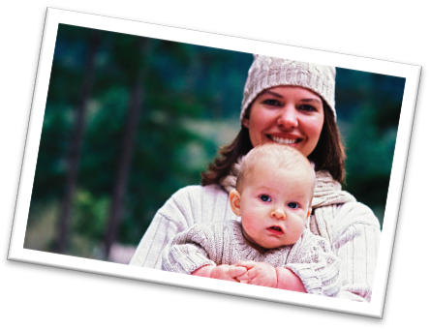
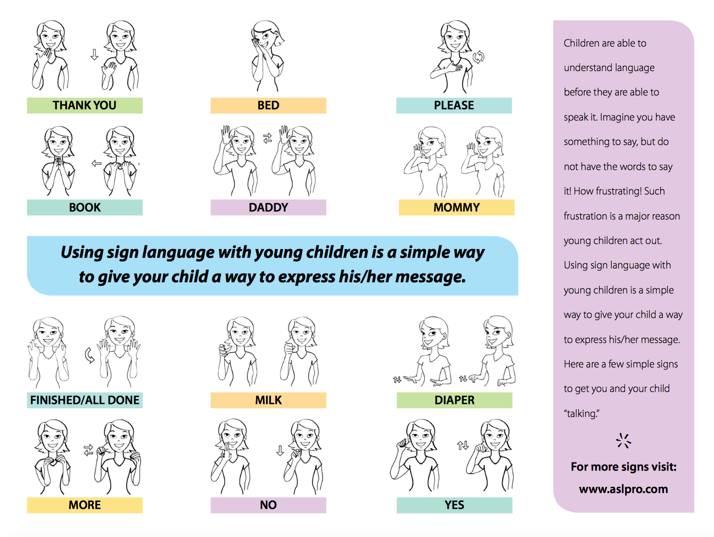

0-2
Activity Post
Let’s Go!
0-2activity post March 2018
Sign Language is an amazing way to begin communication with your baby.
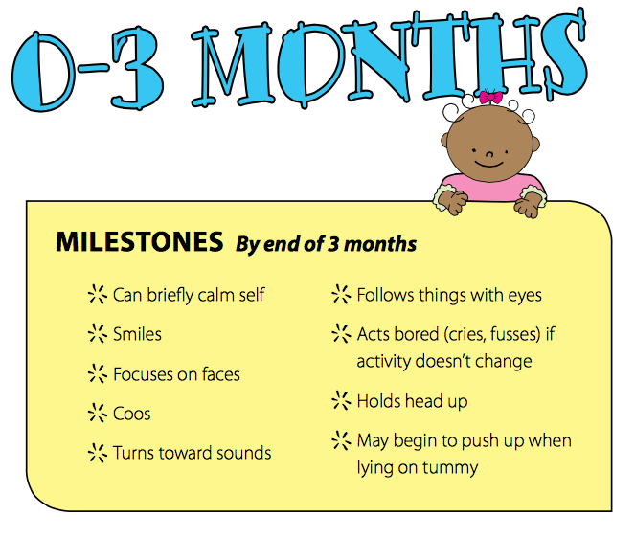
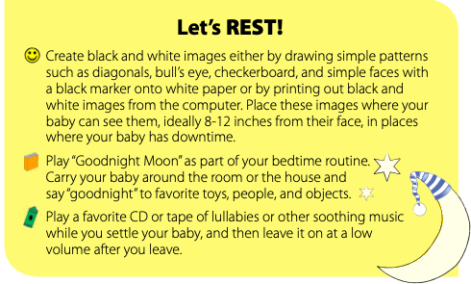
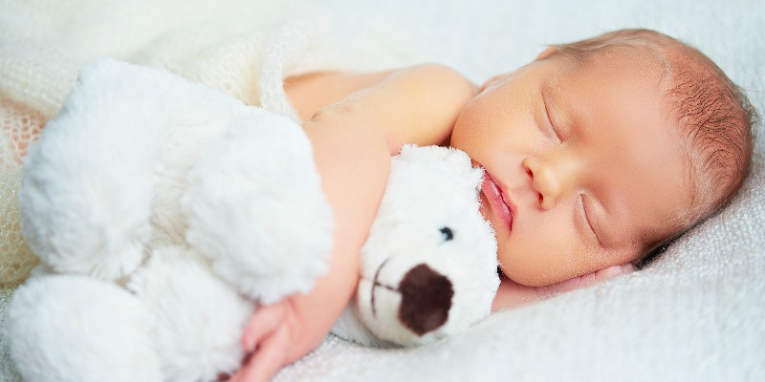
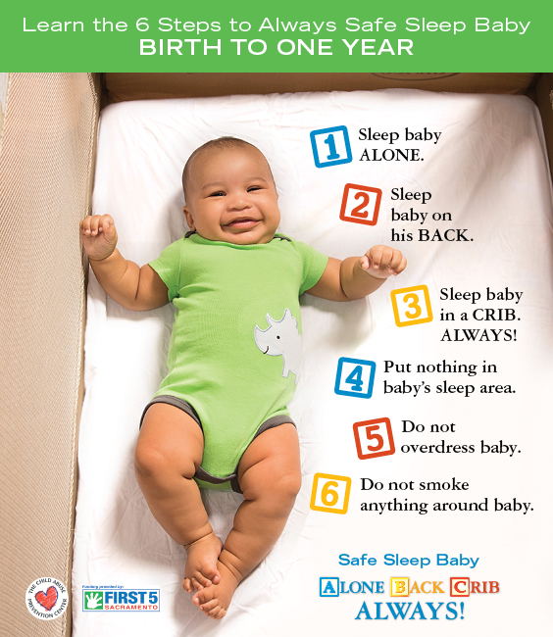

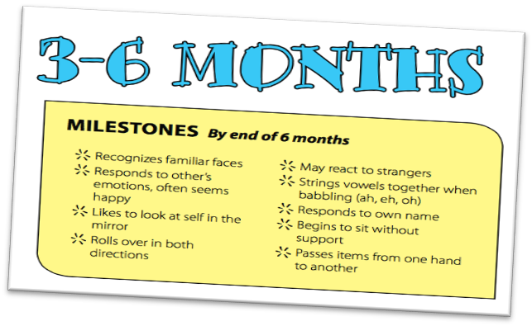
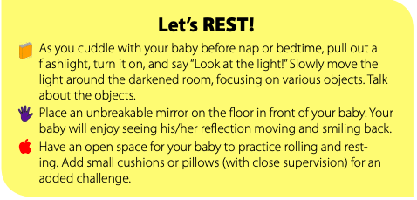
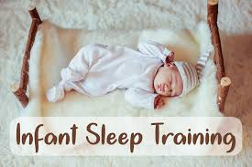
Introduce cardboard or cloth books with brightly colored pictures. Try to select books that reflect the child's own experiences such as books about daily life, family members, animals, or food

Tired signs – sleep cues
As you get to know your baby you will start to learn when he is sleepy and needs to be put down for sleep. Long before they can talk, babies have tired signs or sleep cues in their behaviour that show you what they need. Your baby will have his own special sleep cues but here are some that most babies have that will give you a start in watching for your baby’s cues:
- Yawning, jerky movements, becoming quiet, not wanting to play, ‘grizzling’ or fussing, rubbing their eyes, making a sleepy sound, crying, facial grimaces, including pulling faces, clenched fists, waving arms and legs about.

If you miss the tired signs and don't help your baby to settle, your baby may get more alert and overtired and be very hard to get to relax and sleep. Signs that the baby has got overtired include being very overactive, glazed eyes, and being very quick to cry.

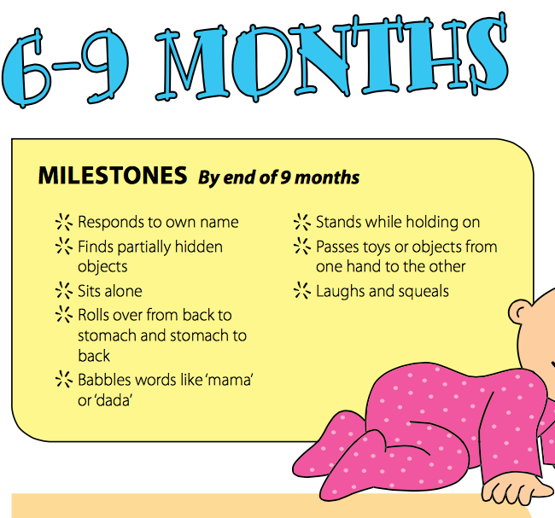
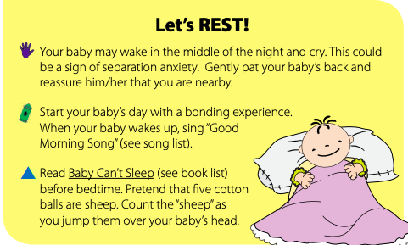
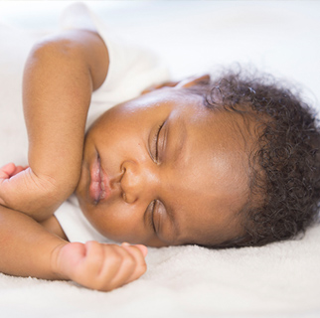
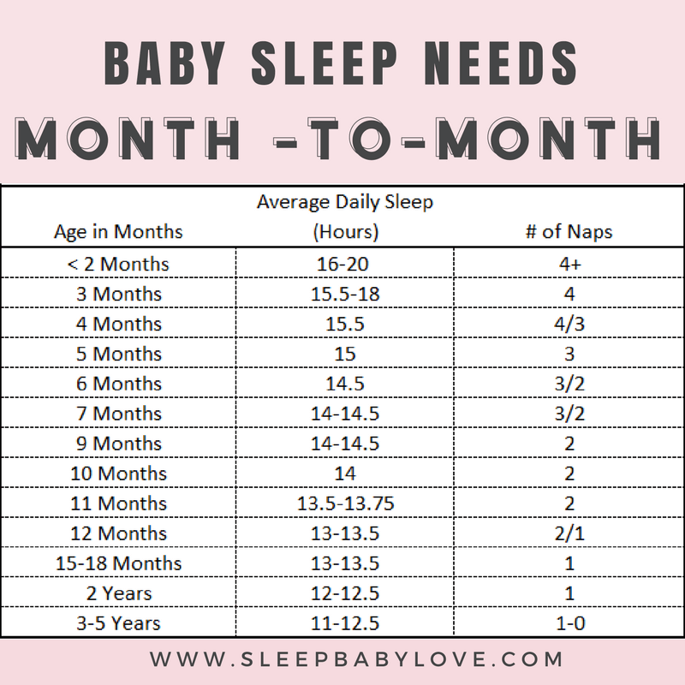
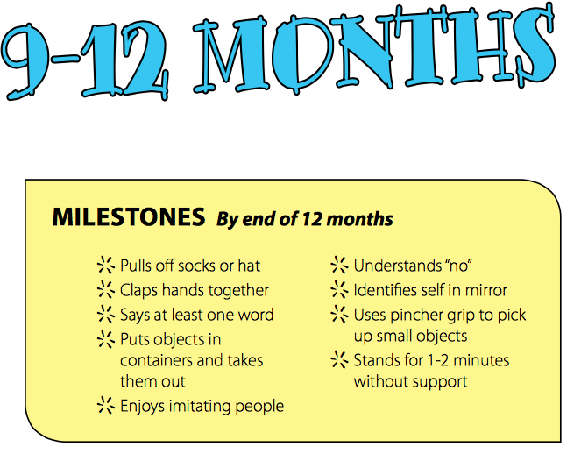
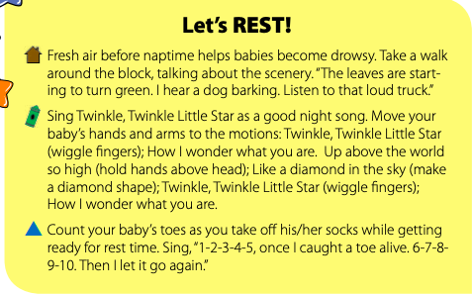
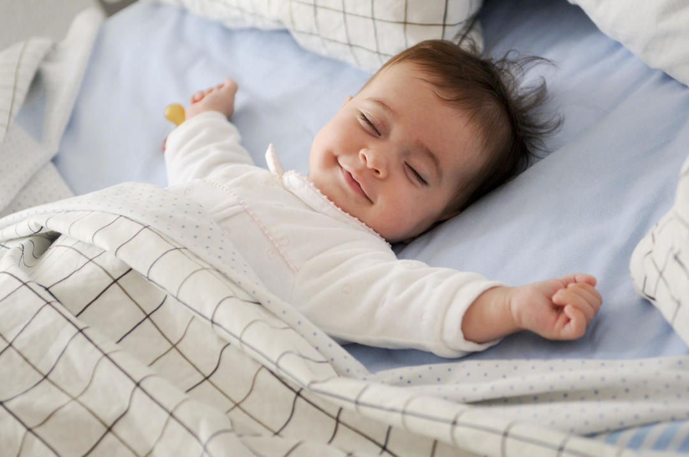

9-12 Months: At 9 months, babies still need an average of 14 hours of sleep a day, with 2 to 3 daytime naps, lasting anywhere from 2 hours to 30 minutes each. Some babies, particularly those who are breastfed, may still wake at night. But most no longer need a middle-of-the-night feeding.
If your baby wakes in the middle of the night, but you don't think it's due to hunger, wait a few minutes before going to your baby. Sometimes, babies just need a few minutes to settle down on their down. Those who don't settle should be comforted without being picked up (talk softly to your baby, rub the back), then left to settle down again — unless they are sick. Sick babies need to be picked up and cared for.
Between 6 and 12 months, separation anxiety, a normal part of development, comes into play. But the rules at night are the same through a baby's first birthday: Try not to pick up your baby, turn on the lights, sing, talk, play, or feed your child. All of these activities do not allow your baby to learn to fall asleep on his or her own and encourage more awakenings.

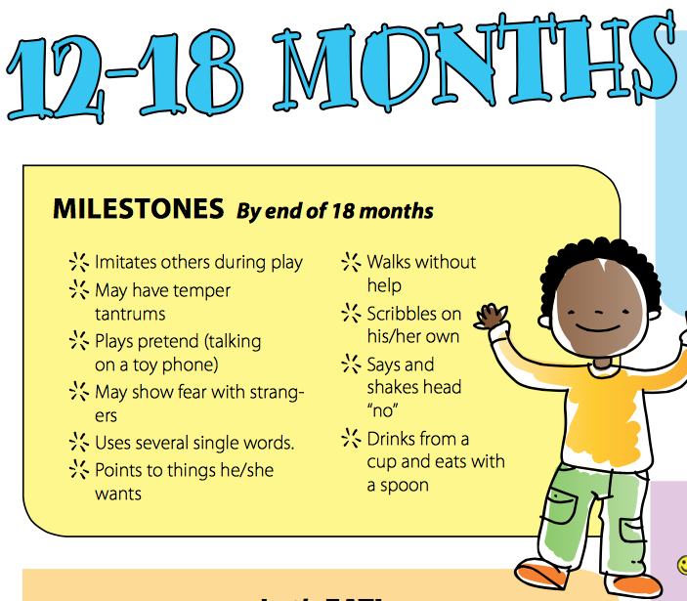
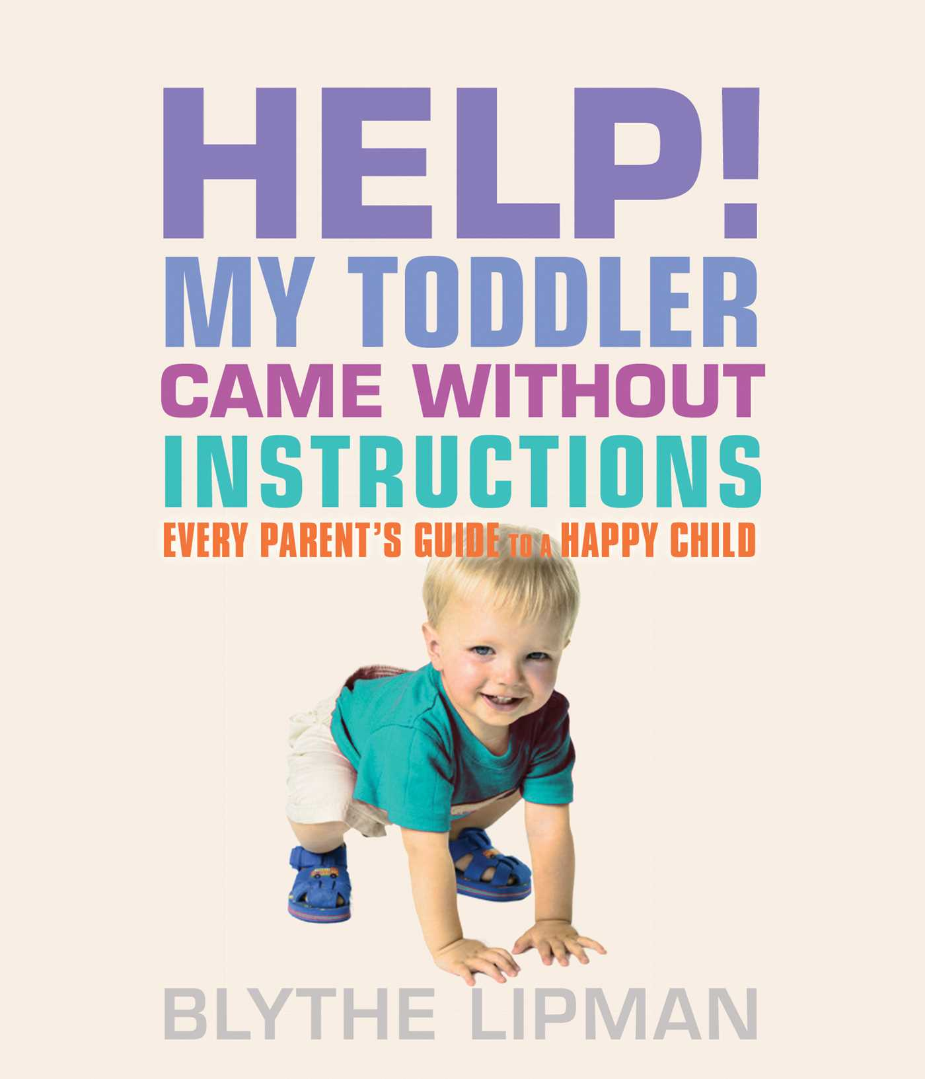
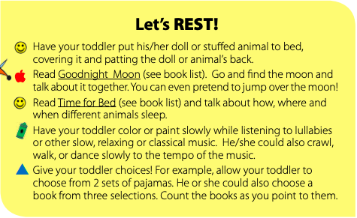
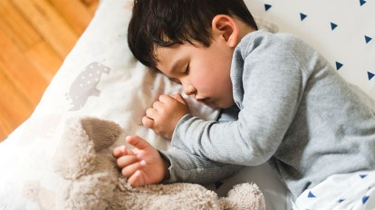

Typical sleep at this age
Now your baby is officially a toddler – but he still needs as much sleep as he did when he was younger. Until his second birthday, your child should get about 14 hours of sleep a day, 11 of those hours at night. The rest will come in nap form.
Your child will still need two naps at 12 months, but by the time he's 18 months old, he may be ready for a single 90-minute to three-hour nap in the afternoon – a pattern he may follow until he's 4 or 5.
The transition from two naps to one can be difficult. Sleep expert Jodi Mindell suggests alternating one-nap and two-nap days, depending on how much sleep your toddler got the night before. You can also try putting your child to bed a little earlier on one-nap days.

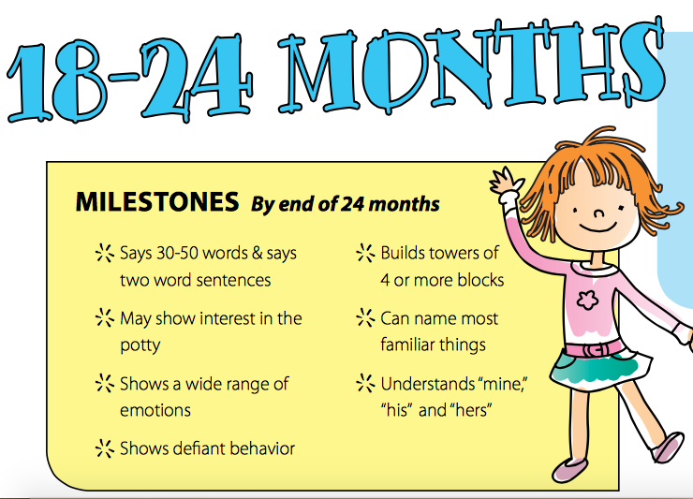
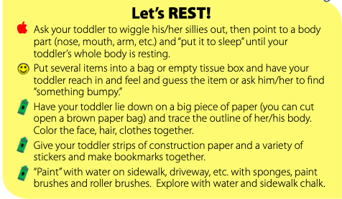

Lorem Ipsum!
0-2 Activity Post
March

Typical sleep at this age
Most toddlers need about 11 to 14 hours of sleep per day, including a one- to three-hour nap each afternoon, according to the American Academy of Sleep Medicine. Some children continue to take two shorter daily naps until they turn 2. (If yours is one of them, don't fight it!)

Establishing healthy sleep habits
Help your child learn to fall asleep on his own consistently. At this age, your child should be able to drift off on his own at night without being rocked, nursed, or otherwise lulled to sleep. If he learns to depend on any of these external cues, he won't be able to fall back to sleep during the night when he wakes up and they're not there.

