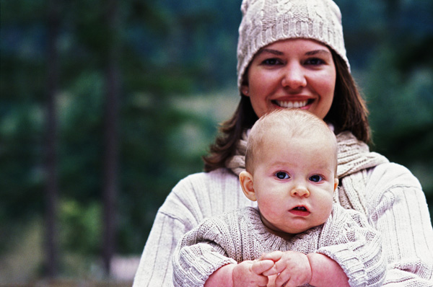
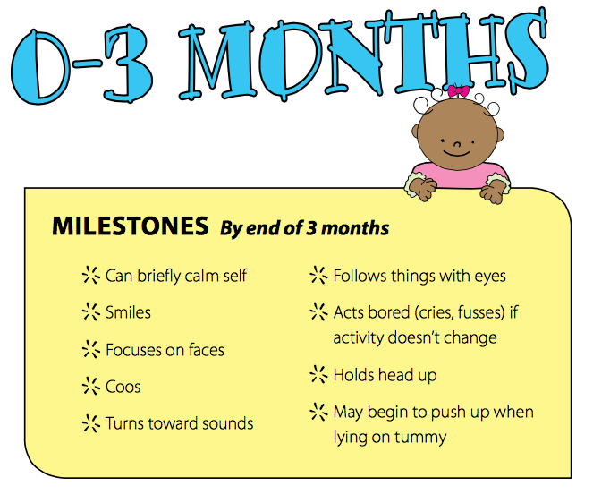
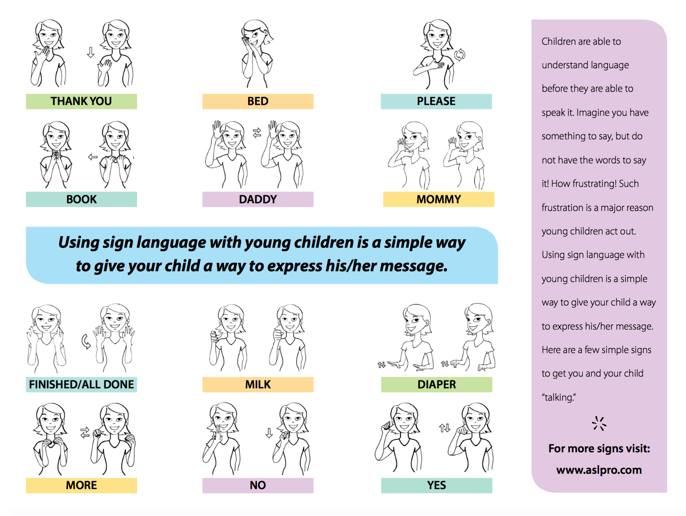
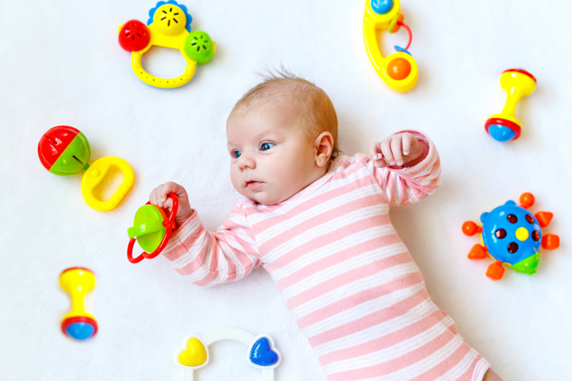


0-2

Activity Post
Milestones

0-2activity post May
Sign Language is an amazing way to begin communication with your baby.

Motor Games and Activities

- Place baby on their tummy to play for a few minutes at a time, a few times a day

- Lie down and place baby tummy down on your chest so you’re face-to-face

- Hold baby’s hands and clap them together while you play music and sing

- Nestle baby close to you while you gently rock and sway

- Change the direction that baby sleeps to encourage head turning and build strength

Sensory Games and Activities
- Hang a colorful mobile above baby’s crib to provide visual stimulation.
- Gently touch and tickle baby to make them giggle.
- Play with baby in a variety of positions.
- Provide plenty of skin to skin contact with a parent or caregiver.
- Smile at baby, touch her hands, feet and forehead. See how she wiggles, reacts to touch and voices.
- Play or sing songs with baby to help enhance baby’s listening skills.
- When changing baby’s diaper touch different body parts and say “beep” baby may begin watching your hand and anticipating touch.
- Hang a mirror on the wall. Tap the mirror and say baby’s name. Over time baby will begin to understand who the baby in the mirror is.
- Show baby family photos or flip through a magazine, pointing out the smiling faces to baby.

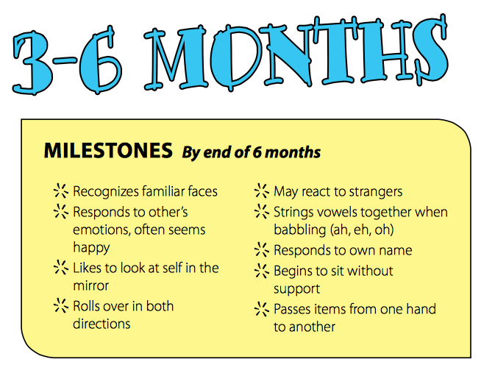
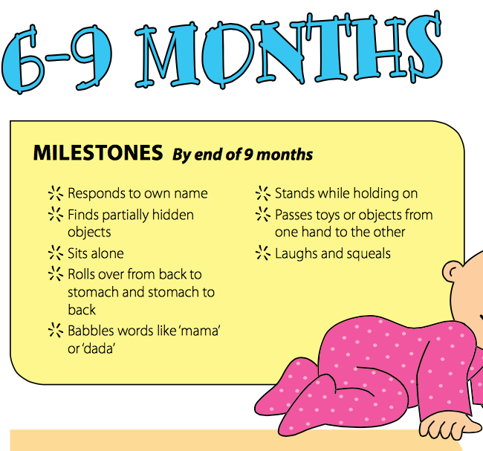
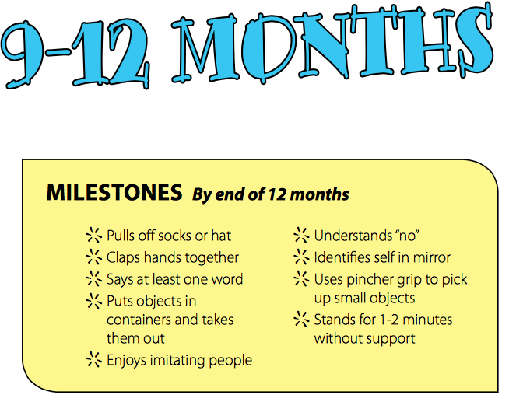
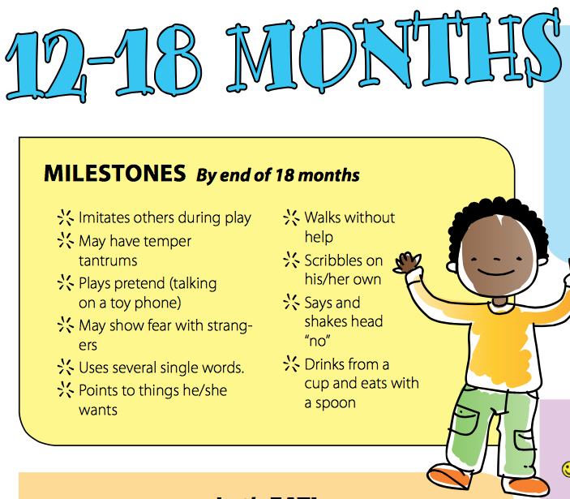
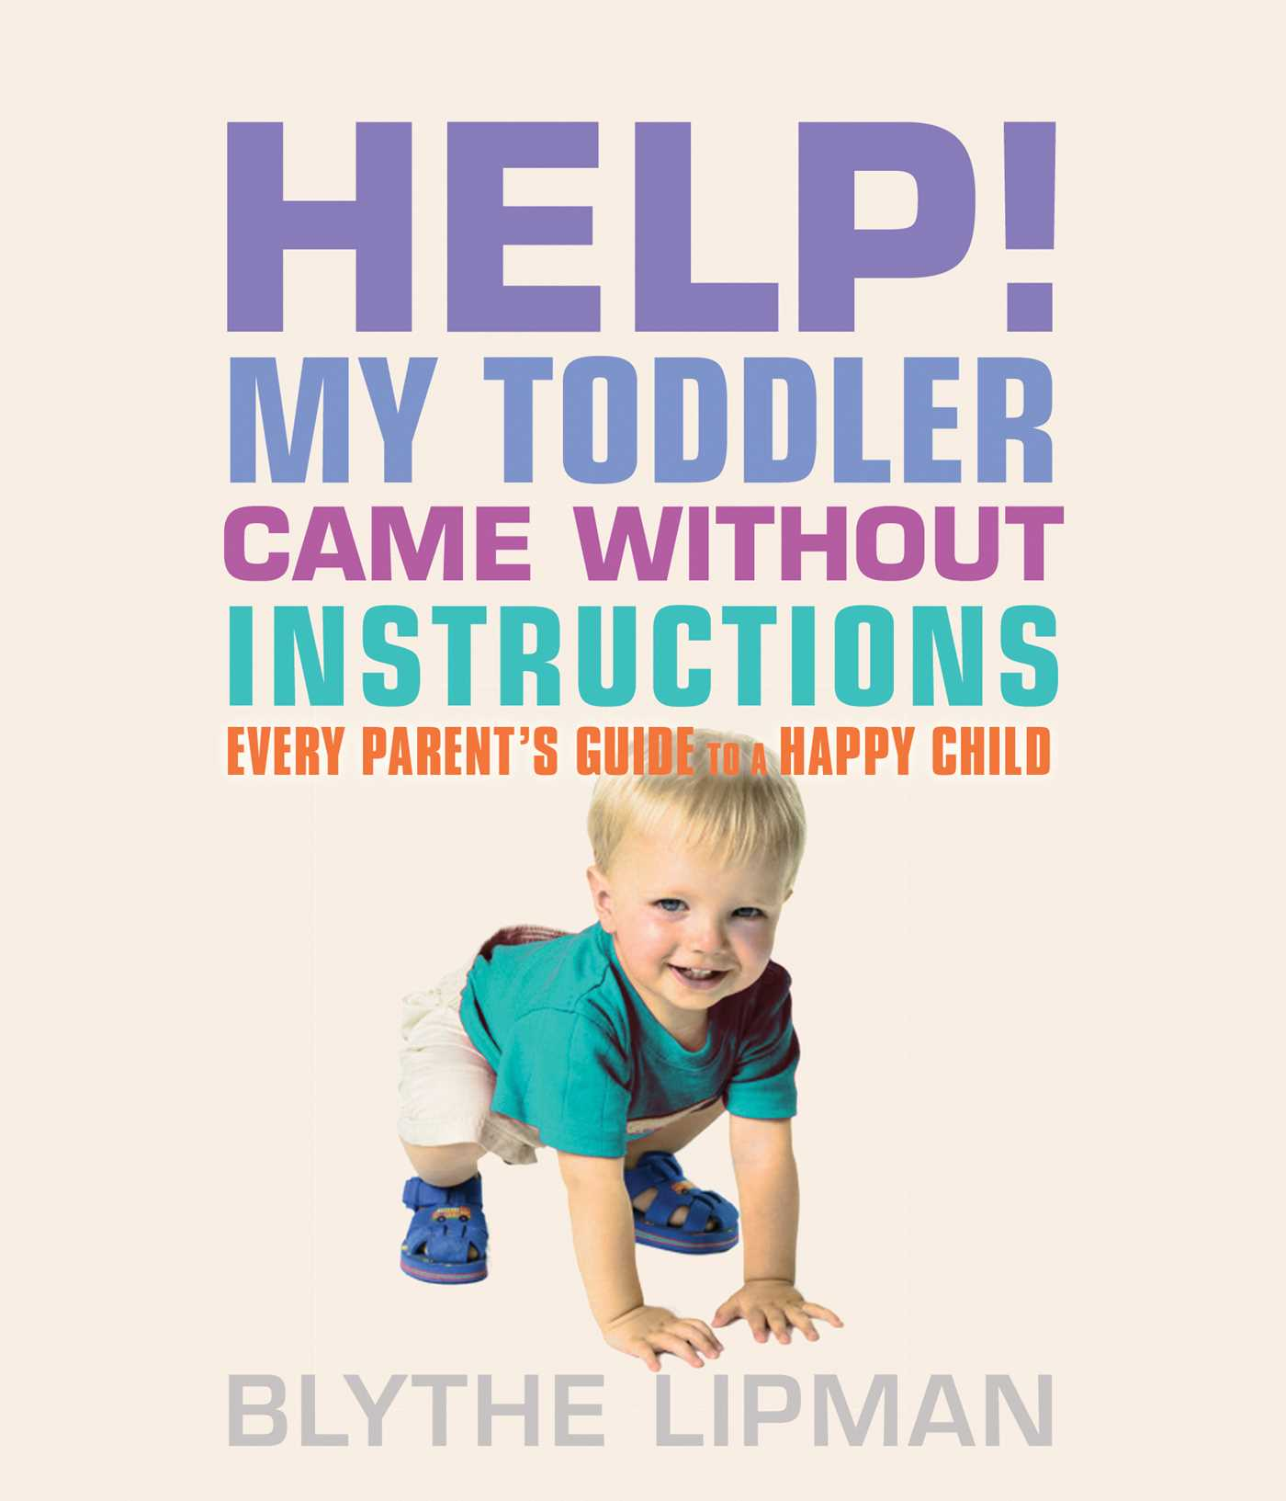
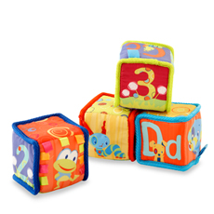
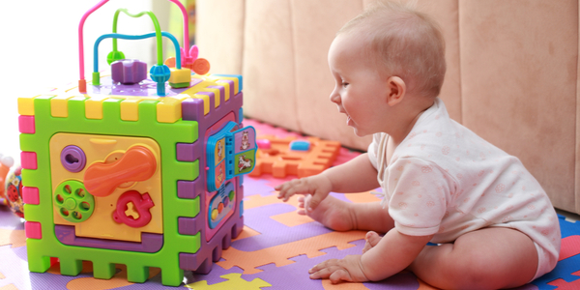
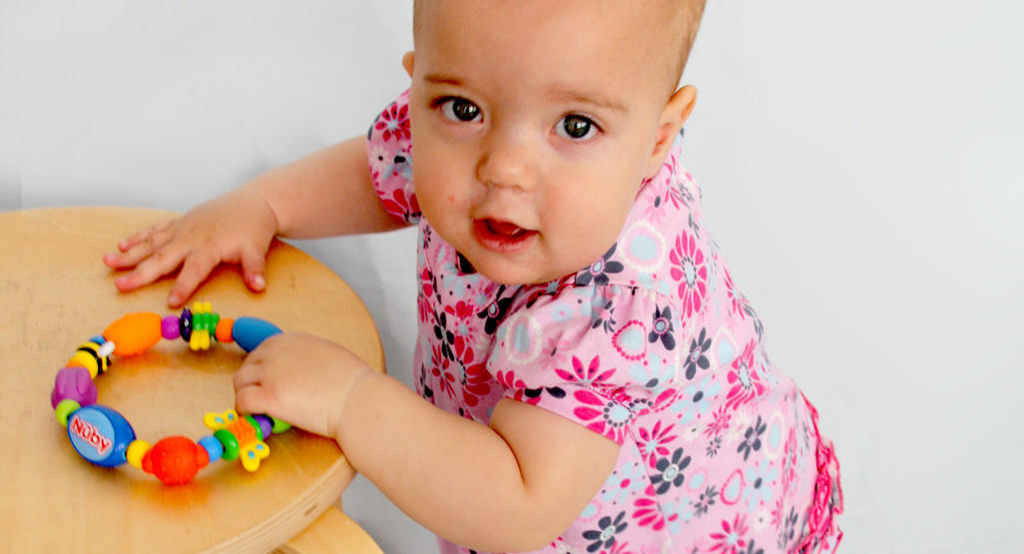
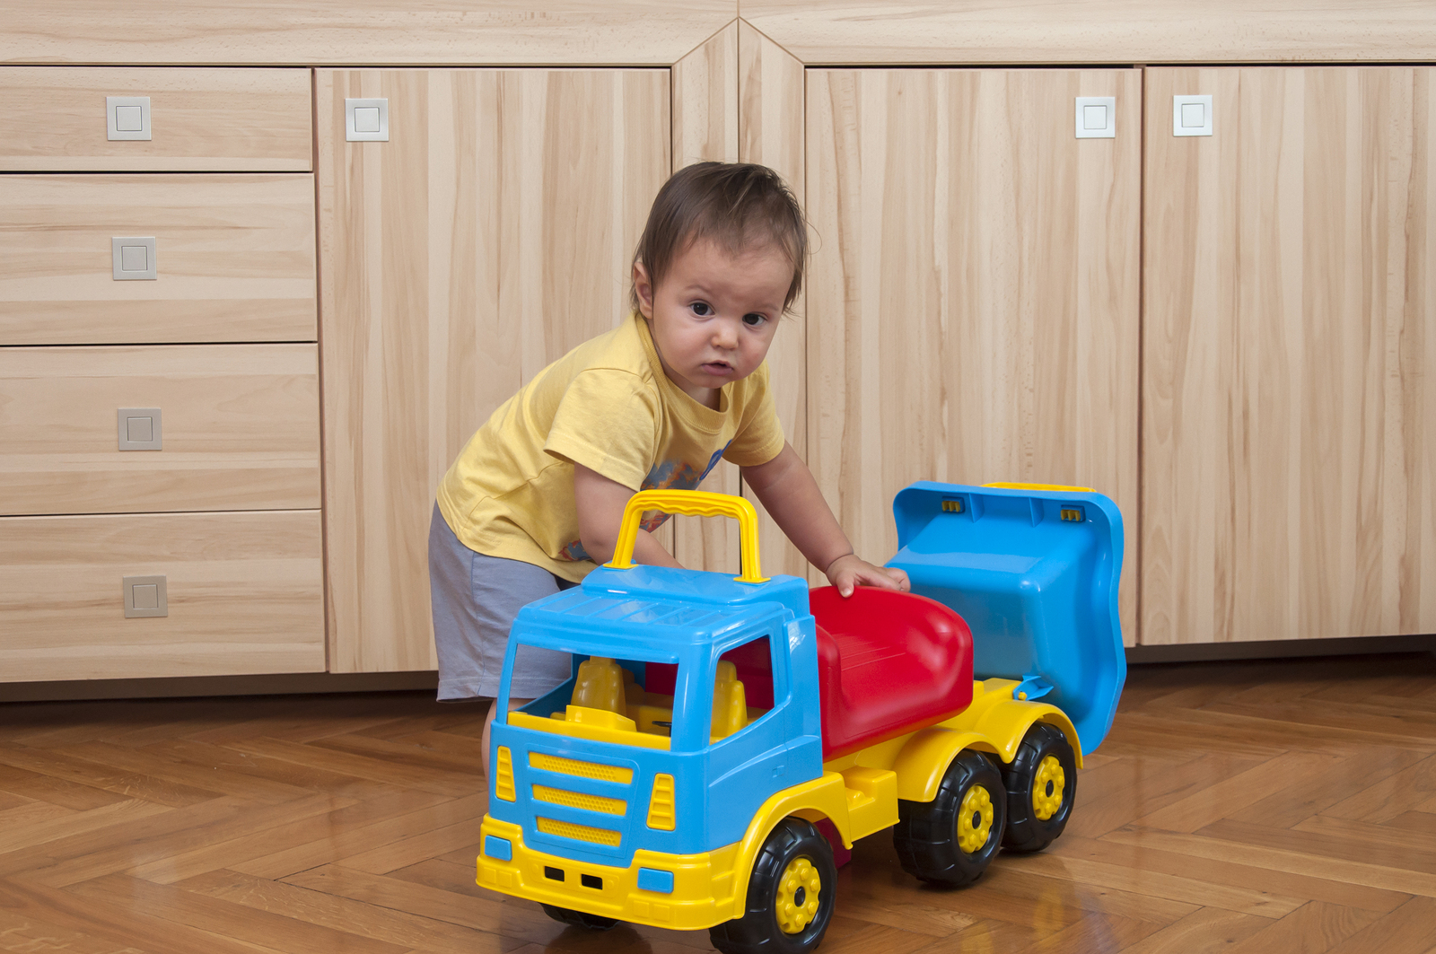
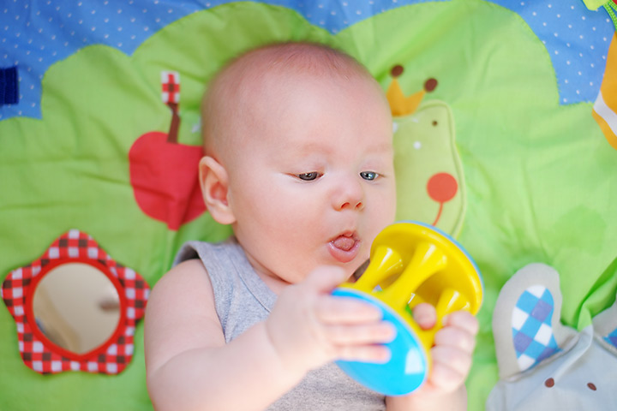
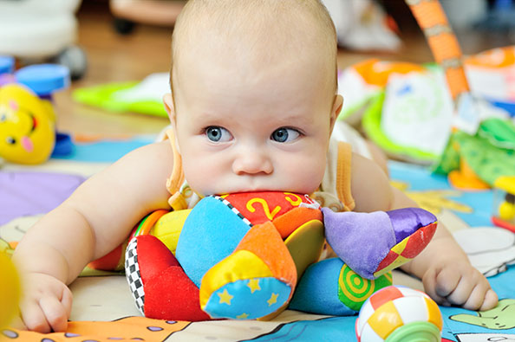

Sensory Games and Activities
- Play peek-a-boo with baby
- Have baby look at their reflection in the mirror and point out each body part
- Encourage baby to crawl over, under, and through various objects in your home
- Introduce baby to new textures through food, toys, clothes, sponges, etc.
- Provide plenty of skin-to-skin contact with caregivers
- Keep baby away from areas where people are smoking or using harsh chemicals

Introduce cardboard or cloth books with brightly colored pictures. Try to select books that reflect the child's own experiences such as books about daily life, family members, animals, or food

Sensory Games and Activities
- Encourage baby to touch fabric with different textures such as wool, corduroy, and velvet
- Lift baby up and down and play in different positions to help develop their sense of movement and balance
- Find balls with different textures and colors. Teach baby how to roll, drop, and bounce them.

Motor Games and Activities
- Place baby on their tummy to play in short spurts for up to an hour over the course of the day
- Place baby tummy down on a blanket and move the blanket slowly around the room
- Allow baby to explore age appropriate toys with their mouth and tongue (be sure that the toys are large enough so that baby does not risk choking)
- Encourage baby to practice repeated rolling from back to tummy. Place toys around to encourage pivoting

Motor Games and Activities
- Put a toy or book inside an empty cardboard box. Wrap it with colorful paper or newspaper comics. Clap your hands when baby yanks it open then announce what is inside.

- Encourage movement by placing toys around baby where they must move to reach them

- Encourage baby pushups during Tummy Time by raising and lowering a rattle over baby’s head

- Engage baby in activities like reading or playing with a ball while in sitting

- Gently push baby back and forth on a swing in the park, but make sure baby can sit up and hold head steady with no problem

- When baby is holding a toy in each hand offer a third toy; watch as baby figures out how to grasp the new toy without letting go of the other two.

- Punch holes in a lid of empty food container and fill with water to make a fun bath time toy.

- Get an empty plastic bucket and have baby throw toy into it.

- Use different household items, like squeeze toys or newspapers to make different noises for baby.

Sensory Games and Activities
- Use your hands to make shadow puppets for baby
- Gently touch baby on the feet and tummy to make them giggle
- Play with a jack in the box or windup toy with baby to show motion
- Use animal sounds when playing with or reading to baby; point out an image of an animal then associate the sound that animal makes with the picture
- Walk with baby in a carrier or baby backpack
- Play with baby in many different positions
- Take baby on a walk in a stroller or jogger
- Use slow, rocking motions for calming and more vigorous motions for play time.

Motor Games and Activities
- Get baby to stack toys such as blocks or rings and describe each toy as your baby picks it up
- Lie down on the floor and have baby crawl over you
- Practice new gestures with baby like blowing kisses, clapping hands, or giving a high five
- Use a toy to encourage baby to crawl when they are in a tummy time position
- Roll a soft ball across the floor and encourage baby to crawl after it
- Allow baby to play with toys they can push or pull across the floor
- Read with baby while they lie on their tummy
- Play with stackable blocks
- Let baby play with large objects like tunnels, pillows, or cushions while supervised
- If baby is already walking, let them try riding toys that they can sit on and scoot across the floor
- Provide push toys that allow baby to practice walking with some support
- Encourage baby to dance and sway to music
- Provide opportunities for baby to experience slow, rocking movements

Motor Games and Activities-The Wobbly Walker
Push toys will be tons of fun for your tot at this age because it allows them to show off their new skill! Toys like these also help them build balance and strength. Baby may still fall occasionally, but it’s okay. Helping baby up and saying “you’re ok” will get them back walking in no time.

Talking Back
Now that baby is a little older you might be able to tell that they understand the words you are saying. Baby probably has several words that they uses regularly and can even respond to simple questions you ask like, “Do you want a cookie?”

No… A Favorite Word
You may have noticed that baby is very curious and is constantly getting into things on their quest to discover new things. Because of this you may be using the word “no” quite a bit and it may even be your tot’s favorite word. Saying “no” is your child’s first show of independence.

Signs of a Sensory Issue:
- Overly sensitive or under reactive to touch, movement, sights, or sounds
- Unusually high or low activity level
- Easily distracted; poor attention to tasks
- Delays in speech, motor skills, or academic achievement
- Coordination problems; appears clumsy or awkward
- Poor body awareness
- Difficulty learning new tasks or figuring out how to play with unfamiliar toys
- Difficulty with tasks that require using both hands at the same time
- Appears to be disorganized most of the time
- Difficulty with transitions between activities or environments
- Immature social skills
- Impulsivity or lack of self-control
- Difficulty calming self once “wound up”

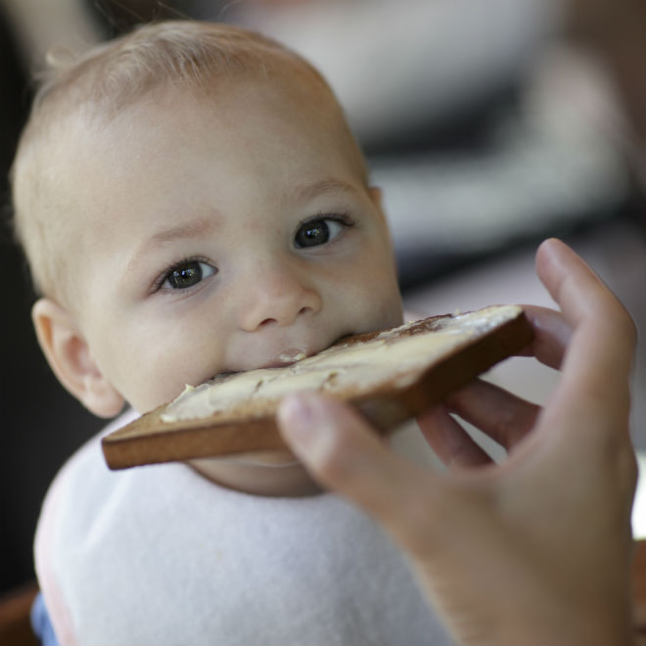
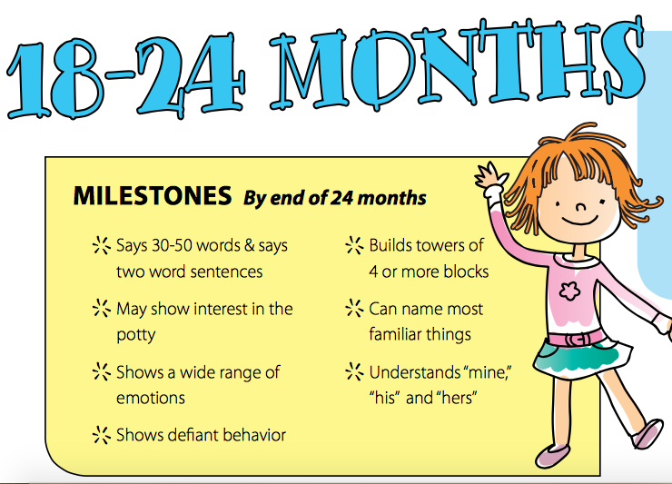


Lorem Ipsum!
0-2 Activity Post
May
Spit it Out

Baby is having a language explosion! Don’t worry if not everyone can understand your little one. You are around them every day so you know what sounds or words they mispronounce. You may be tempted to fill in words they are trying to say or complete their sentences, but try not to rush them as they learn to master new words.

Personality All Their Own

Your child’s likes and dislikes are becoming more obvious during playtime. They probably like to stack blocks and knock them down, scribble, and put things in containers. All of these are great activities to learn new fine motor skills

Structured and Unstructured Play
Structured play requires a child to follow directions or rules, and is guided by an adult. This could include board games, puzzles, and organized classes like dance or art, or team sports like soccer.
In unstructured play a child can do what interests them. That is what makes it so fun! Playing on the jungle gym, playing dress up, and exploring the outdoors are all examples of unstructured play. But the possibilities are endless. As long as there aren’t guidelines on how to play, it is unstructured play.
Both structured and unstructured play are important for children and balance is key.

