
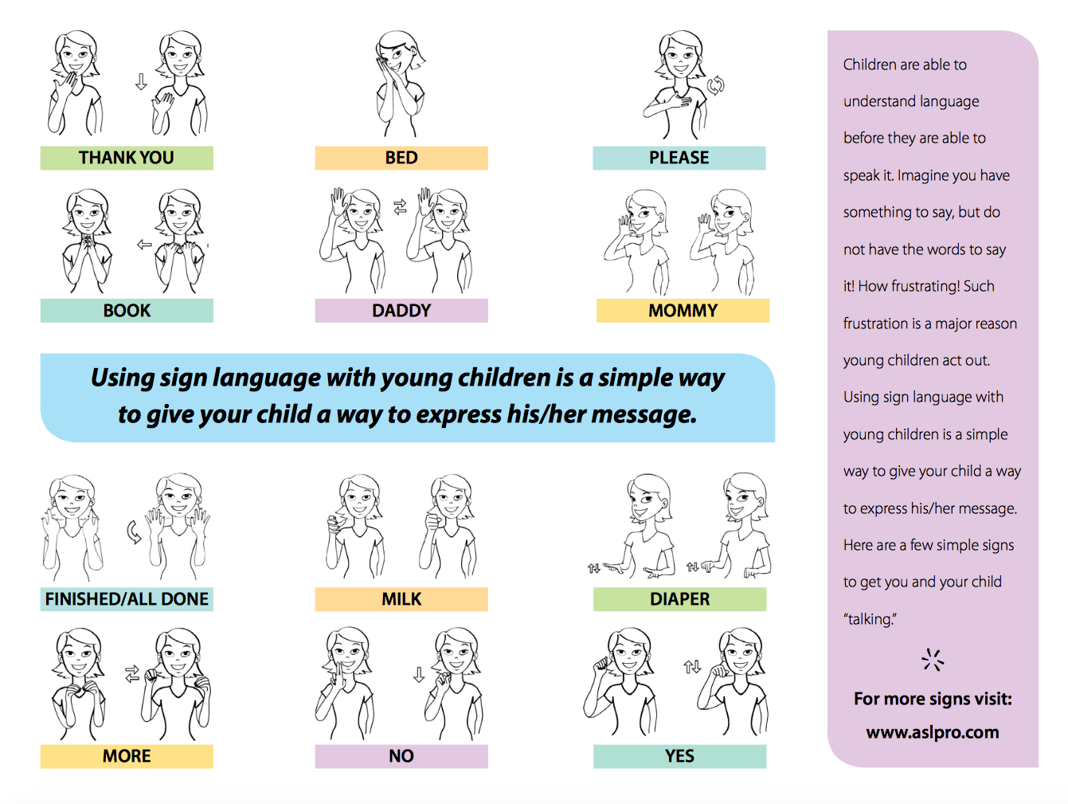
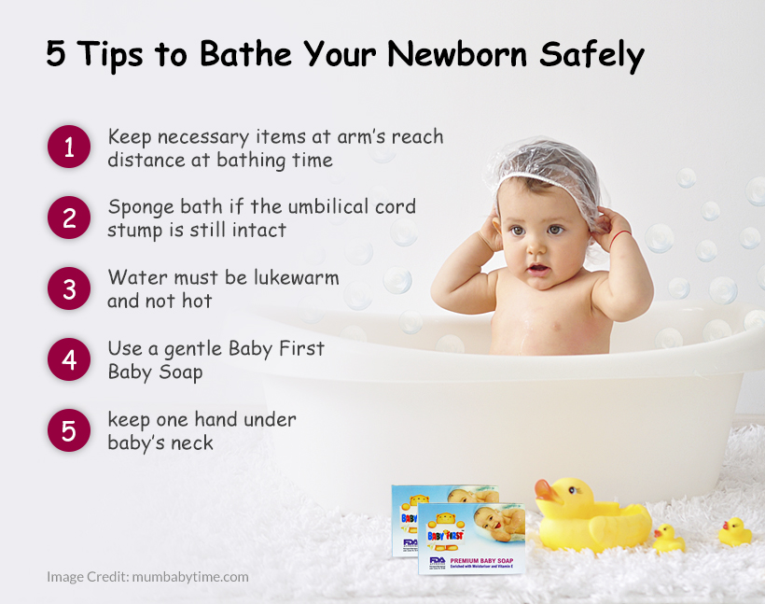
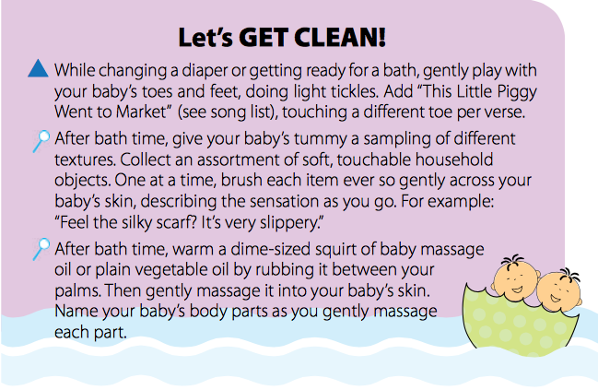
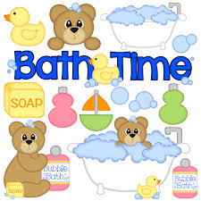
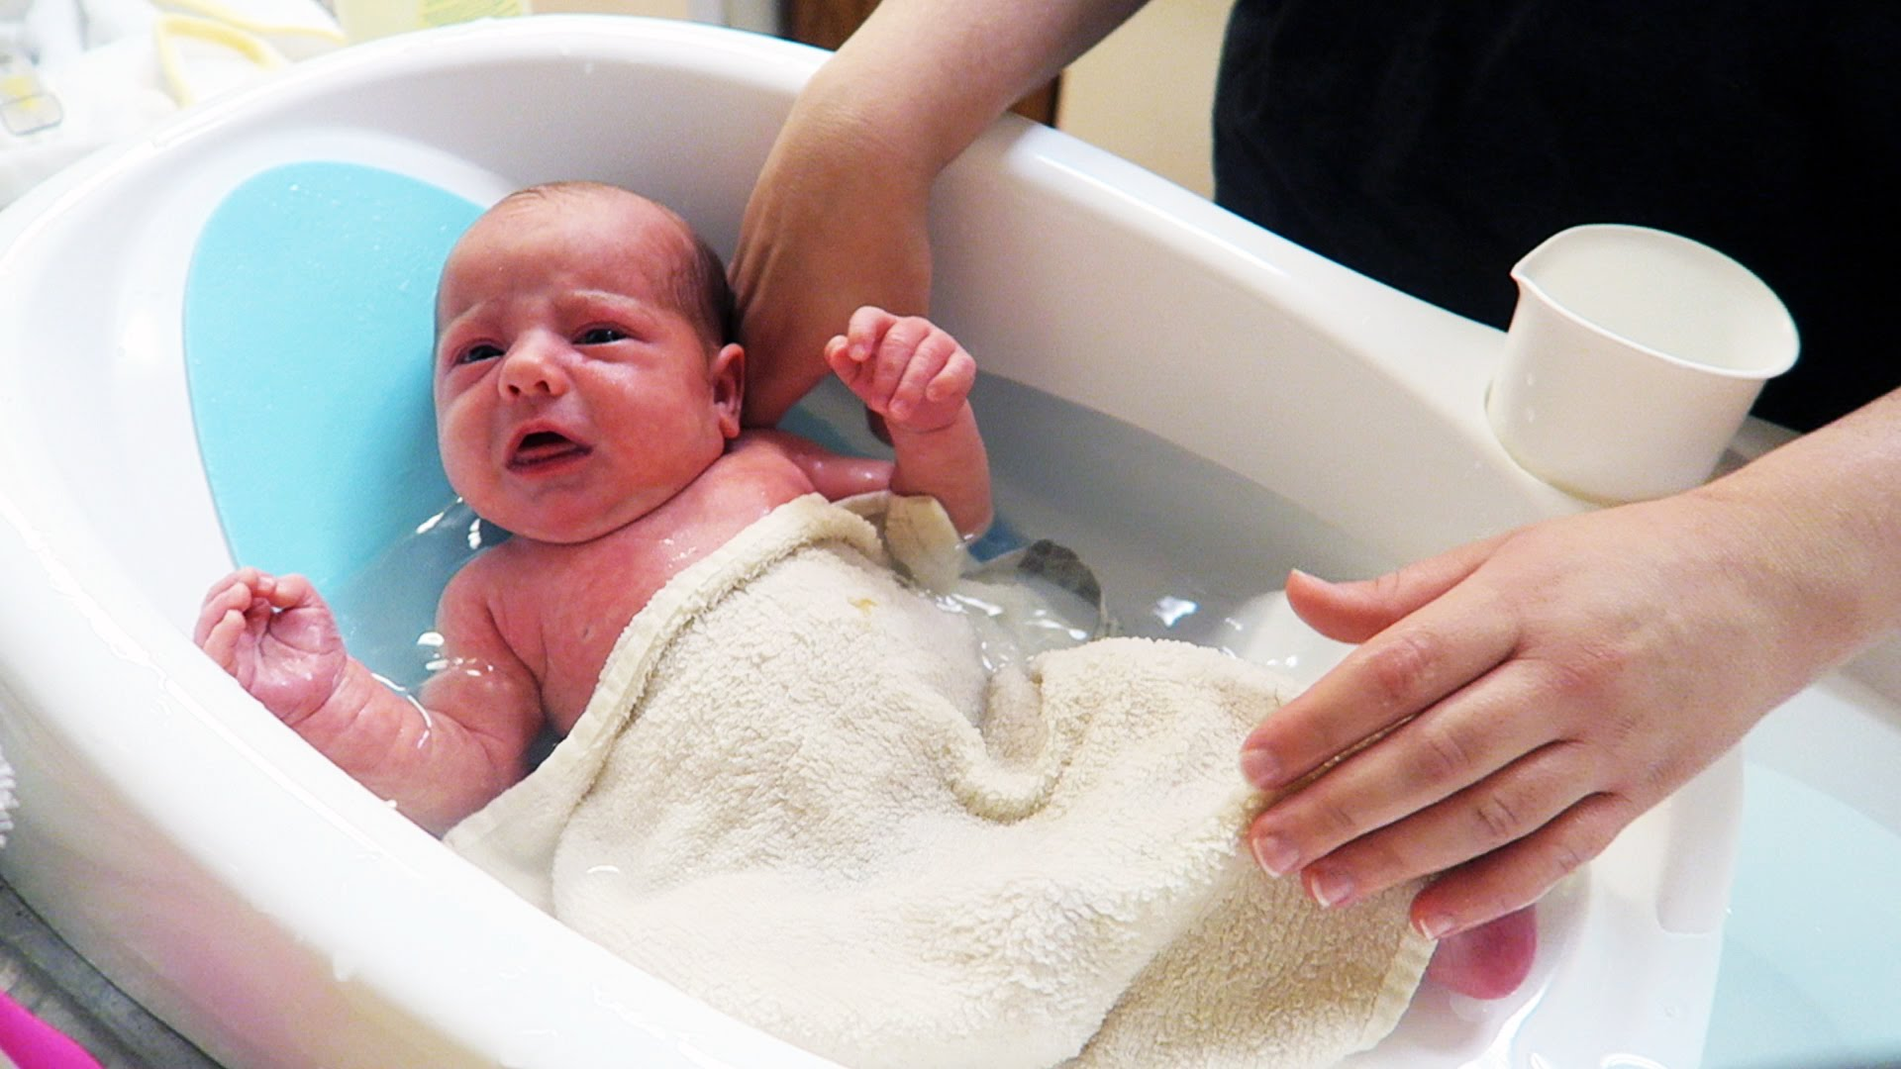
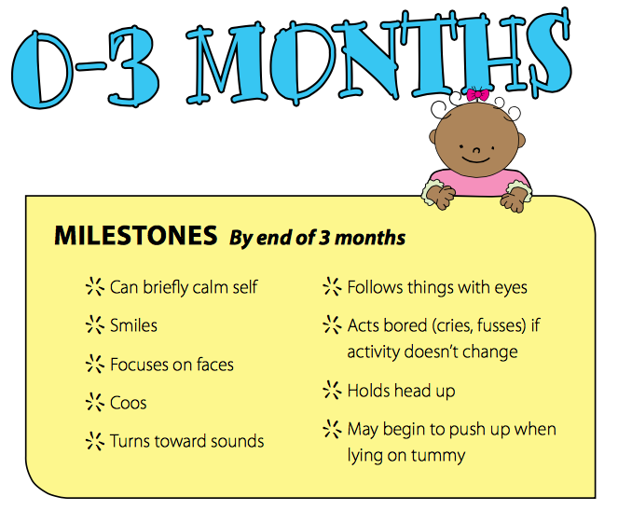
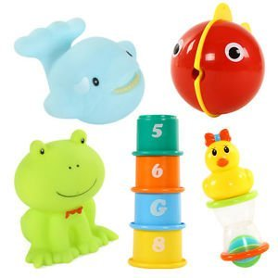
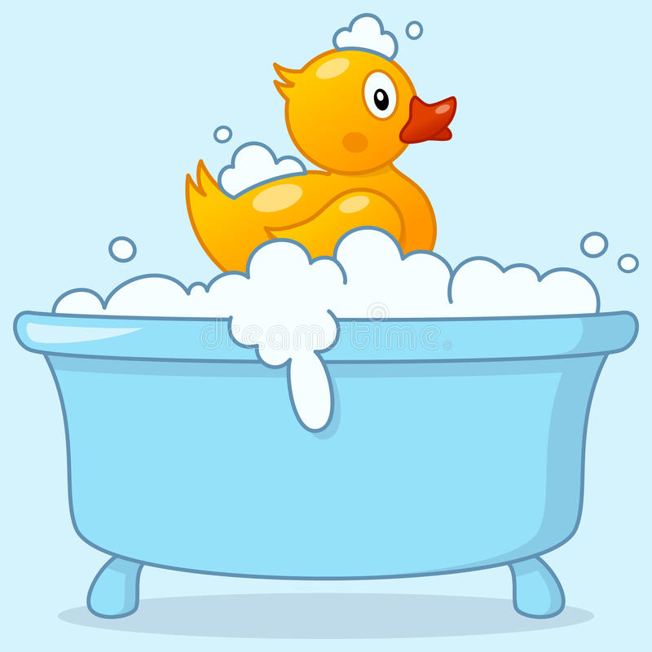
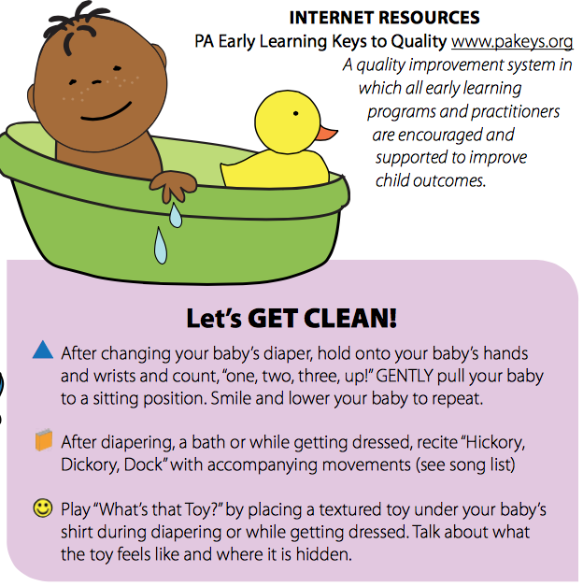
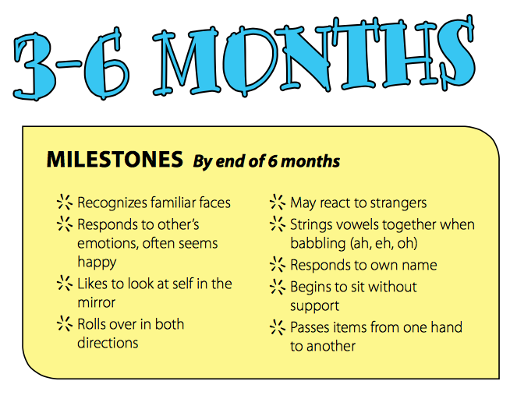
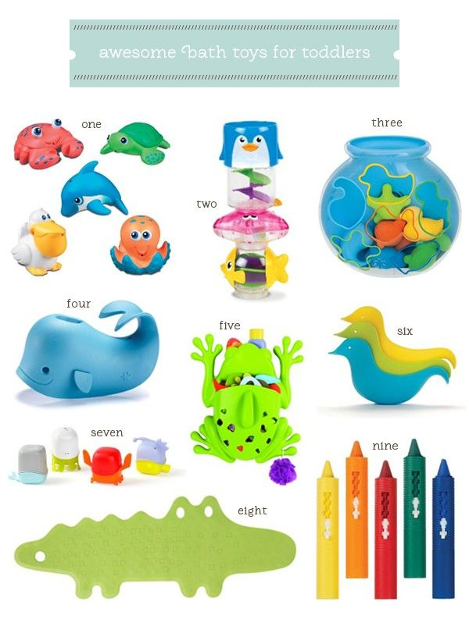
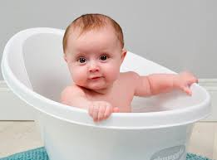
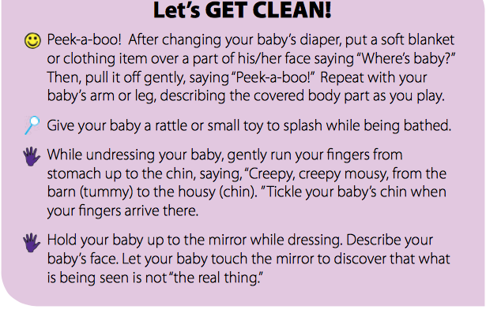
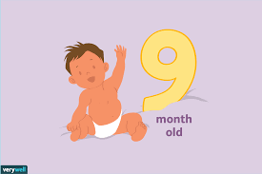
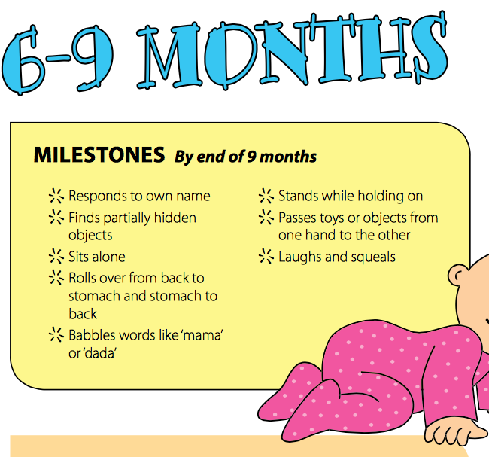
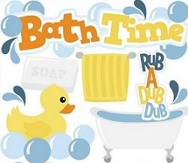
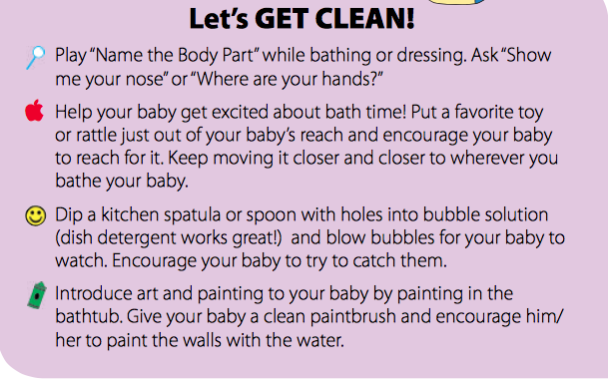
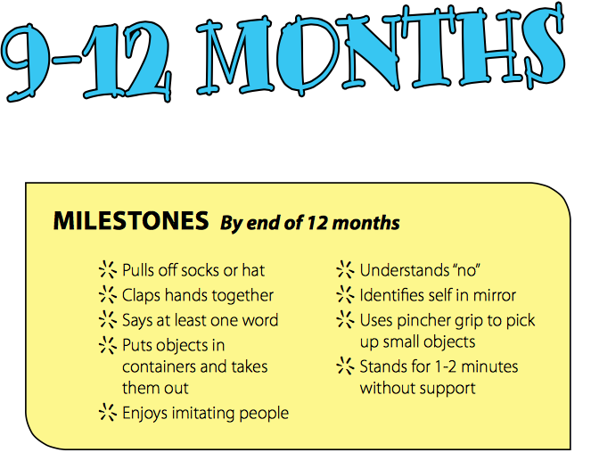
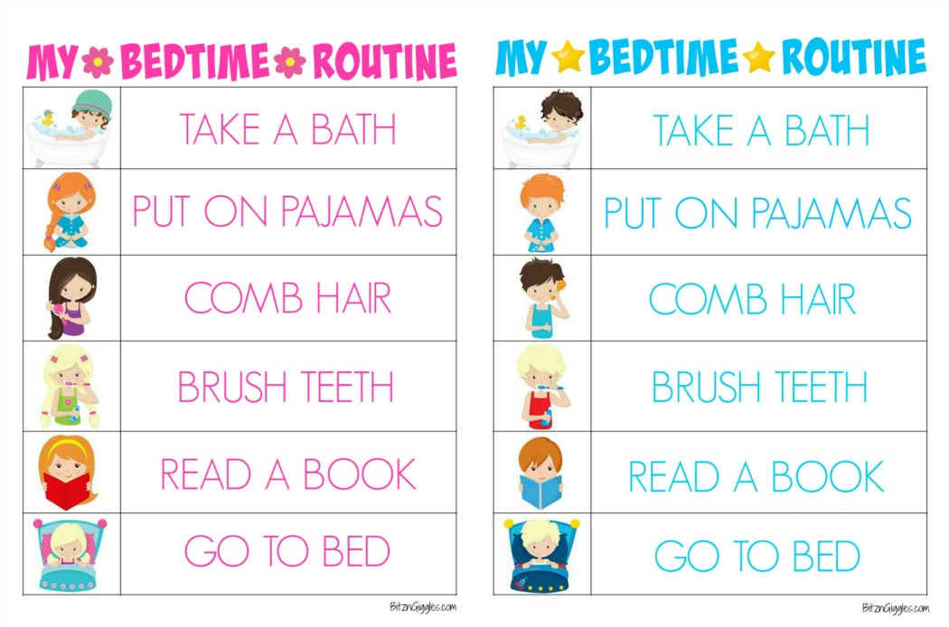
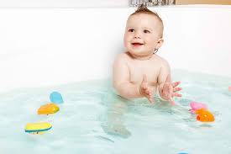
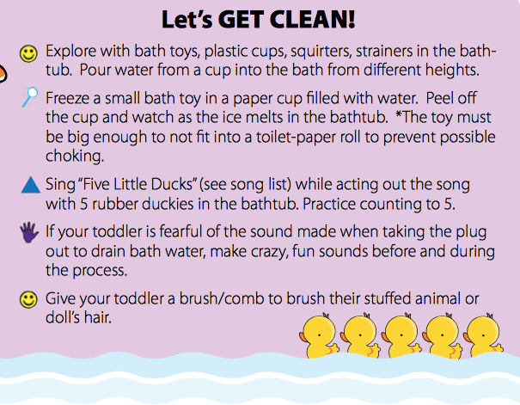
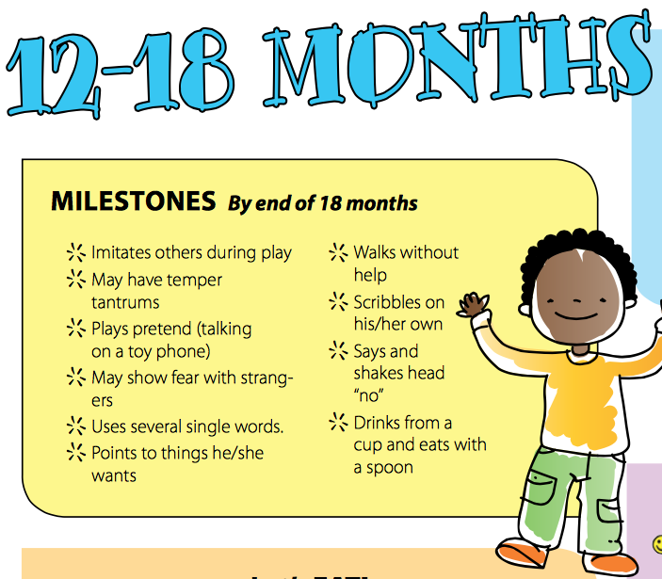
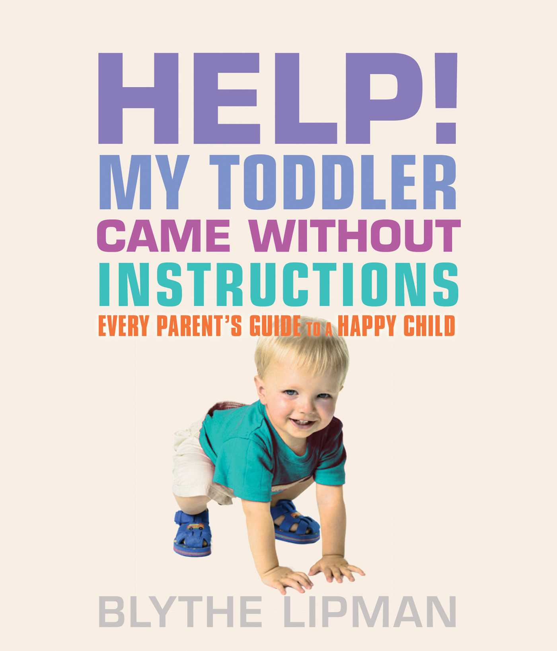
Sign Language is an amazing way to begin communication with your baby.

0-2
  - Let’s Get Clean!

Activity Post
0-2activity post November 2018

Bath Time Tips
1. No-tears shampoo It’s all fun and games till someone gets soap in his eyes. Place a cloth on his forehead, instruct him to look at stickers you’ve stuck on the ceiling and then rinse as fast as you can. Have a towel ready.
2. Make it an event Add some disco flair: Give them Day-Glo bracelets, dim the lights and pump the music. Toss in ice cubes or food colouring. If you make fun—not cleanliness—the priority, you’ll have a win-win scenario on your hands.
3. Take security measures The slip and slide factor of baths can be unnerving for kids. Help them feel more secure by adding a non-skid tub mat. Or keep them steady by joining them. Let them be the boss and wash your hair for a change.
4. The more, the merrier Take advantage of peer pressure and bathe your kids together. If he sees his older brother blowing bubbles, he might want to try it, too.
5. Change the time Some kids hate going to bed with wet hair, or you might find nighttime baths make them more hyper. Try giving your little one a bath after a nap or before breakfast on a weekend.
6. Let them take a standKids might prefer to kneel or stand in the tub. They don’t have to stay seated, especially if you have a tub mat. Or let them have a shower—your kids might like it better.

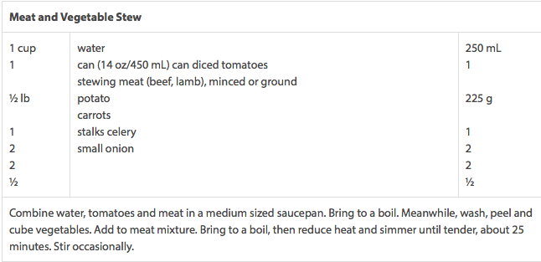

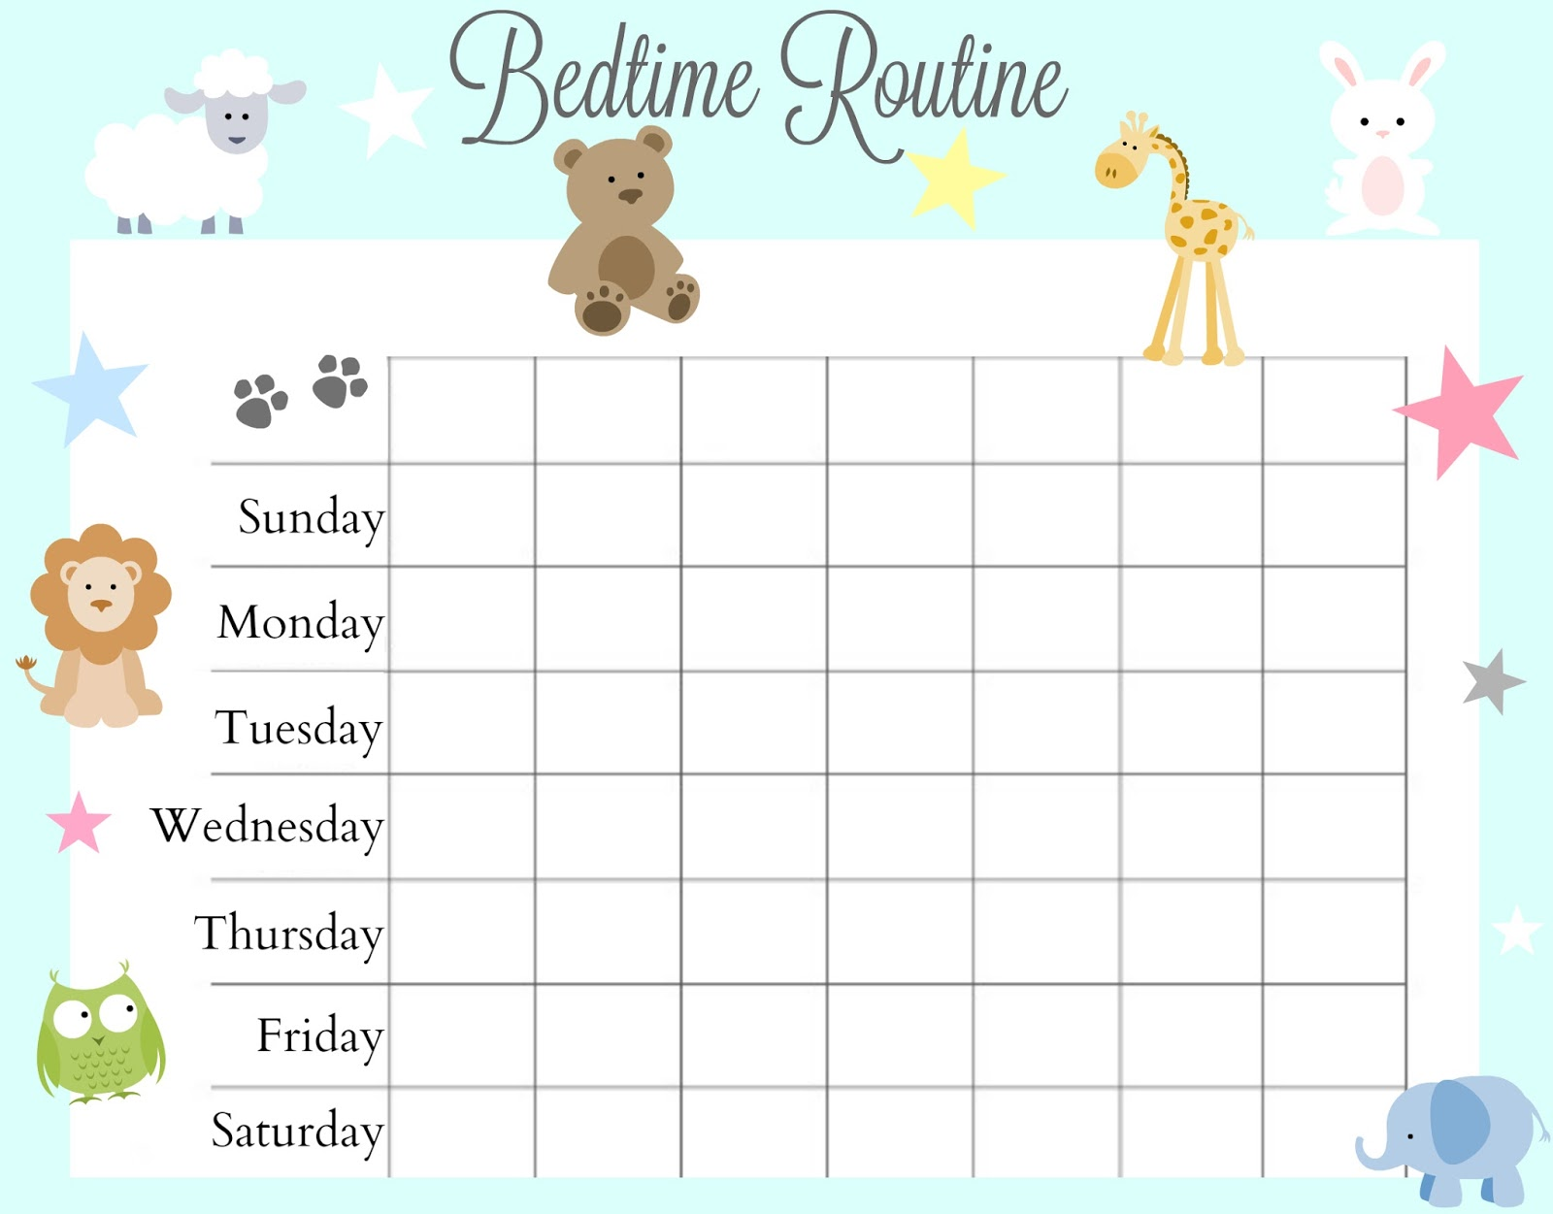
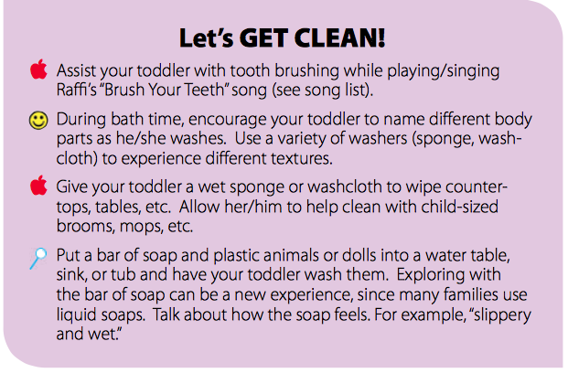
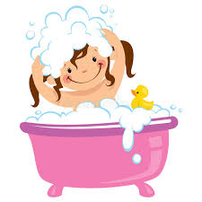
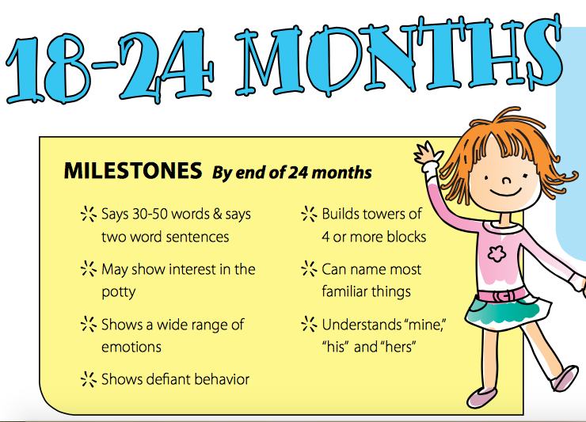

NovemBER
0-2 Activity Post
Lorem Ipsum!

